
Water and Environment management Information System (WEMIS)
WASMIS user manual

Contents
1. Introduction 3
2. Getting Started 3
3. User Manual for WASMIS (Data Download) 4
4. User Manual for WASMIS (Dashboard) 9
5. User Manual for WASMIS Data Entry: F1A.Point Water Source 11
6. User Manual for WASMIS Update: Various Forms 41
7. Form 4 - Point Water Sources: 43
8. S5 - Duplicate Sources: 45
9. S6 - Wrong Coordinates (PWS): 46
10. D6 - Linking Tap to Schemes: 48
11. S9 - Rainwater Harvesting Tank Update: 50
12. S10 - Decommissioning: 52
13. D4 - Update Schemes: 53
14. User Manual for WASMIS Profile Screen 55

User Manual for WASMIS

Introduction
This user manual provides instructions on how to use the WASMIS app. WASMIS is a mobile application designed to provide access to various services related to the Water Supply Management Information System (WASMIS).

Getting Started
- Download and Install:
  - Download the WASMIS app from the Google Play Store or App Store.
  - Install the app on your Android or iOS device.
- Open the App:
  - Tap the WASMIS app icon on your device's home screen or app drawer.

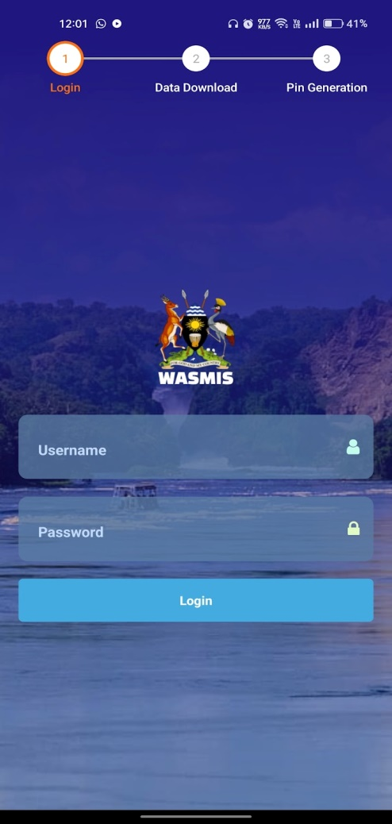

Logging In
- Enter Username:
  - In the "Username" field, enter your WASMIS username.
- Enter Password:
  - In the "Password" field, enter your WASMIS password.
- Tap "Login":
  - Tap the "Login" button to proceed.
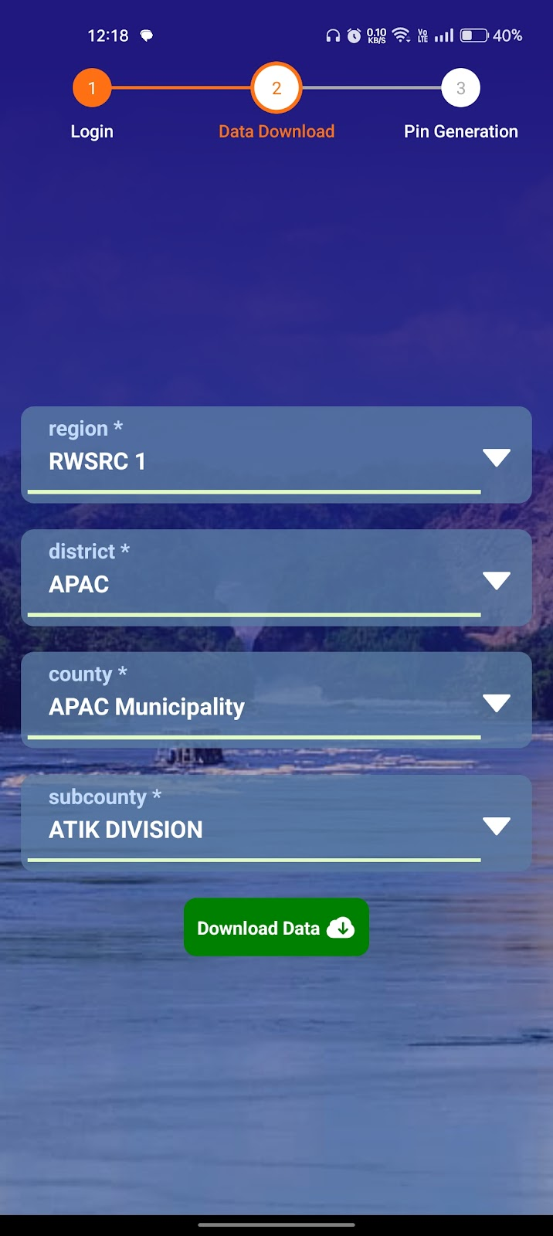

User Manual for WASMIS (Data Download)
Introduction
This user manual provides instructions on how to use the data download feature within the WASMIS app. This feature allows you to download relevant data and documents related to your WASMIS application.

Data Download Process
- Select Region:
  - The screen will display a dropdown menu labelled "Region".
  - Tap on the dropdown arrow and select the appropriate region from the list.
- Select District:
  - A new dropdown menu labelled "District" will appear.
  - Tap on the dropdown arrow and select the district that corresponds to your application.
- Select County:
  - Another dropdown menu labelled "County" will appear.
  - Tap on the dropdown arrow and select the county that corresponds to your application.
- Select Subcounty:
  - A final dropdown menu labelled "Subcounty" will appear.
  - Tap on the dropdown arrow and select the subcounty that corresponds to your application.
- Download Data:
  - Once you have selected all the required fields, tap on the "Download Data" button.
  - The app will initiate the data download process.
Downloading Data
- Progress Bar: A progress bar will be displayed indicating the download progress.
- Download Status: The app will display the total number of records once the download is complete. You can then choose whether to proceed with the download or not.
Additional Tips:
- Internet Connection: Ensure you have a stable internet connection to download data.
- Storage Space: Make sure your device has sufficient storage space to accommodate the downloaded data.
- File Management: Organize and manage the downloaded files for easy access.
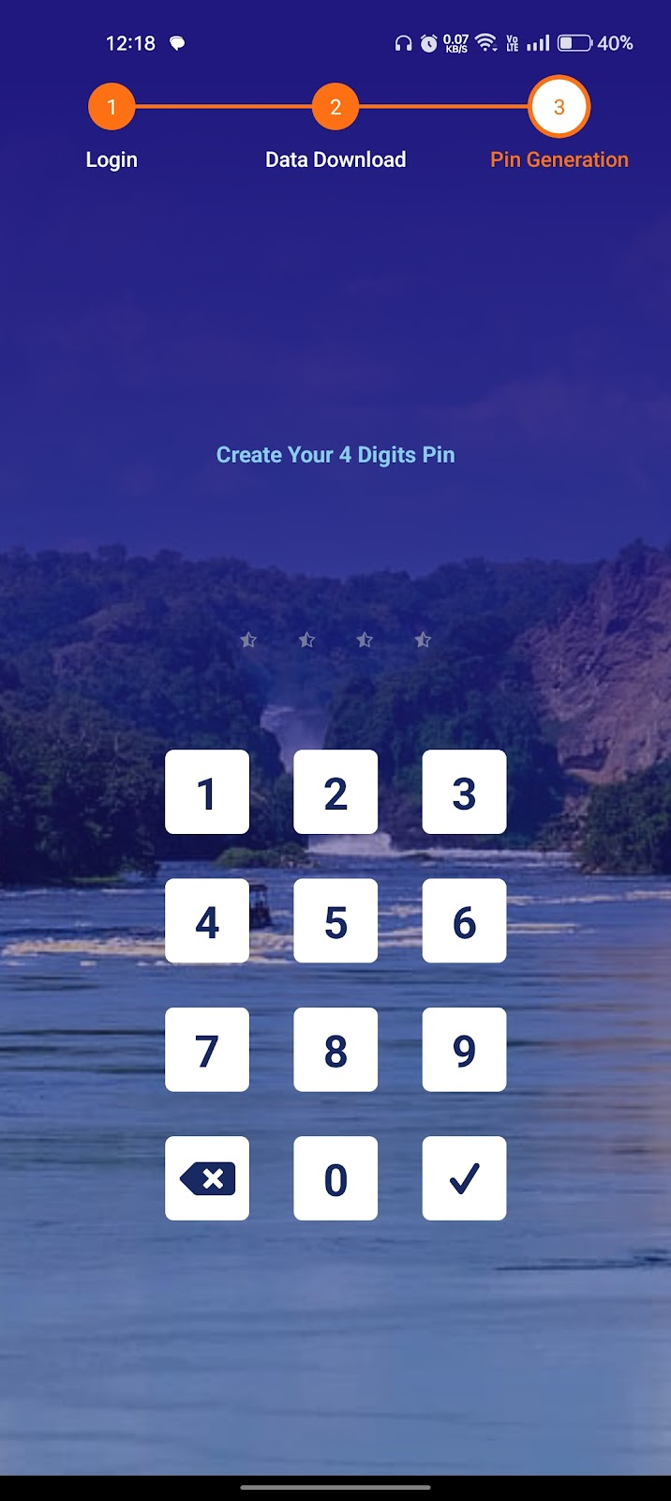
User Manual for WASMIS (Pin Generation)
Introduction
This user manual provides instructions on how to use the pin generation feature within the WASMIS app. This feature allows you to generate a PIN for secure access to certain services within the app.
Pin Generation Process
- Create PIN:
  - Enter your 4-digit PIN using the keypad.
  - Each number you enter will be displayed as an asterisk (*) on the screen.
- Confirm PIN:
  - Re-enter your 4-digit PIN to confirm.
- Submit:
  - Once you have entered the PIN twice, tap on the checkmark (✓) button to submit.
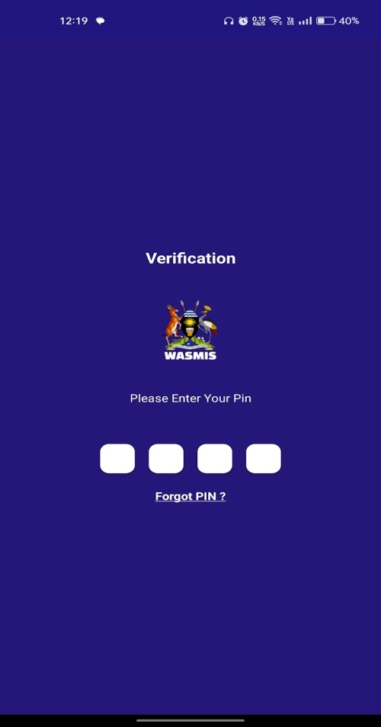
Pin Generation Confirmation
- Success Message: If the PIN is confirmed successfully, the app will display a confirmation message.
- Error Message: If the PIN is incorrect, the app will display an error message and prompt you to re-enter the PIN.
Additional Tips
- PIN Security: Keep your PIN confidential and avoid sharing it with anyone.
- PIN Reset: If you forget your PIN, you may need to contact the WASMIS support team for assistance with resetting it.

User Manual for WASMIS (Verification)
Introduction
This user manual provides instructions on how to use the verification feature within the WASMIS app. This feature is used to verify your identity and access certain services within the app.
Verification Process
- Enter PIN:
  - The screen will display a message "Please Enter Your Pin".
  - A numerical keypad will appear on the screen.

- Enter PIN:
  - Enter your 4-digit PIN using the keypad.
  - Each number you enter will be displayed as an asterisk (*) on the screen.
- Submit:
  - Once you have entered the PIN, tap on the "Submit" button (or a similar button indicated on the screen).
Verification Confirmation
- Success: If the PIN is correct, you will be granted access to the requested service.
- Failure: If the PIN is incorrect, you will be prompted to re-enter the PIN or contact the WASMIS support team.
Forgot PIN
- Forgot PIN Option: If you forget your PIN, tap on the "Forgot PIN?" link.
- PIN Reset: Follow the instructions provided on the screen to reset your PIN. This process may involve contacting the WASMIS support team.
Additional Tips
- PIN Security: Keep your PIN confidential and avoid sharing it with anyone.
- PIN Reset: If you forget your PIN, contact the WASMIS support team for assistance with resetting it.

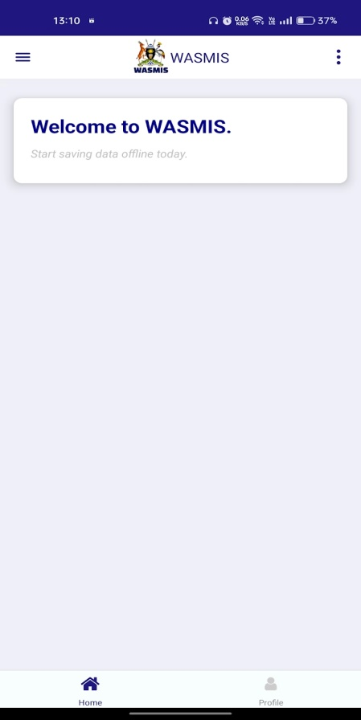
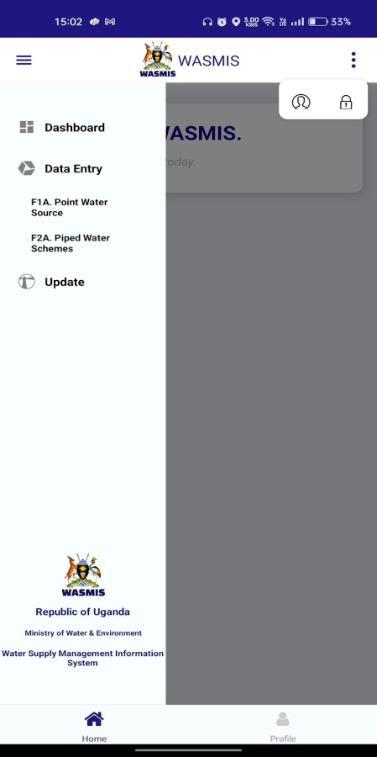

User Manual for WASMIS (Dashboard)
Introduction
This user manual provides instructions on how to use the Dashboard feature within the WASMIS app. The Dashboard provides an overview of key information and functionalities related to the Water Supply Management Information System.
Dashboard Overview
Top Bar:
- Menu Button: Clicking this button opens a navigation drawer.
- WASMIS Logo: This is the logo of the Water Supply Management Information System.
Additionally, on click on three dots may include other options such as:
- Profile: This option will allow you to view and edit your user profile information.
- Logout: This option will allow you to log out of the app.

Main Content Area:
- Welcome Message: It displays a welcome message “Welcome to WASMIS, start saving data offline today”.

Navigation Bar:
- Home: This button takes you to the main home screen.
- Profile: This button takes you to your user profile settings.

Bottom Bar:
- Republic of Uganda Logo: This indicates the country where the system is used.
- Ministry of Water & Environment Logo: This indicates the ministry responsible for the system.
- Water Supply Management Information System: This is the full name of the system.

Possible Functionality:
The WASMIS app appears to be designed for data entry and management related to water supply systems in Uganda. Users can input data about various water sources and schemes, and potentially monitor and analyse this data through the dashboard.

Action on Menu:
when the menu button is clicked, the screen will likely display a navigation drawer. This drawer will contain a list of options, including:
- Dashboard: This option will take you back to the main dashboard screen, which provides an overview of key metrics and information.
- Data Entry: This option will allow you to input new data into the system, such as information about water sources, population served, etc.
- Update: This option will enable you to update existing data or make changes to the system.
The exact options available in the navigation drawer may vary depending on the specific features and functionalities of the WASMIS app. However, the general structure and layout of the navigation drawer should be similar to what is described above.
Click on “F1A.Point Water Source” button.
Click on "Menu” button.
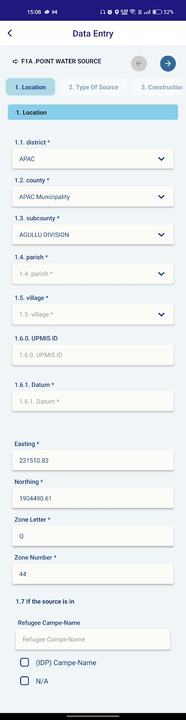
Click on arrow button to move Type of Source section.

User Manual for WASMIS Data Entry: F1A.Point Water Source
Introduction
This user manual provides instructions on how to use the data entry feature within the WASMIS app to input information about point water sources.
Data Entry Process
Select Data Entry Type:
  - On the Data Entry screen, select "F1A. Point Water Source" to enter data about a specific water source.
1. Location Information:
  - District: Will fetch automatically to the dropdown menu.
  - County: Will fetch automatically to the dropdown menu.
  - Subcounty: Will fetch automatically to the dropdown menu.
  - Parish: Select the parish from the dropdown menu.
  - Village: Select the village from the dropdown menu.
  - UPMIS ID: Enter the Unique Parish Monitoring Information System (UPMIS) identifier for the location.
  - Datum: Select the geodetic datum used for the coordinates.
  - Easting: Will get automatically from current place coordinates.
  - Northing: Will get automatically from current place coordinates.
  - Zone Letter: Will get automatically from current place coordinates.
  - Zone Number: Will get automatically from current place coordinates.
  - If the source is in: Select if the water source is located in a refugee camp or IDP camp.

Move to the Next section of Current form.
- After filling all the data in Location, click on the arrow mark top of right corner.
- It will redirect to Types of Source section of point water sources form.

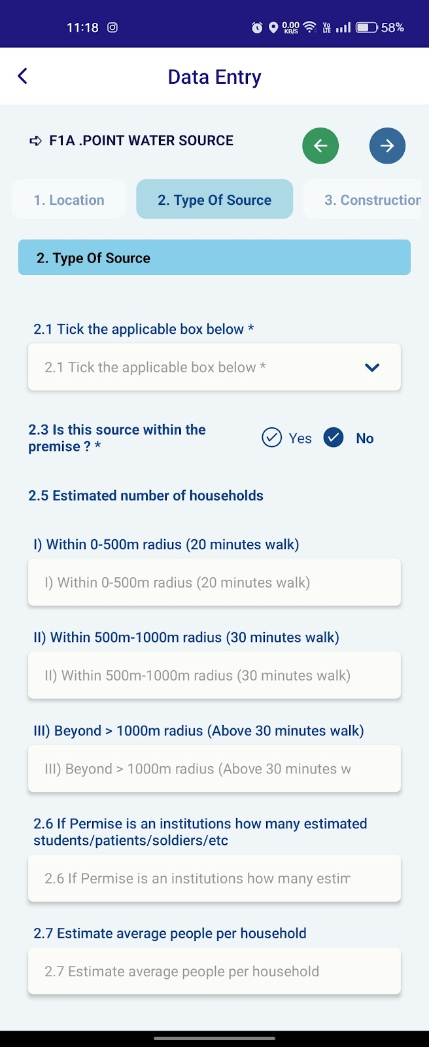

User Manual: F1A.POINT WATER SOURCE (Type of Source)
Overview
This manual provides a guide to accurately classifying the type of a point water source. A point water source is a single, identifiable source of water supply.
Key Types of Point Water Sources
Hand Pump:
A manually operated pump used to extract water from underground sources like wells or boreholes.
Characterized by a vertical pipe and a handle or lever.
Borewell:
A deep well drilled into the ground to access groundwater.
Often equipped with a motor-pump to extract water.
Tap Water:
Water supplied through a system of pipes to individual households or public taps.
Typically sourced from municipal water treatment plants or other reliable sources.
River/Stream:
A natural flowing water body, sourced from rainfall or melting snow.
Often used for domestic, agricultural, and industrial purposes.
Pond/Lake:
A natural or artificial body of standing water.
Can be used for drinking, irrigation, and recreational activities.
Rainwater Harvesting:
A system that collects and stores rainwater for later use.
Often involves tanks or reservoirs.
Others (Specify):
Any other type of point water source not listed above.
This category is for unique or less common sources.
Classification Guidelines
Prioritize Primary Source: If a location has multiple water sources, prioritize the primary source used by the majority of households.
Consider Water Quality: While the physical structure of a source is important, consider the quality of water. A contaminated well, for instance, might not be a reliable source.
Seasonal Variations: Account for seasonal changes in water availability. A source that is reliable during certain months might be less so in others.
Local Knowledge: Consult with local residents to gain insights into traditional water sources and usage patterns.

Data Entry Tips
Accuracy: Ensure accurate data entry to maintain data integrity.
Consistency: Use consistent terminology and classification criteria.
Completeness: Fill in all relevant fields to provide a comprehensive understanding of the water source.
Verification: Double-check entries to avoid errors.
By following these guidelines, you can accurately classify point water sources and contribute to valuable data for water resource management and planning.
Move to the Next section of Current form.
After filling all the data in Types of Source, click on the arrow mark top of right corner.
It will redirect to Construction and Ownership section of point water sources form.
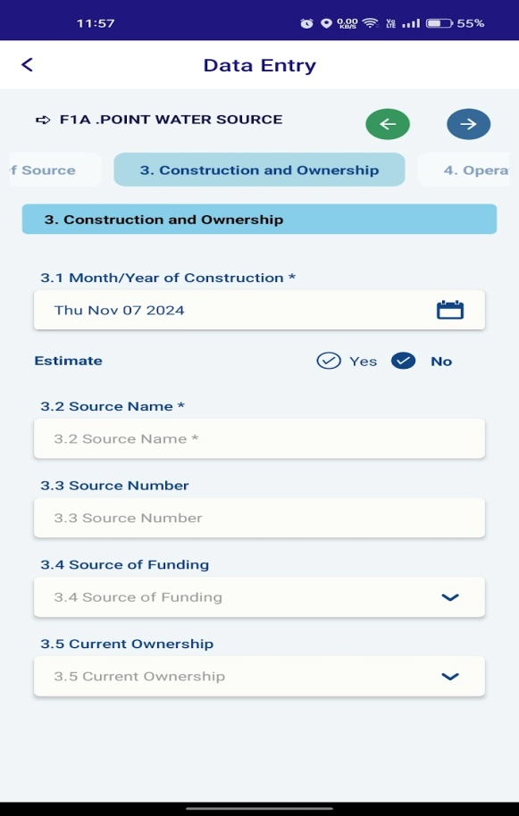
Click on arrow button to move next section of the form.
User Manual: F1A.POINT WATER SOURCE (Construction and Ownership)
Overview
This manual provides instructions on how to use the data entry form for the "Construction and Ownership" section of the F1A.POINT WATER SOURCE. This form is designed to collect information about the construction details and current ownership of the water source.
Form Fields
3. Construction and Ownership
3.1 Month/Year of Construction
Select the month and year of construction using the calendar icon.
If the exact date is unknown, you can estimate the year.
Select "Yes" if the information is an estimate.
Select "No" if the information is accurate and verified.
3.2 Source Name
Enter the name of the water source. This could be a local name or a formal designation.
3.3 Source Number
Enter the unique identification number assigned to the water source, if any.
3.4 Source of Funding
Select the source of funding for the construction of the water source from the dropdown options. This may include government agencies, NGOs, community contributions, or other sources.
3.5 Current Ownership
Select the current owner of the water source from the dropdown options. This could be a government agency, a community group, a private individual, or a combination.
Additional Tips
Use clear and concise language when entering information.
Double-check all entries before submitting to avoid errors.
If you encounter any difficulties, refer to the help section within the app or contact the support team.
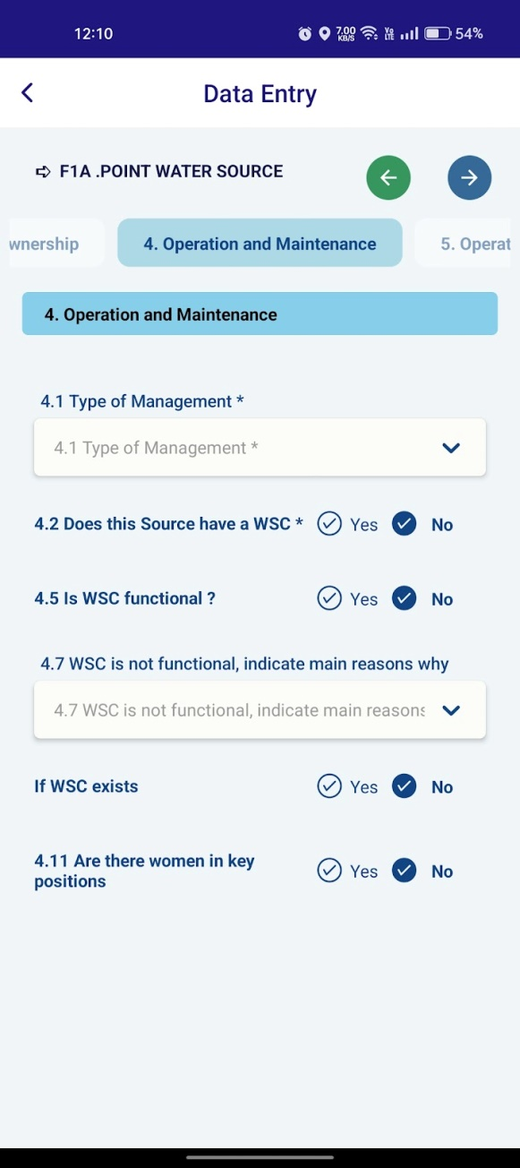

User Manual: F1A.POINT WATER SOURCE (Operation and Maintenance)
Overview
This manual provides instructions on how to use the data entry form for the "Operation and Maintenance" section of the F1A.POINT WATER SOURCE. This form is designed to collect information about the management, functionality, and operation of the water source.
4. Operation and Maintenance
4.1 Type of Management
Select the type of management for the water source from the dropdown options. This may include community-based management, government management, or private management.
4.2 Does this Source have a WSC?
Select "Yes" if the water source has a Water Supply Committee (WSC).
Select "No" if the water source does not have a WSC.
4.3 If Yes is selected ,then select Month/Year of establishment.
4.4 If established, then select Month/Year of establishment.
4.5 Is WSC functional?
If you selected "Yes" for the previous question, select "Yes" if the WSC is
functional.
Select "No" if the WSC is not functional.
4.6 If WSC is functional, tick applicable box (Environment /sanitation around the source is ok, WSC is collecting user fees etc)
4.7 WSC is not functional, indicate main reasons why
If you selected "No" for the previous question, select the main reasons why the WSC is not functional from the dropdown options. This may include lack of funds, lack of training, or other reasons.
4.8 If WSC Exists, enter the number of members on WSC.
4.9 Enter the number of active members on WSC.
4.10 Enter the number of women on WSC
4.11 Are there women in key positions?
Select "Yes" if there are women in key positions within the WSC.
Select "No" if there are no women in key positions.
4.12 If yes, enter the number of women holding key positions. (Chairperson, secretary etc)
Submitting the Form
Once you have completed all the fields, review the information to ensure accuracy.
Submit the form to save the data.
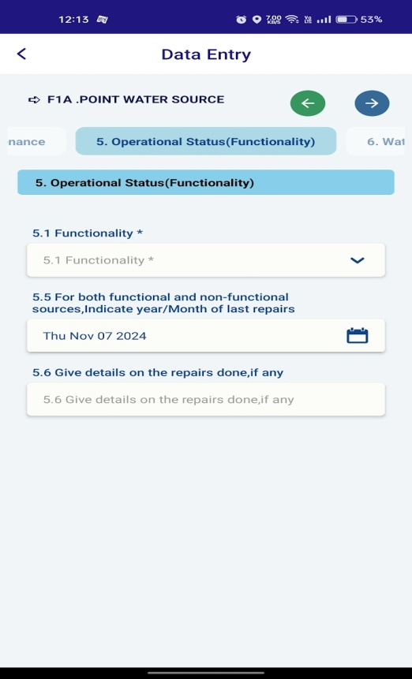

User Manual: F1A.POINT WATER SOURCE (Operational Status)
Overview
This manual provides instructions on how to use the data entry form for the "Operational Status (Functionality)" section of the F1A.POINT WATER SOURCE. This form is designed to collect information about the current functionality and repair history of the water source.
Form Fields
5. Operational Status (Functionality)
5.1 Functionality
Select the current functionality of the water source from the dropdown options. This may include "Functional," "Non-functional," or "Partially functional."
5.5 For both functional and non-functional sources, Indicate year/Month of last repairs
Select the month and year of the last repair using the calendar icon.
If no repairs have been done, leave this field blank.

5.6 Give details on the repairs done, if any
If repairs have been done, provide a brief description of the repairs carried out. This may include details like the type of repair, materials used, and the person or organization who performed the repair.
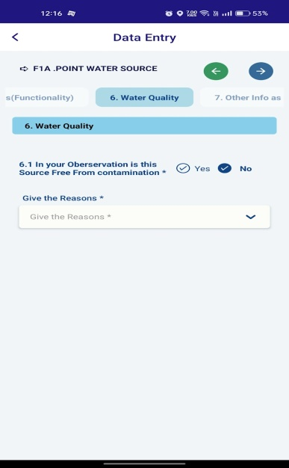
User Manual: F1A.POINT WATER SOURCE (Water Quality)
Overview
This manual provides instructions on how to use the data entry form for the "Water Quality" section of the F1A.POINT WATER SOURCE. This form is designed to collect information about the perceived quality of the water source.
Form Fields
6. Water Quality
6.1 In your Observation is this Source Free from Contamination?
Select "Yes" if you believe the water source is free from contamination.
Select "No" if you believe the water source is contaminated.
Give the Reasons
If you selected "No" for the previous question, provide a brief description of the reasons why you believe the water source is contaminated. This may include visible signs of pollution, unusual odours, or information from local residents.
If you encounter any difficulties, refer to the help section within the app or contact the support team.
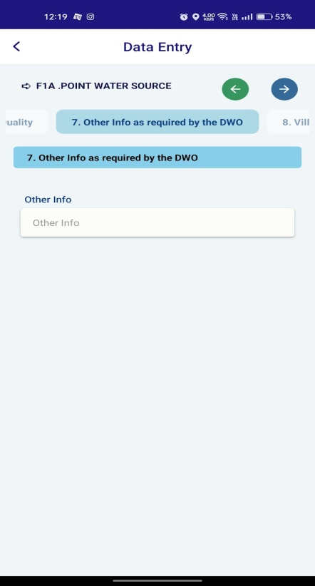

User Manual: F1A.POINT WATER SOURCE (Other Info)
Overview
This manual provides instructions on how to use the data entry form for the "Other Info as required by the DWO" section of the F1A.POINT WATER SOURCE. This section is designed for any additional information that might be relevant to the water source but is not covered in the previous sections.
Form Fields
7. Other Info as required by the DWO
This section provides two text fields for entering any additional information.
Use these fields to provide any specific details that are relevant to the water source, such as:
Unique characteristics: Unusual features or historical significance.
Local concerns: Any issues or problems reported by local residents.
Future plans: Proposed improvements or developments related to the water source.
Any other relevant information: Any other information that you think might be important.

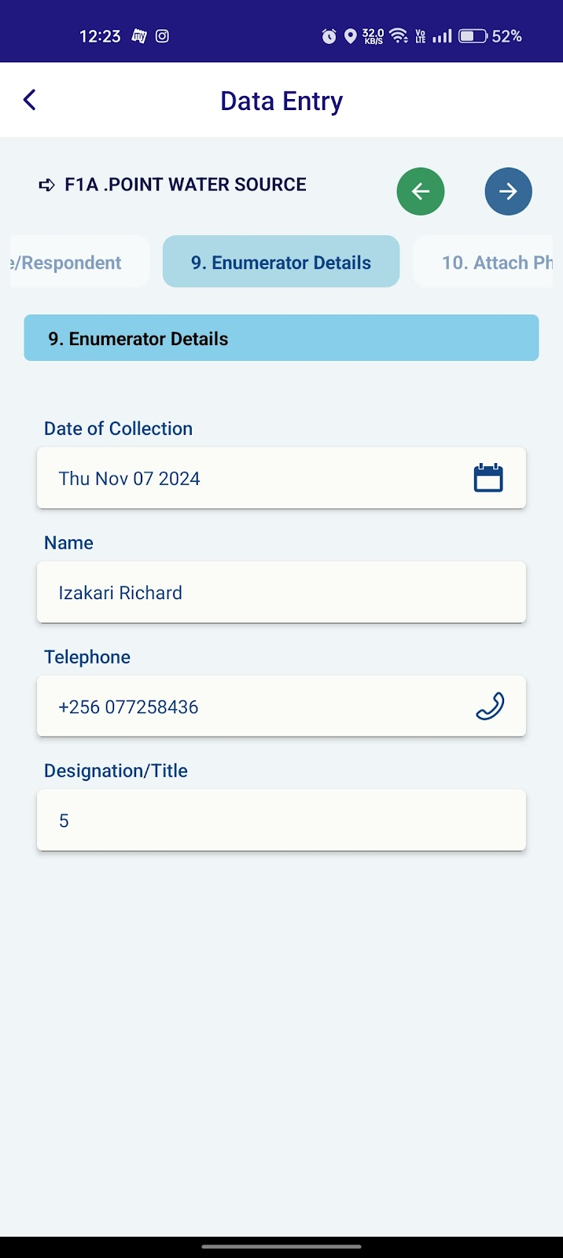
User Manual: F1A.POINT WATER SOURCE (Enumerator Details)
Overview
This manual provides instructions on how to use the data entry form for the "Enumerator Details" section of the F1A.POINT WATER SOURCE. This form is designed to collect information about the person who collected the data for the water source.
Form Fields
9. Enumerator Details
Date of Collection
Automatically fetch the current date.

Name
Automatically fetch the full name of the enumerator who collected the data.
Telephone
Automatically fetch the phone number of the enumerator.
Designation/Title
Enter the designation or title of the enumerator, such as "Field Officer," "Data Collector," or "Surveyor."
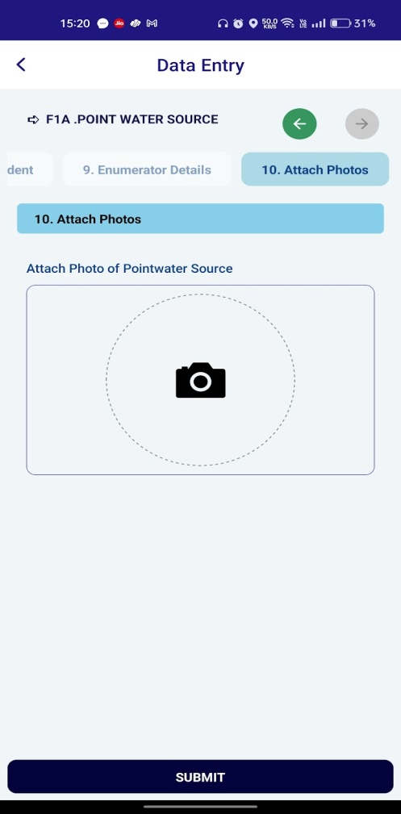

User Manual: F1A.POINT WATER SOURCE (Attach Photos)
Introduction
This user manual provides instructions on how to use the photo attachment feature within the WASMIS app to capture and upload images of point water sources during the data entry process.
Attaching Photos
Tap the Camera Icon:
Tap on the camera icon within the "Attach Photo of Point Water Source" section.
Camera Access:
Allow the app access to your device's camera.
Capture Photo:
Use your device's camera to capture a clear photo of the point water source.
Review and Confirm:
Review the captured photo. If satisfied, tap on the "Confirm" button.
Additional Photos:
If needed, repeat steps 1-4 to capture additional photos.
Submit:
Once you have attached all the necessary photos, tap on the "Submit" button to save the data entry.
Additional Tips:
Ensure that the photos are clear and well-lit to provide accurate information about the water source. Size of the photo should be below 5 mbs only allowed to upload.
Capture photos from multiple angles to provide a comprehensive view of the water source.
If the photo quality is not satisfactory, you can retake the photo.
Always review the attached photos before submitting the data entry to ensure accuracy.
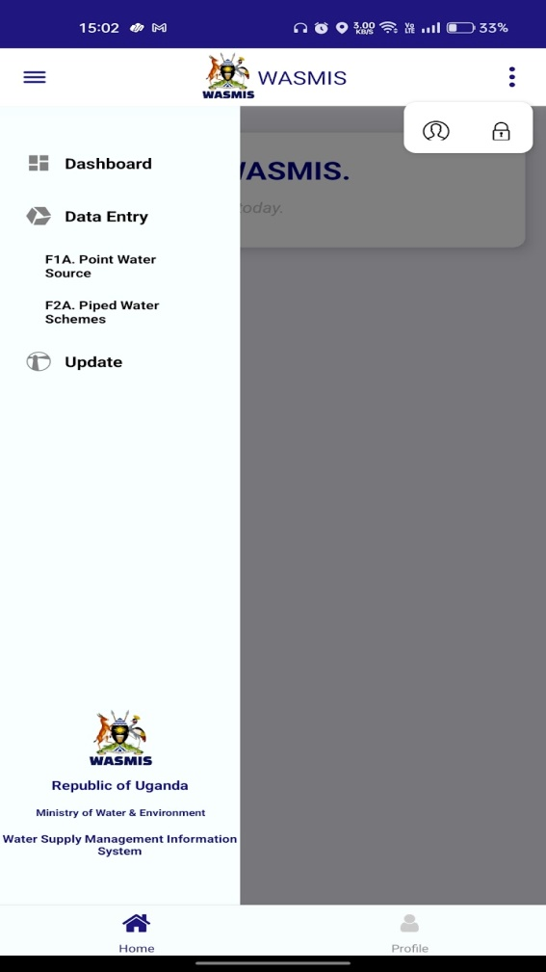
Click on “F2A.Piped Water Schemes” button.

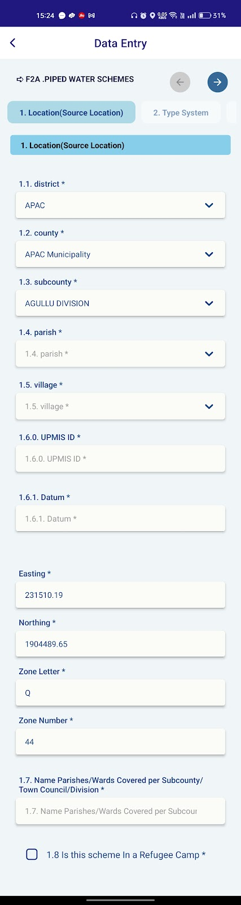
User Manual for WASMIS Data Entry: Piped Water Schemes
Introduction
This user manual provides instructions on how to use the data entry feature within the WASMIS app to input information about piped water schemes.
Data Entry Process
1. Location (Source Location)
1.1. District: Will fetch automatically to the dropdown menu.
1.2. County: Will fetch automatically to the dropdown menu.
1.3. Subcounty: Will fetch automatically to the dropdown menu.
1.4. Parish: Select the parish from the dropdown menu.
1.5. Village: Select the village from the dropdown menu.
1.6.0. UPMIS ID: Enter the Unique Parish Monitoring Information System (UPMIS) identifier for the location.
1.6.1. Datum: Select the geodetic datum used for the coordinates.
Easting: Will get automatically from current place coordinates.
Northing: Will get automatically from current place coordinates.
Zone Letter: Will get automatically from current place coordinates.
Zone Number: Will get automatically from current place coordinates.
1.7. Name Parishes/Wards Covered: Enter the names of the parishes or wards covered by the water scheme.
1.8. Is this scheme in a Refugee Camp: Select "Yes" or "No" to indicate if the scheme is located in a refugee camp.
Additional Tips:
Ensure that all data entered is accurate and up-to-date.
If you encounter any errors or issues, contact the WASMIS support team for assistance.
Regularly update the app to the latest version to ensure optimal performance and access to new features.
Move to the Next section of Current form.
After filling all the data in Location, click on the arrow mark top of right corner.
It will redirect to Types of Source fill all the filled alike above form.
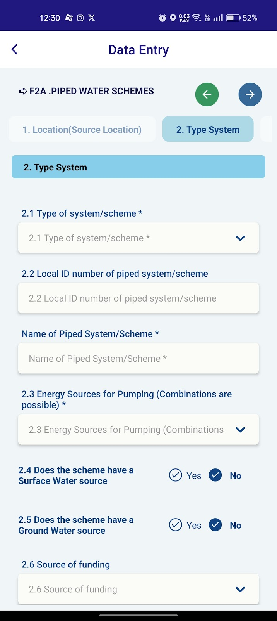
User Manual: F2A.PIPED WATER SCHEMES (Type System)
Overview
This manual provides instructions on how to use the data entry form for the "Type System" section of the F2A.PIPED WATER SCHEMES. This form is designed to collect information about the type, identification, and energy source of the piped water system/scheme.
Form Fields
2. Type System
2.1 Type of system/scheme
Select the type of system/scheme from the dropdown options. This may include options like "Community piped water supply," "Public tap," or "Private piped water supply."
2.2 Local ID number of piped system/scheme
Enter the unique identification number assigned to the piped system/scheme, if any.
Name of Piped System/Scheme
Enter the name of the piped system/scheme. This could be a local name or a formal designation.
2.3 Energy Sources for Pumping (Combinations are possible)
Select the energy source(s) used for pumping water in the system from the dropdown options. This may include options like "Electricity," "Diesel," "Solar," or "Hand pump."
2.4 Does the scheme have a Surface Water source?
Select "Yes" if the scheme sources water from a surface water source like a river, lake, or reservoir.
Select "No" if the scheme does not source water from a surface water source.
2.5 Does the scheme have a Ground Water source?
Select "Yes" if the scheme sources water from a groundwater source like a well or borehole.
Select "No" if the scheme does not source water from a groundwater source.
2.6 Source of funding
Select the source of funding for the construction and maintenance of the piped system/scheme from the dropdown options. This may include options like "Government," "NGO," "Community," or "Private."

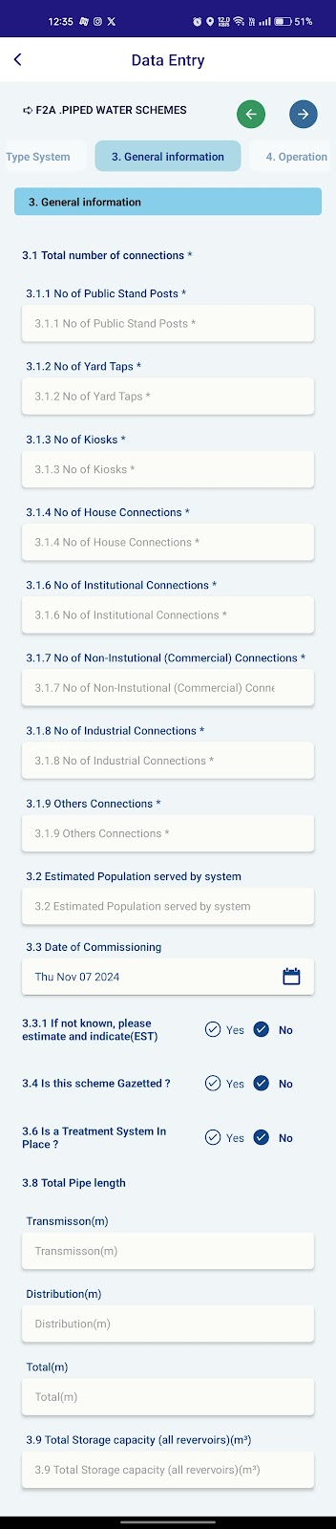

User Manual:F2A.PIPED WATER SCHEMES (General Information)
Overview
This manual provides instructions on how to use the data entry form for the "General Information" section of the F2A.PIPED WATER SCHEMES. This form is designed to collect information about the overall characteristics of the piped water scheme.
Form Fields
3. General Information
3.1 Total number of connections
3.1.1 No of Public Stand Posts: Enter the number of public stand posts connected to the scheme.
3.1.2 No of Yard Taps: Enter the number of yard taps connected to the scheme.
3.1.3 No of Kinks: Enter the number of kinks in the pipeline system.
3.1.4 No of House Connections: Enter the number of house connections to the scheme.
3.1.6 No of Institutional Connections: Enter the number of institutional connections (schools, hospitals, etc.) to the scheme.
3.1.7 No of Non-Institutional (Commercial) Connections: Enter the number of commercial connections to the scheme.
3.1.8 No of Industrial Connections: Enter the number of industrial connections to the scheme.
3.1.9 Others Connections: Enter the number of any other type of connections not listed above.
3.2 Estimated Population served by system
Enter the estimated number of people served by the piped water system.
3.3 Date of Commissioning
Select the date of commissioning of the piped water system using the calendar icon.
If the exact date is unknown, select "No" for "If not known, please estimate and indicate (EST)" and enter an estimated year.
3.4 Is this scheme Gazetted?
Select "Yes" if the scheme is officially recognized by the government.
Select "No" if the scheme is not officially recognized.

3.5 If scheme Gazetted is yes then What is the Water Authority?
Select the authority (NWSC,Umbrella authority)
3.6 Is a Treatment System in Place?
Select "Yes" if the scheme has a water treatment system.
Select "No" if the scheme does not have a water treatment system.
3.7 If treatment type selected is Water Treatment Plant, Frequency of Water Treatment to be selected.
Select the frequency (Annually, Bi-Annually, Daily, monthly etc)
3.8 Total Pipe length
Transmission: Enter the total length of the transmission pipeline.
Distribution: Enter the total length of the distribution pipeline.
Total: Enter the total length of all pipelines in the system.
3.9 Total Storage capacity (all reservoirs)
Enter the total storage capacity of all reservoirs in the system.
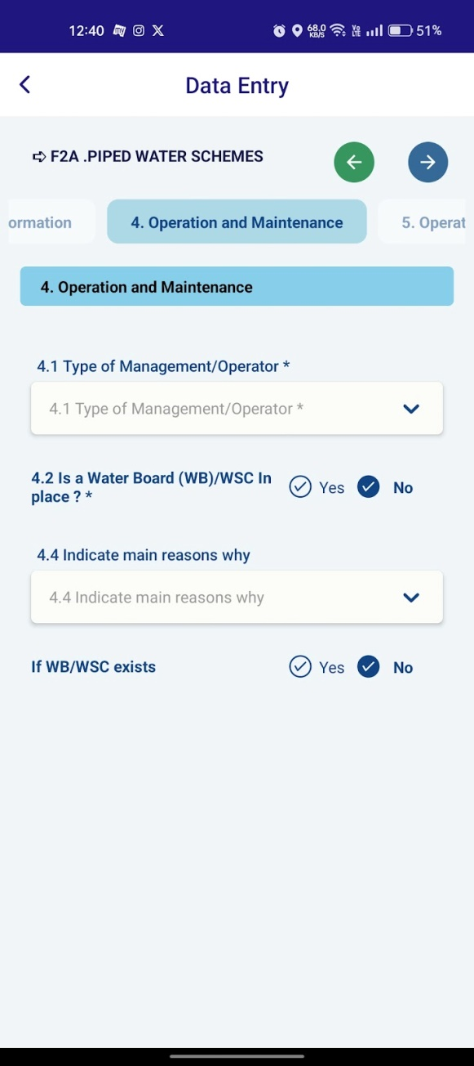
.

User Manual: F2A.PIPED WATER SCHEMES (Operation and Maintenance)
Overview
This manual provides instructions on how to use the data entry form for the "Operation and Maintenance" section of the F2A.PIPED WATER SCHEMES. This form is designed to collect information about the management and operation of the piped water scheme.
Form Fields
4. Operation and Maintenance
4.1 Type of Management/Operator
Select the type of management or operator for the piped water scheme from the dropdown options. This may include options like "Government," "NGO," "Community-based organization," or "Private operator."
4.2 Is a Water Board (WB)/WSC in place?
Select "Yes" if there is a Water Board or Water Supply Committee (WSC) responsible for managing the scheme.
Select "No" if there is no such board or committee.
4.3 Is WB/WSC is functional?
Select Yes or No
4.4 Indicate main reasons why
If you selected "No" for the previous question, select the main reasons why a WB/WSC is not in place from the dropdown options. This may include lack of awareness, lack of funds, or other reasons.
If WB/WSC exists
If you selected "Yes" for the question "Is a Water Board (WB)/WSC is in place?", you may need to answer additional questions about the functionality and effectiveness of the WB/WSC. These questions may vary depending on the specific form and data collection requirements.
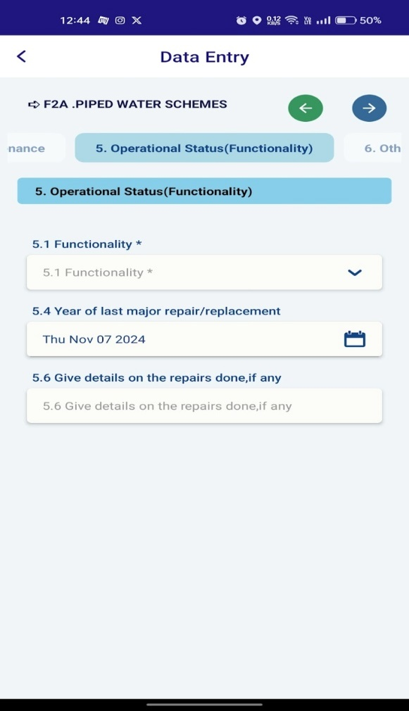
User Manual: Data Entry Form - F2A.PIPED WATER SCHEMES (Operational Status)
Overview
This manual provides instructions on how to use the data entry form for the "Operational Status (Functionality)" section of the F2A.PIPED WATER SCHEMES. This form is designed to collect information about the current functionality and repair history of the piped water scheme.
Form Fields
5. Operational Status (Functionality)
5.1 Functionality
Select the current functionality of the piped water scheme from the dropdown options. This may include options like "Functional," "Non-functional," or "Partially functional."
  - If the system is not fully functional, when did it become non-functional or only partially functional?
Select the year and month.
  - If other than functional option is selected from 5.1, then Reasons why the scheme/system is not fully functional to be selected.
Select the option (Alternative water Facility nearby, Dry/Low yielding etc)
5.4 Year of last major repair/replacement
Select the year of the last major repair or replacement using the calendar icon. If no major repairs or replacements have been done, leave this field blank.
5.6 Give details on the repairs done, if any
If repairs have been done, provide a brief description of the repairs carried out. This may include details like the type of repair, materials used, and the person or organization who performed the repair.
Additional Tips
Use clear and concise language when entering information.
Double-check all entries before submitting to avoid errors.
If you encounter any difficulties, refer to the help section within the app or contact the support team.
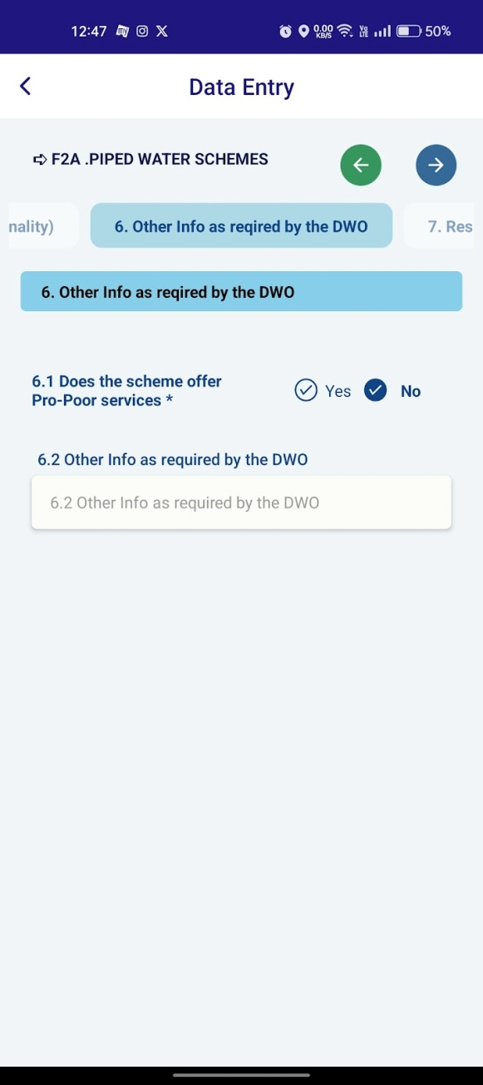

User Manual: Data Entry Form - F2A.PIPED WATER SCHEMES (Other Info)
Overview
This manual provides instructions on how to use the data entry form for the "Other Info as required by the DWO" section of the F2A.PIPED WATER SCHEMES. This section is designed to collect any additional information that might be relevant to the piped water scheme, as required by the relevant authority.
Form Fields
6. Other Info as required by the DWO
6.1 Does the scheme offer Pro-Poor services?
Select "Yes" if the scheme offers services specifically targeted at poor or marginalized communities.
Select "No" if the scheme does not offer such services.
6.2 Other Info as required by the DWO
This field allows you to enter any additional information that is relevant to the piped water scheme but is not covered in the previous sections. This could include:
Unique features: Special characteristics of the scheme, such as innovative technologies or community-based management practices.
Challenges: Any specific challenges faced by the scheme, such as water scarcity, financial constraints, or technical issues.
Future plans: Proposed improvements or expansions for the scheme.
Any other relevant information: Any other information that you think might be important.
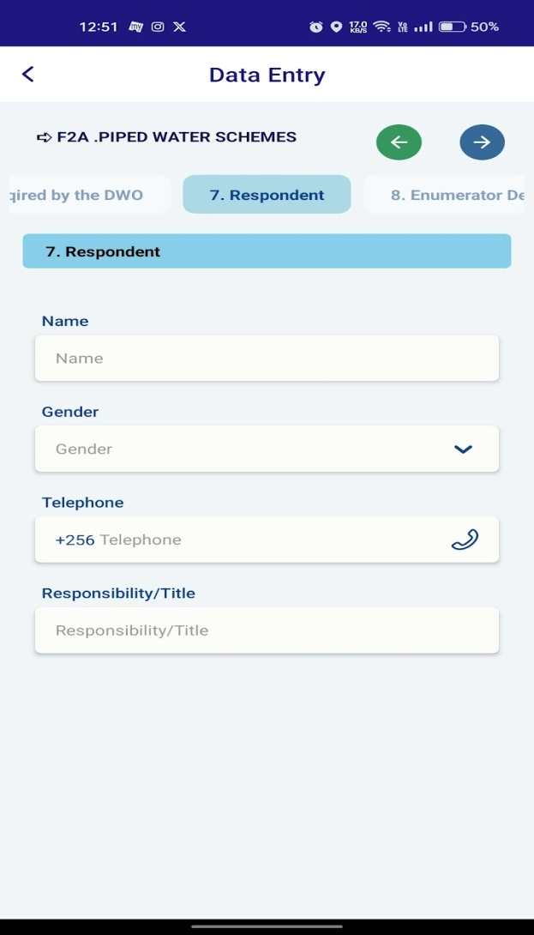

User Manual: Data Entry Form - F2A.PIPED WATER SCHEMES (Respondent)
Overview
This manual provides instructions on how to use the data entry form for the "Respondent" section of the F2A.PIPED WATER SCHEMES. This form is designed to collect information about the person who provided the information for the piped water scheme.
Form Fields
7. Respondent
Name
Enter the full name of the respondent.
Gender
Select the gender of the respondent from the dropdown options.
Telephone
Enter the phone number of the respondent. You can start with the country code (+256 in this case) and then enter the remaining digits.
Responsibility/Title
Enter the role or title of the respondent, such as "Water Committee Member," "Scheme Operator," or "Local Government Official."
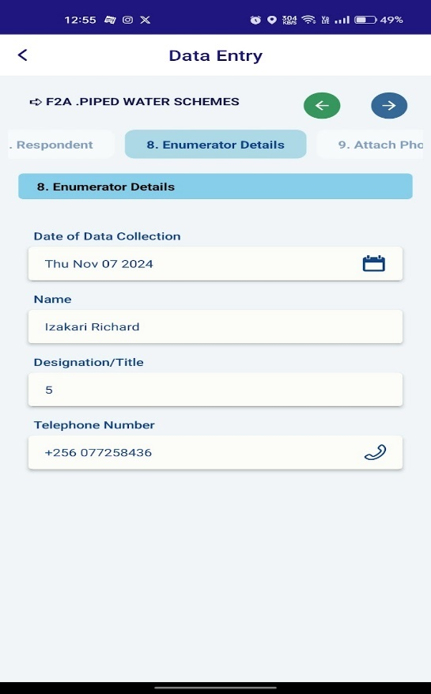
User Manual: Data Entry Form - F2A.PIPED WATER SCHEMES (Enumerator Details)
Overview
This manual provides instructions on how to use the data entry form for the "Enumerator Details" section of the F2A.PIPED WATER SCHEMES. This form is designed to collect information about the person who collected the data for the piped water scheme.
Form Fields
8. Enumerator Details
Date of Data Collection
Automatically fetch the current date using the calendar icon.
Name
Automatically fetch the full name of the enumerator who collected the data.
Designation/Title
Enter the designation or title of the enumerator, such as "Field Officer," "Data Collector," or "Surveyor."
Telephone Number
Automatically fetch the phone number of the enumerator.
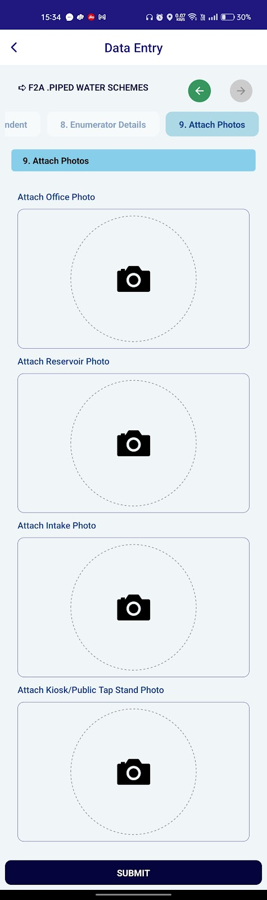

User Manual for WASMIS Data Entry: Attaching Photos for Piped Water Schemes
Introduction
This user manual provides instructions on how to use the photo attachment feature within the WASMIS app to capture and upload images of various components of piped water schemes during the data entry process.
Attaching Photos
Tap the Camera Icon:
Tap on the camera icon within the desired photo section (Office Photo, Reservoir Photo, Intake Photo, or Kiosk/Public Tap Stand Photo).
Camera Access:
Allow the app access to your device's camera.

Capture Photo:
Use your device's camera to capture a clear photo of the respective component.
Review and Confirm:
Review the captured photo. If satisfied, tap on the "Confirm" button.
Additional Photos:
If needed, repeat steps 1-4 to capture additional photos for the same component.
Submit:
Once you have attached all the necessary photos, tap on the "Submit" button to save the data entry.
Additional Tips:
Ensure that the photos are clear and well-lit to provide accurate information about the water scheme components.
Capture photos from multiple angles to provide a comprehensive view of the components.
If the photo quality is not satisfactory, you can retake the photo.
Always review the attached photos before submitting the data entry to ensure accuracy.
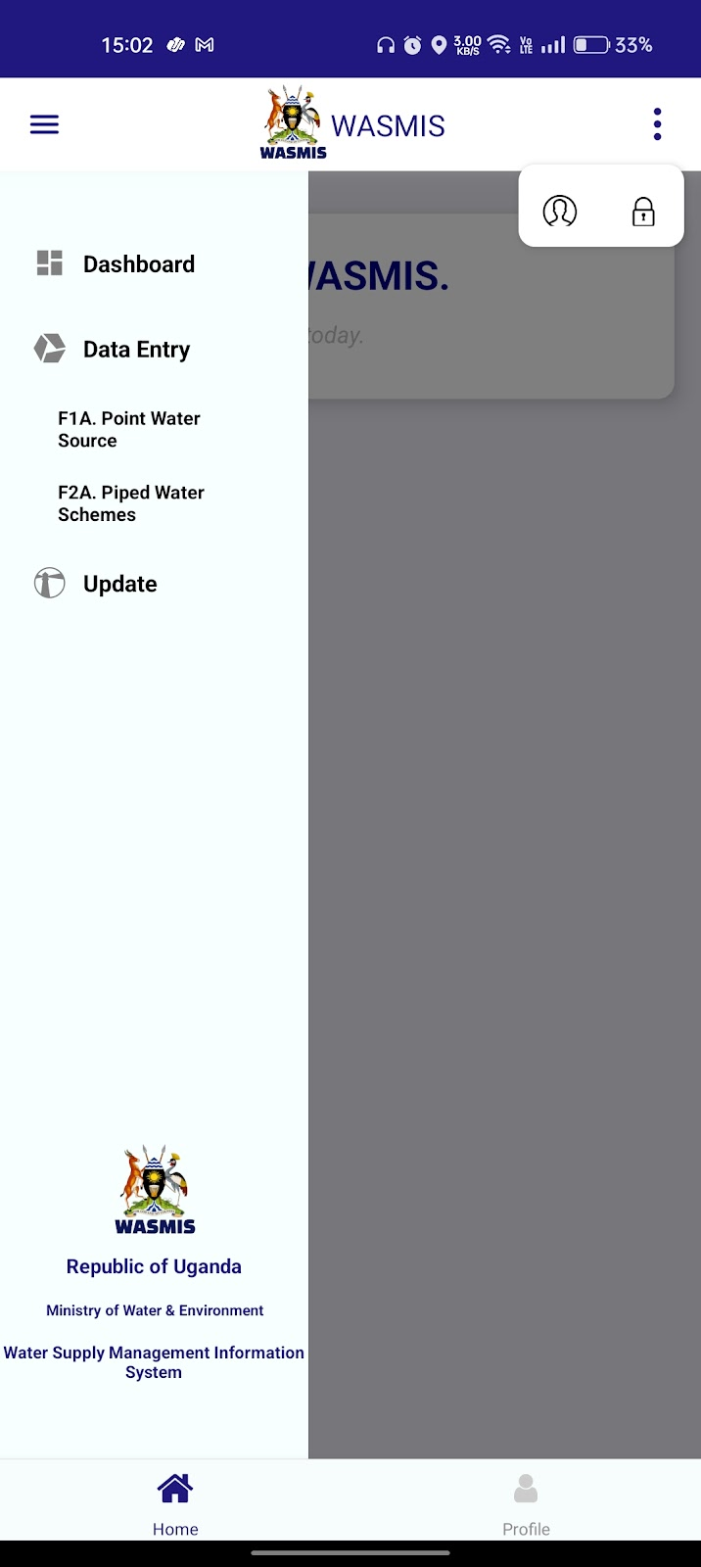
Click on “Update” button to move Update section. application.
Click on arrow button to move Dashboard of application.

User Manual for WASMIS Update: Various Forms
This user manual provides instructions on how to use the update feature within the WASMIS app to modify existing information related to different aspects of water supply systems.
Accessing the Update Feature
- Login:
  - Open the WASMIS app and log in using your WASMIS username and password.
- Home Screen:
  - After successful login, you will be presented with the Home screen.
- Update:
  - Tap on the "Update" option from the navigation drawer.

Updating Various Forms
Once you access the Update screen, you will see a list of different update forms. Here's a breakdown of each form:
Form 4 - Point Water Sources:
- Instructions: Follow the instructions provided to update information about point water sources, such as functionality, management, gender composition, parish, village, year of construction, and source status.
- Add Filters: Use the filters to narrow down the list of point water sources based on district, county, subcounty, and parish.
- Update: Select a specific point water source and make the necessary changes.
S5 - Duplicate Sources:
- This form allows you to identify and correct duplicate entries in the database.
- Review the list of duplicate sources and take appropriate action, such as merging or deleting duplicates.
S6 - Wrong Coordinates (PWS):
- This form allows you to identify and correct errors in the geographic coordinates of point water sources.
- Review the list of sources with incorrect coordinates and update them with the correct values.
D6 - Linking Tap to Schemes:
- This form allows you to link water taps to specific water supply schemes.
- Select a tap and assign it to the appropriate scheme.
S9 - Rainwater Harvesting Tank Update:
- This form allows you to update information about rainwater harvesting tanks, such as their status, capacity, and maintenance.
- Select a rainwater harvesting tank and make the necessary changes.
S10 - Decommissioning:
- This form allows you to mark water sources or schemes as decommissioned.
- Select the relevant source or scheme and indicate that it has been decommissioned.
D4 - Update Schemes:
- This form allows you to update information about piped water schemes, such as their source, distribution network, and service coverage.
- Select a water scheme and make the necessary changes.
Additional Tips:
- Ensure that all data entered is accurate and up-to-date.
- If you encounter any errors or issues, contact the WASMIS support team for assistance.
- Regularly update the app to the latest version to ensure optimal performance and access to new features.

Form 4 - Point Water Sources:
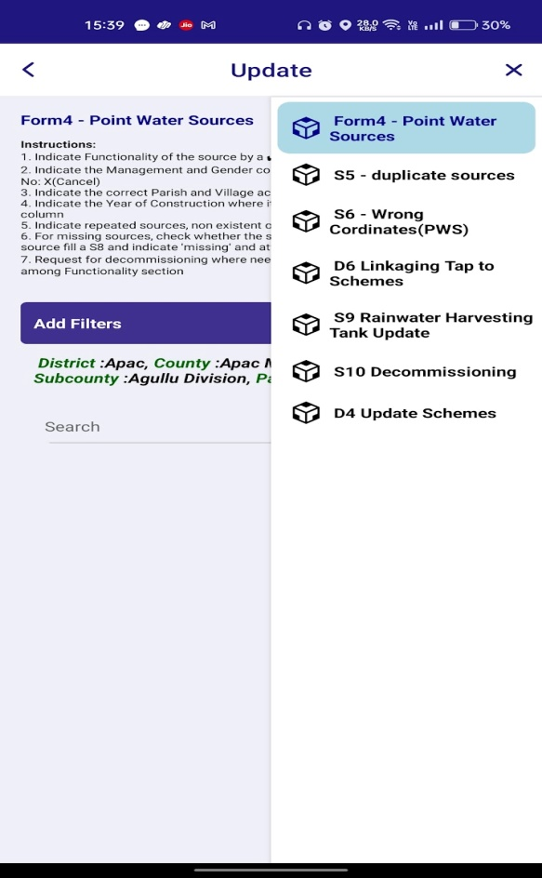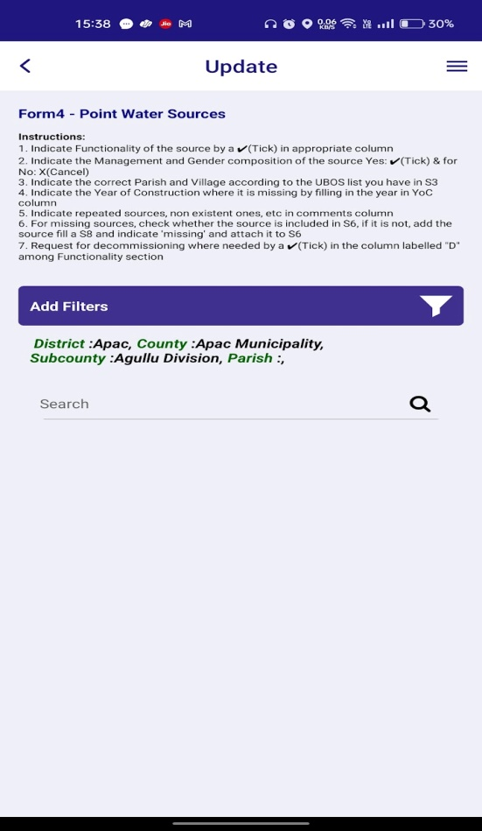
Click on “Filter button” to get the options for filter.

Click on “Form 4 - Point Water Sources:” By applying the filter we can get and update the form.
” button to move Update section. application.
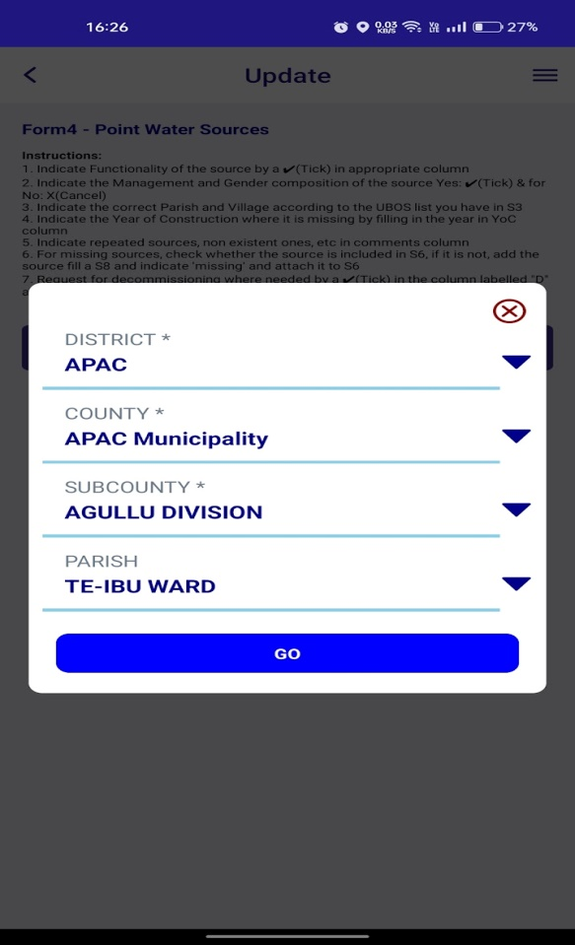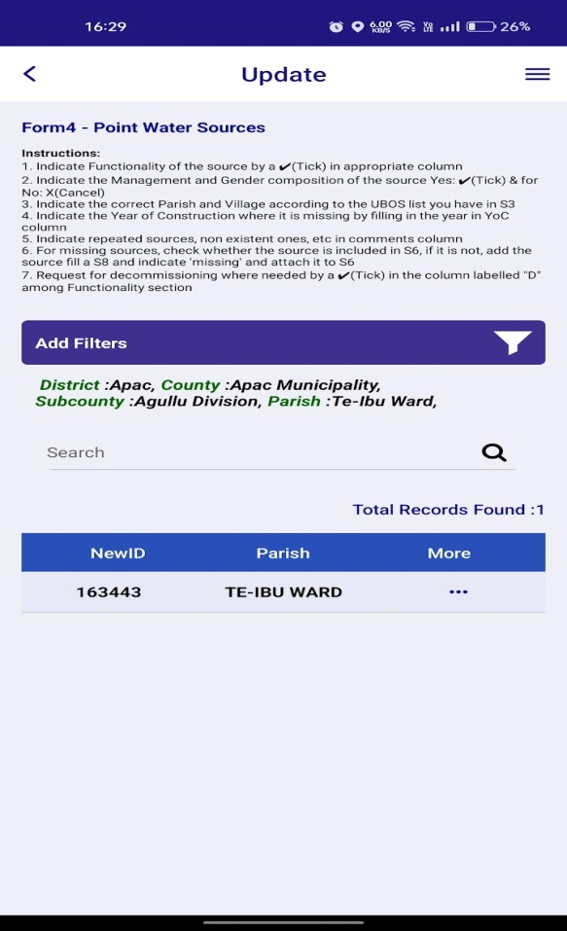
Click on three dots to view the related data.
Click on “Go” button to find the respective saved records.
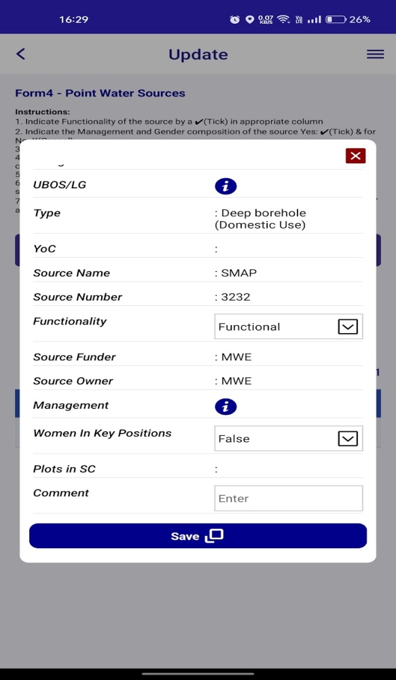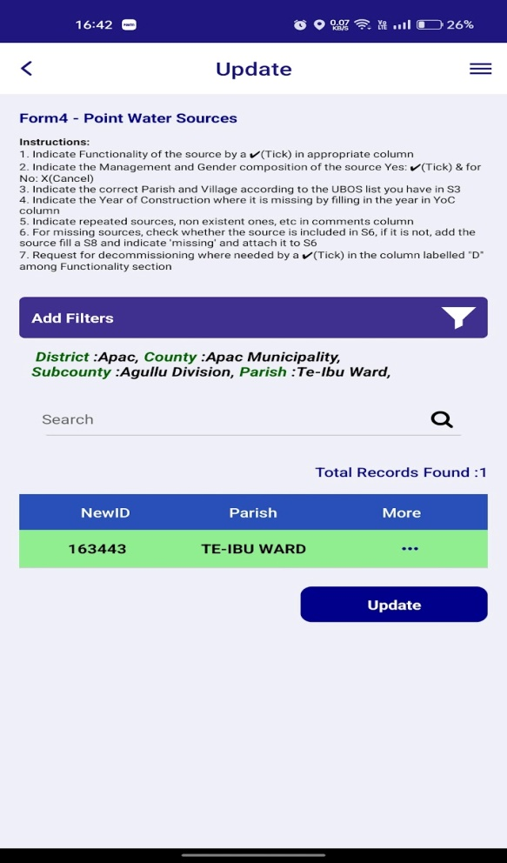
Change the input values for update.
- After clicking on the “Save” button, the respective row colour will change to green.
- When click on the “Update” button again the respective row colour will change to grey.
- Then we can get the data on Dashboard.

S5 - Duplicate Sources:
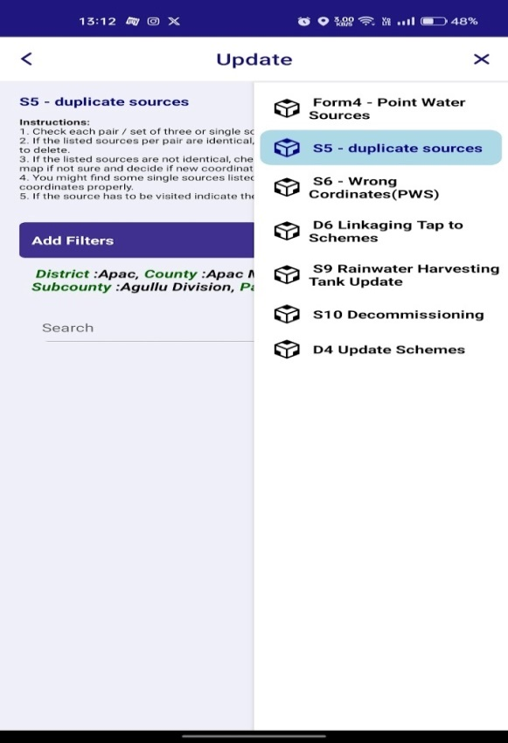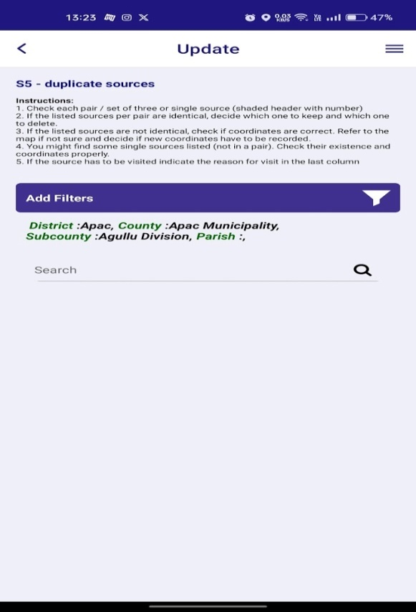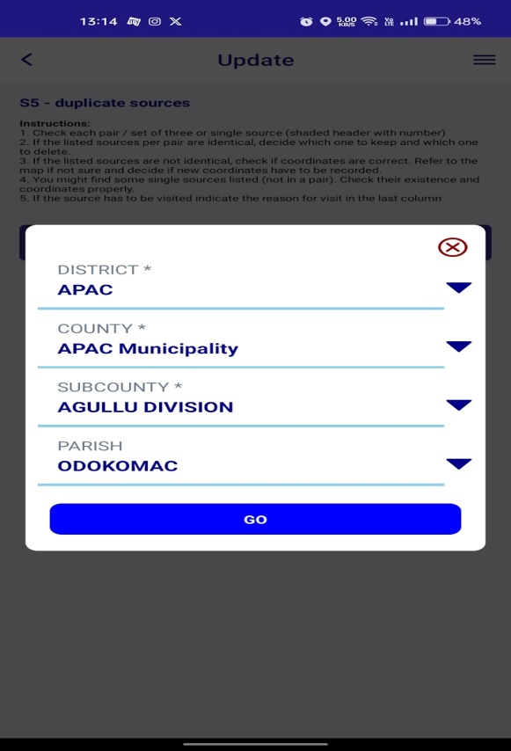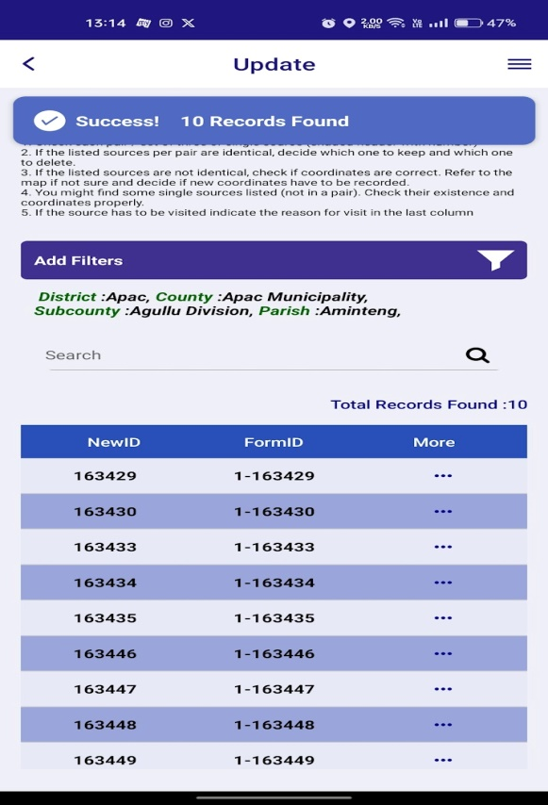
Click on “Go” button to view the related data.
Click on three dots to view the related data.
Click on “Filter button” to get the options for filter.

Click on “S5 - Duplicate Sources:” By applying the filter we can get and update the form.
” button to move Update section. application.
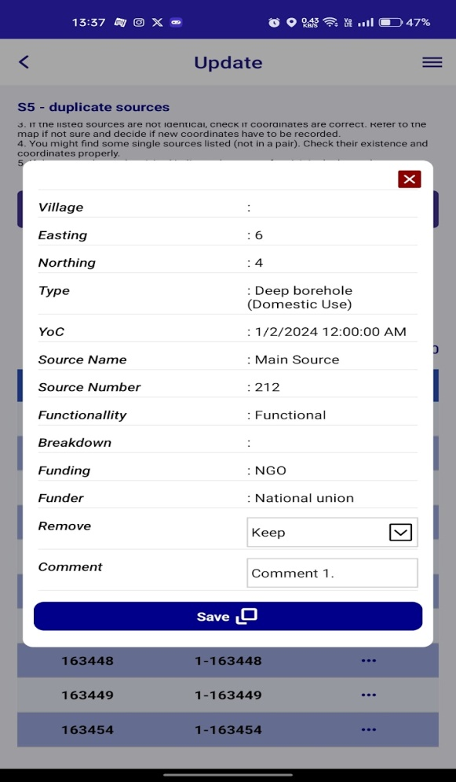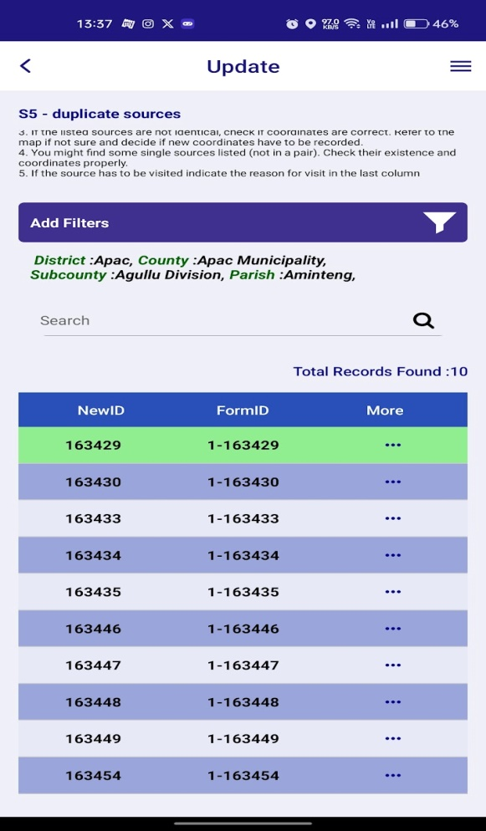
- After clicking on the “Save” button, the respective row colour will change to green.
Change the input values for update.
- When click on the “Update” button again the respective row colour will change to grey.
- Then we can get the data on Dashboard.

S6 - Wrong Coordinates (PWS):
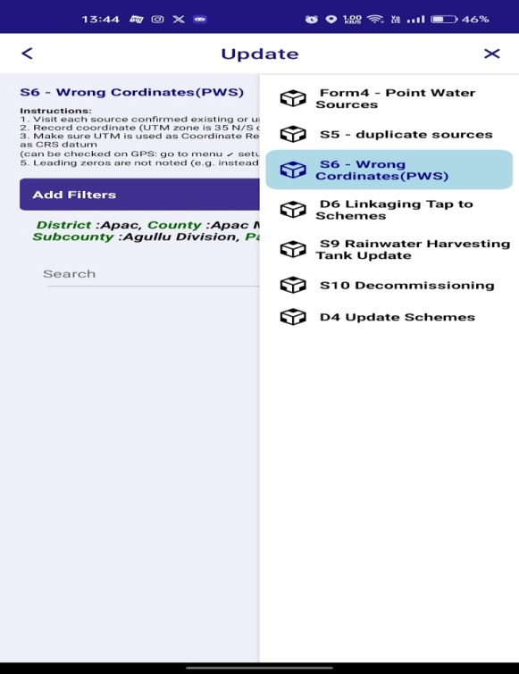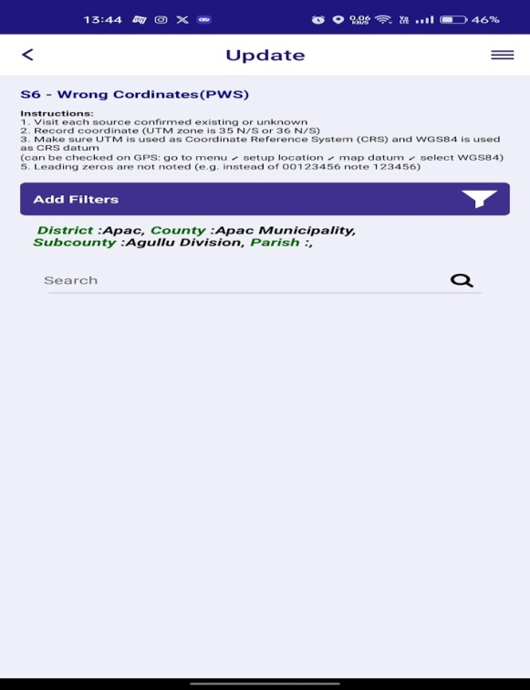
Click on filter button.

Click on “S6 - Wrong Coordinates (PWS):” By applying the filter we can get and update the form.

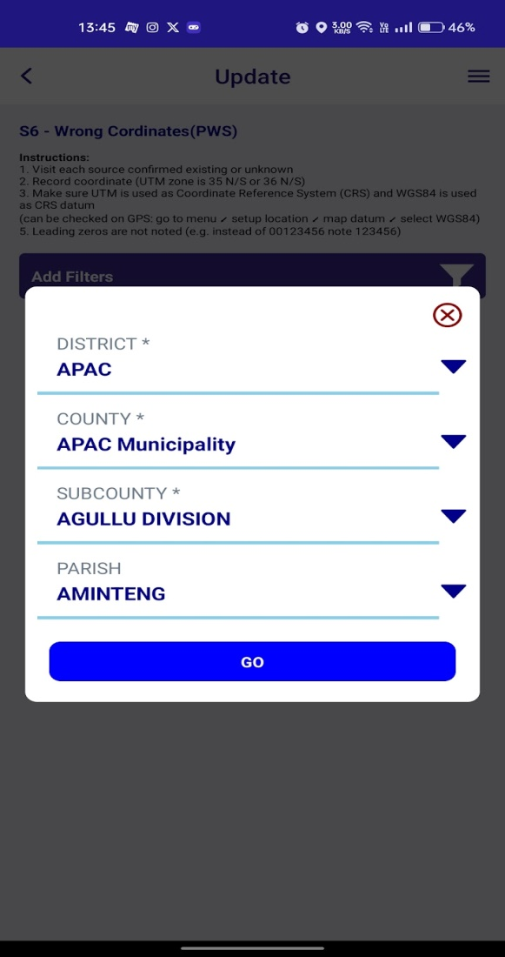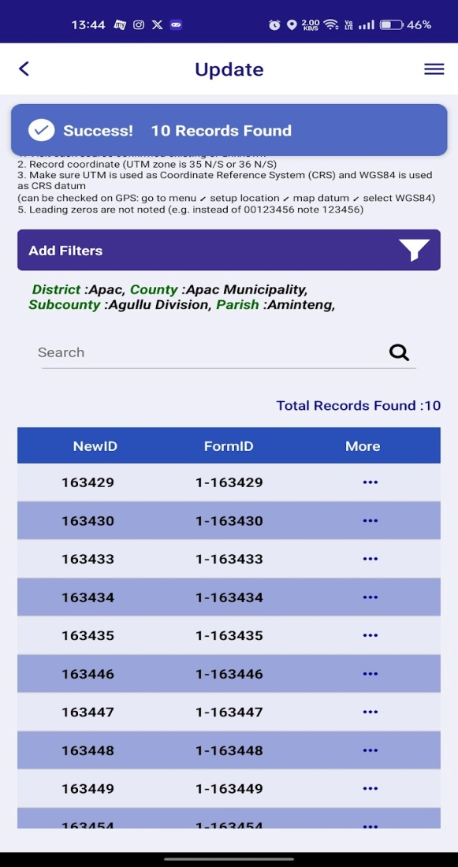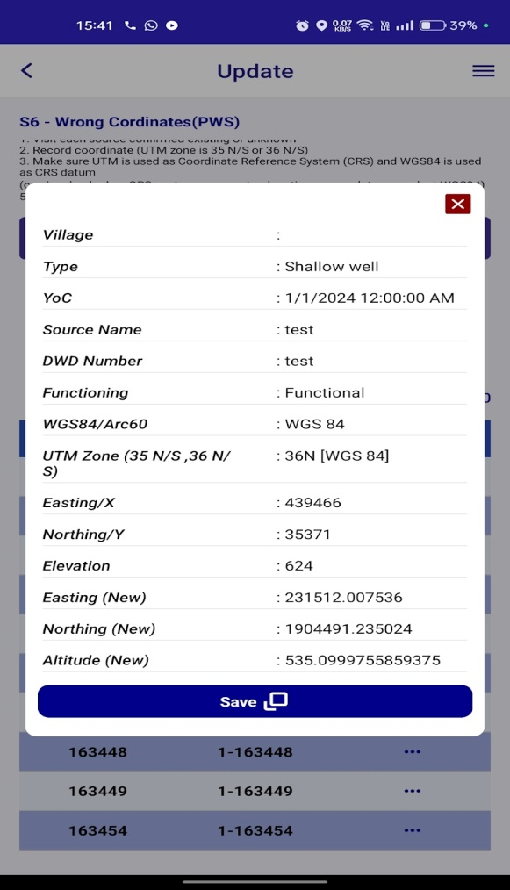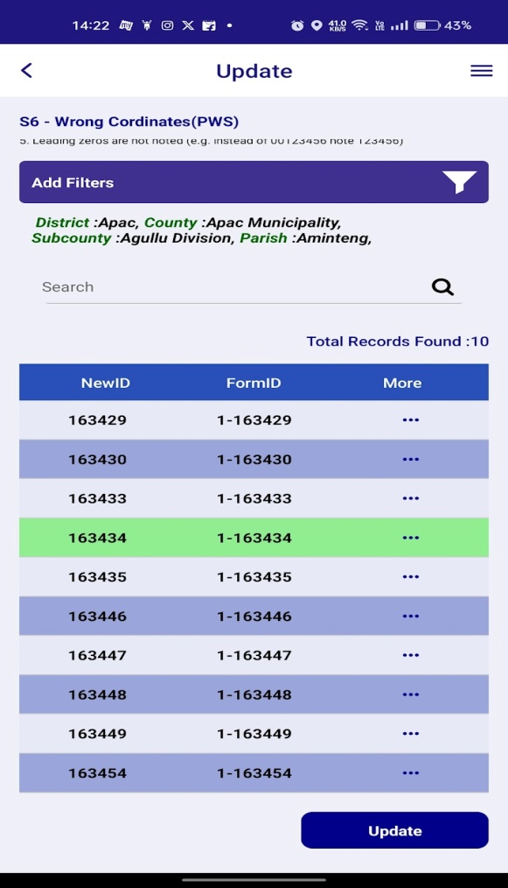
Current place coordinates are updated automatically. Then click on “Save” button.

Click on "Go” button.

Click on three dots to view the related data.

- After clicking on the “Save” button, the respective row colour will change to green.
- When click on the “Update” button again the respective row colour will change to grey.
- Then we can get the data on Dashboard.

D6 - Linking Tap to Schemes:
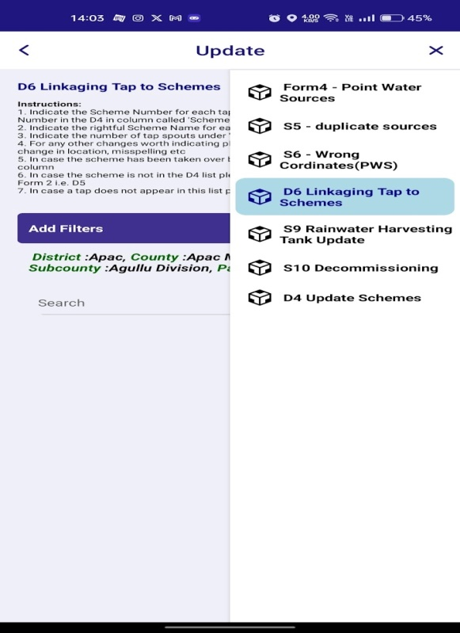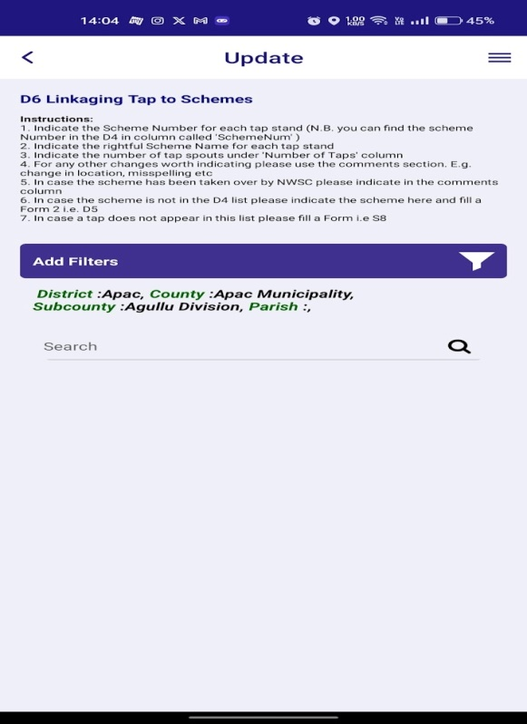
Click on filter button.

Click on “D6 - Linking Tap to Schemes:” By applying the filter we can get and update the form.

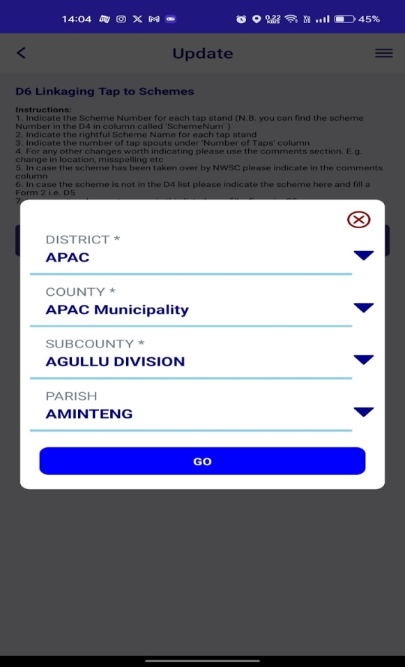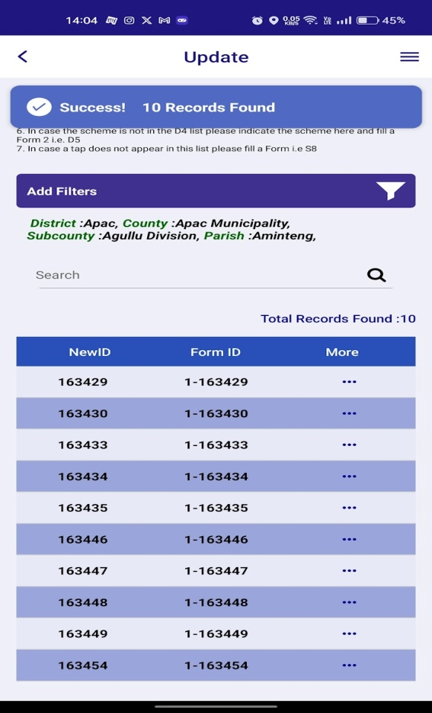
Click on three buttons.

Click on “Go” button.

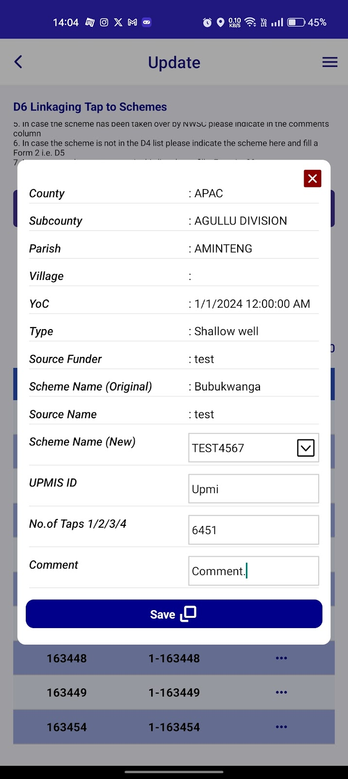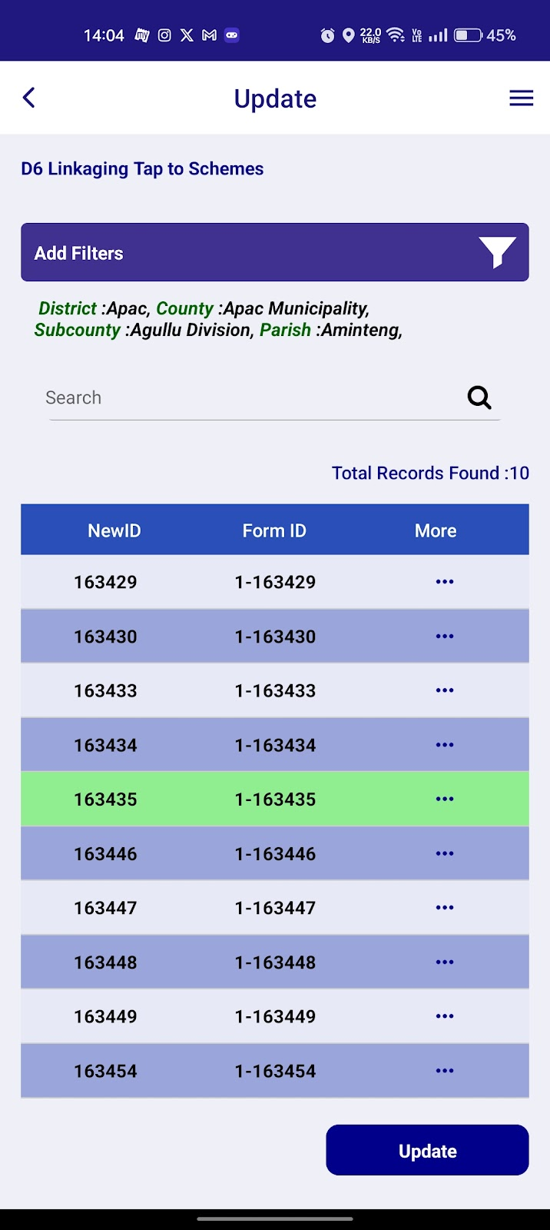
Change the input values for update.
- After clicking on the “Save” button, the respective row colour will change to green.
- When click on the “Update” button again the respective row colour will change to grey.
- Then we can get the data on Dashboard.

S9 - Rainwater Harvesting Tank Update:
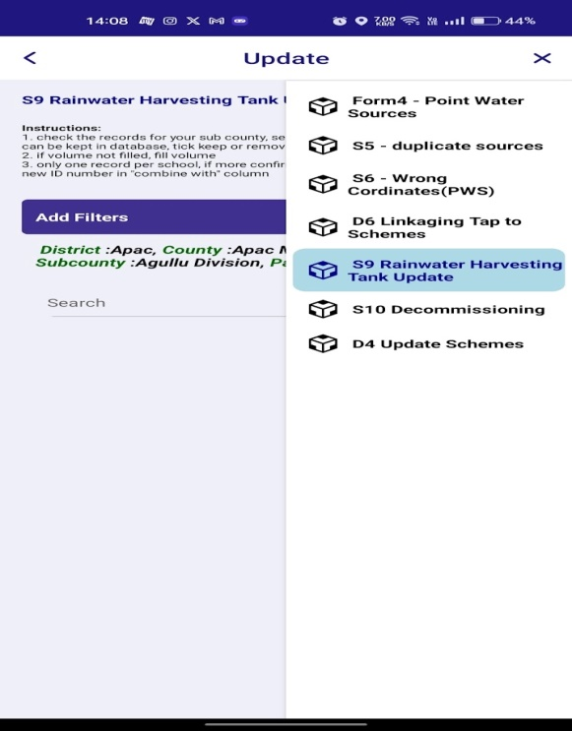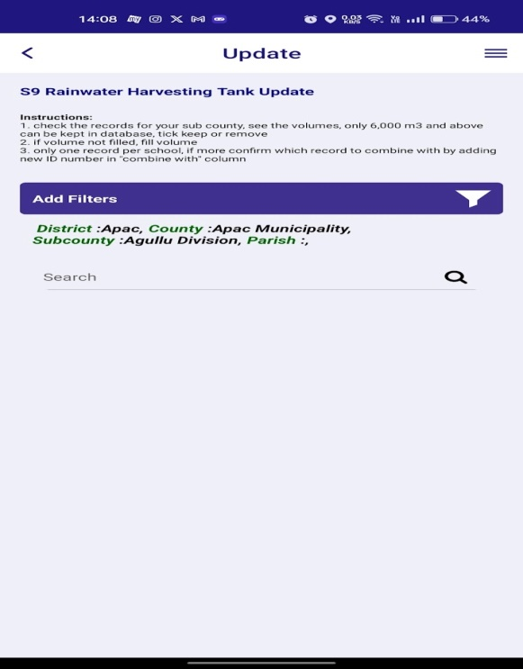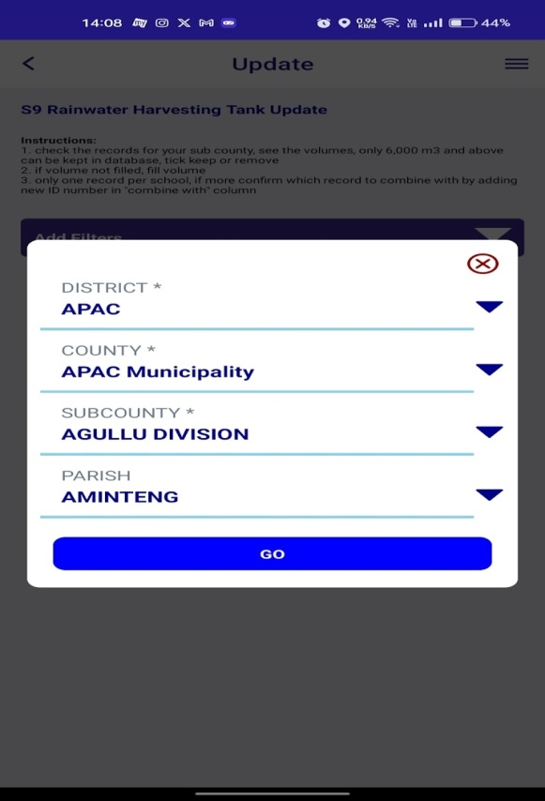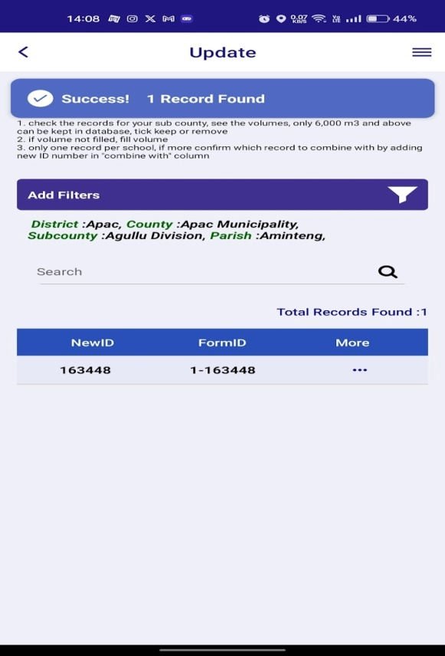
Click on “S9 - Rainwater Harvesting Tank Update:” By applying the filter we can get and update the form.

Click on three buttons.

Click on “Go” button.

Click on filter button.

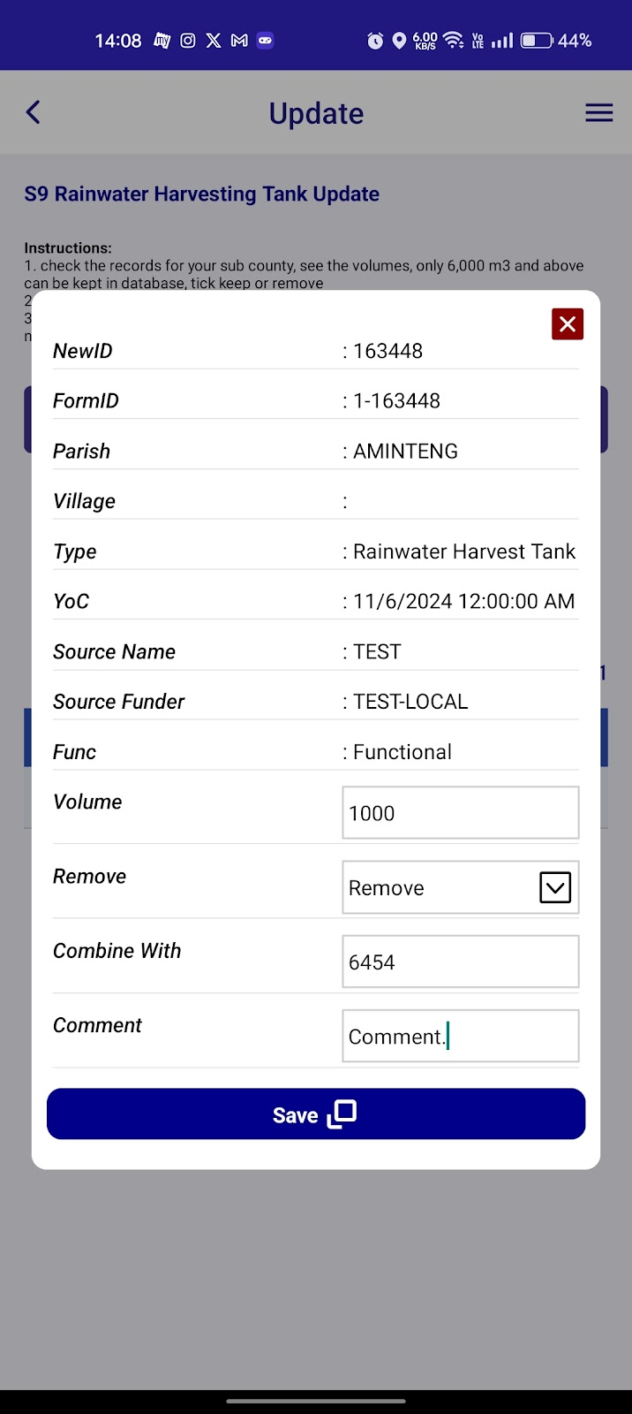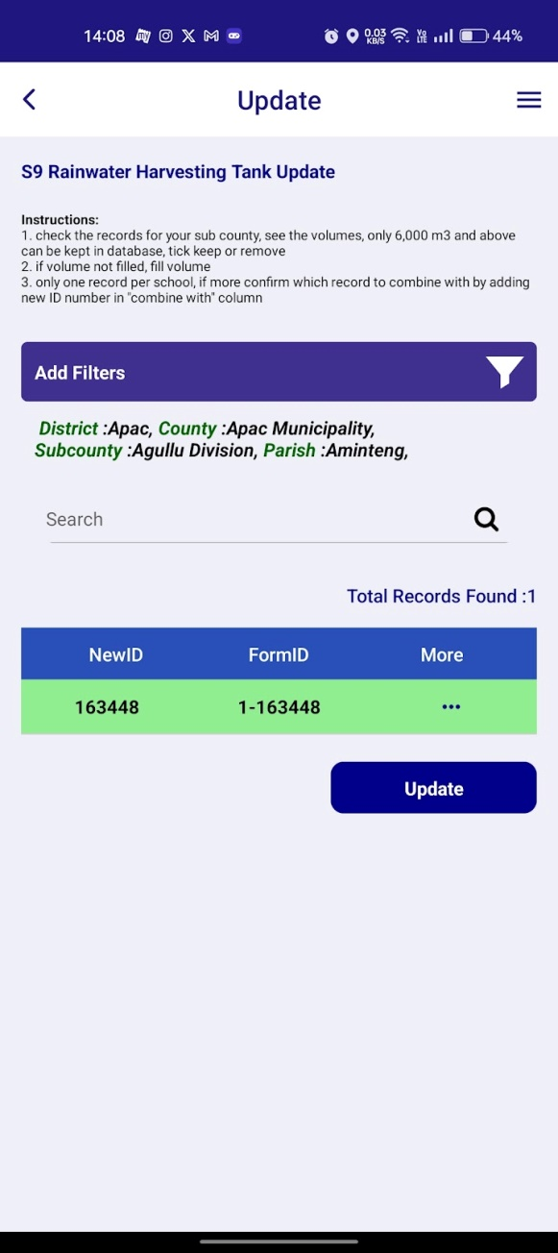
Change the input values for update.

- After clicking on the “Save” button, the respective row colour will change to green.
- When click on the “Update” button again the respective row colour will change to grey.
- Then we can get the data on Dashboard.

S10 - Decommissioning:
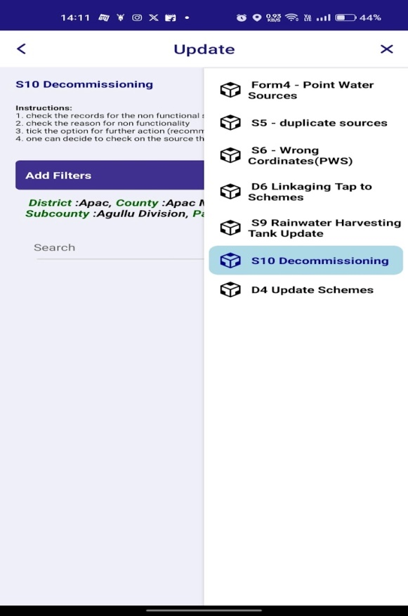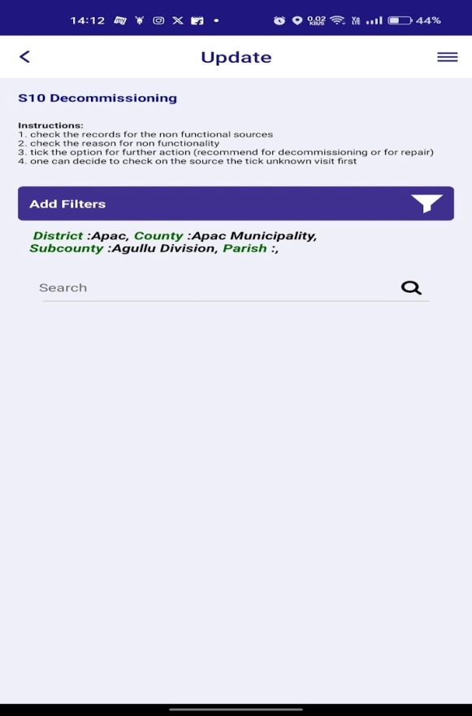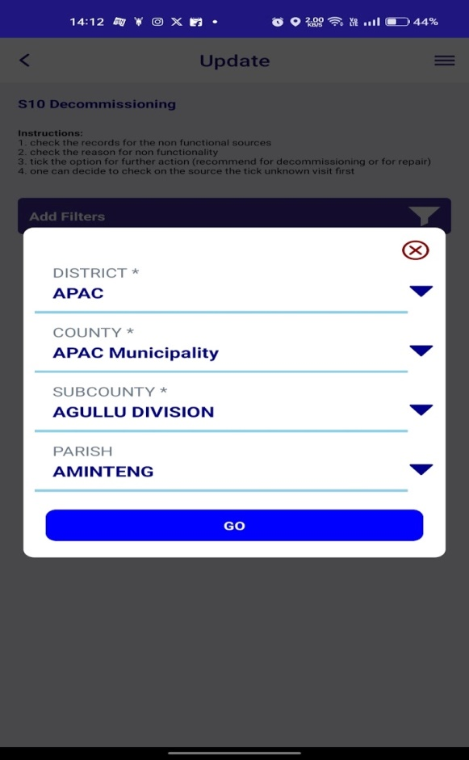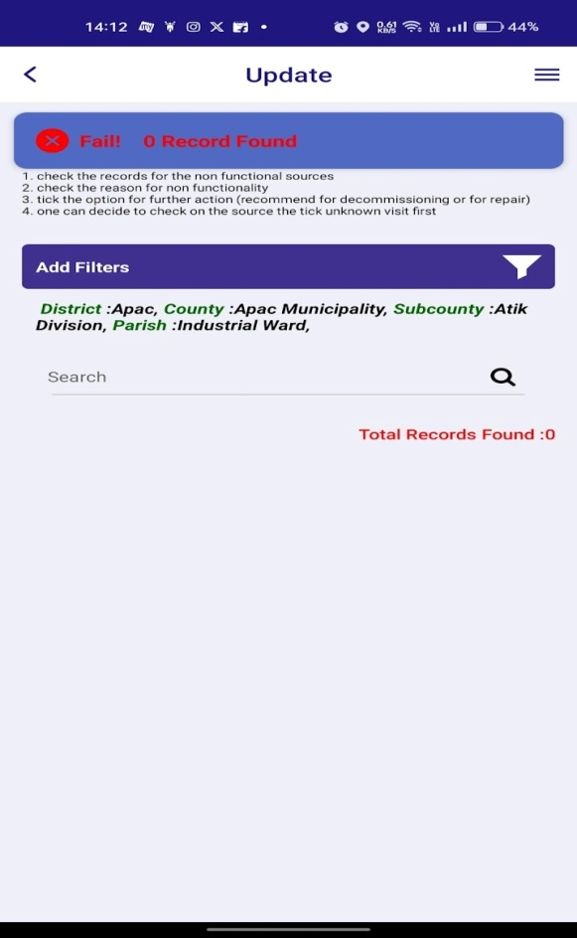
Click on “S10 Decommissioning:” By applying the filter we can get and update the form.

Click on “Go” button.

Click on filter button.

- If there is no data with respective to selected values error message will show
“no records found”.

D4 - Update Schemes:
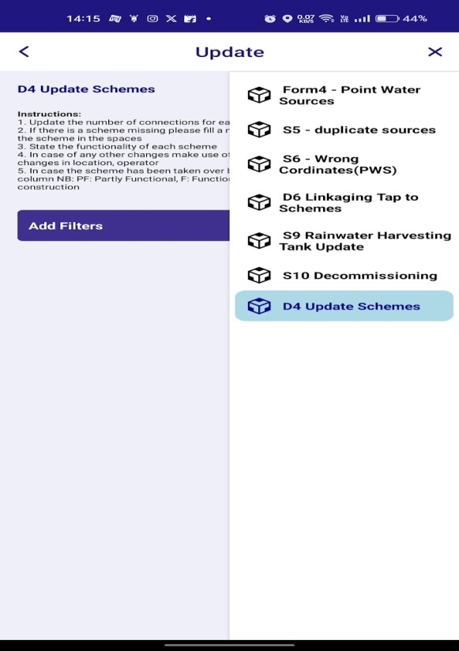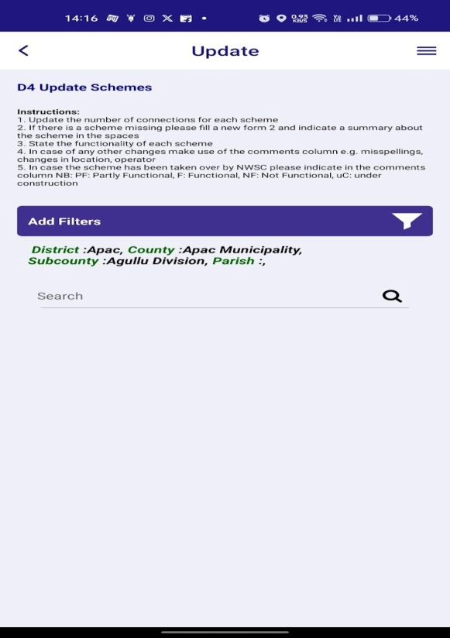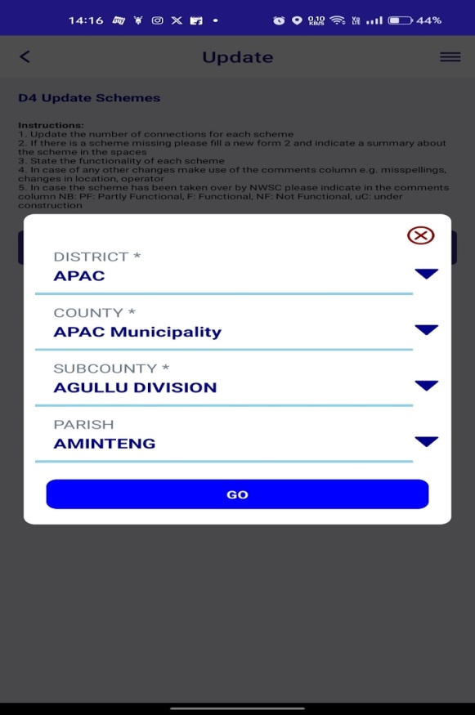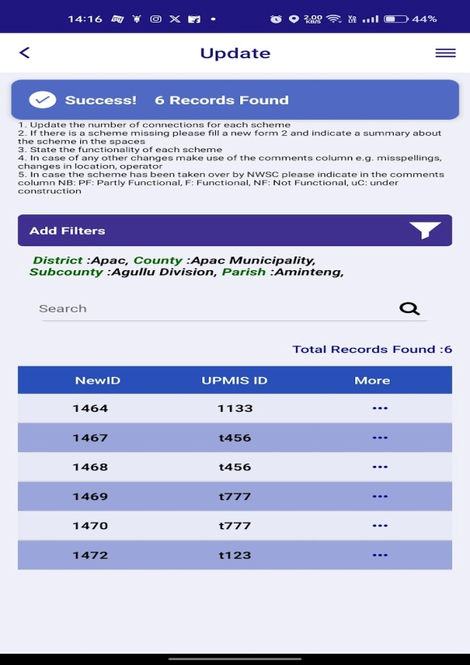
Click on three buttons.

Click on “Go” button.

Click on “D4- Update Schemes: “By applying the filter we can get and update the form.

Click on filter button.

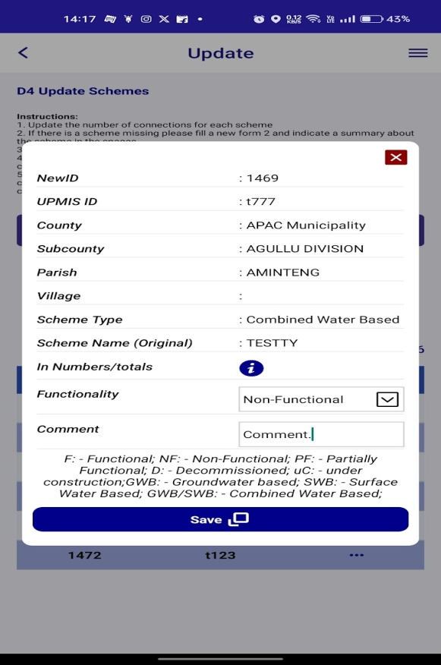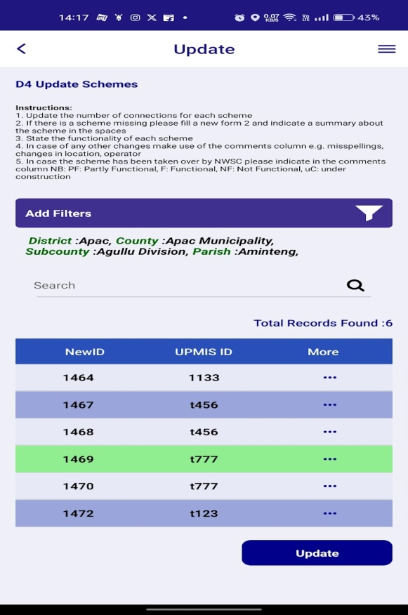

- After clicking on the “Save” button, the respective row colour will change to green.
Change the input values for update.
- When click on the “Update” button again the respective row colour will change to grey.
- Then we can get the data on Dashboard.
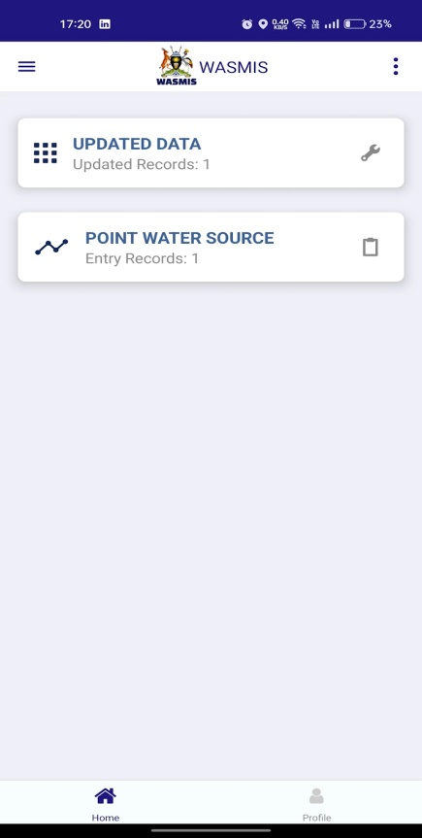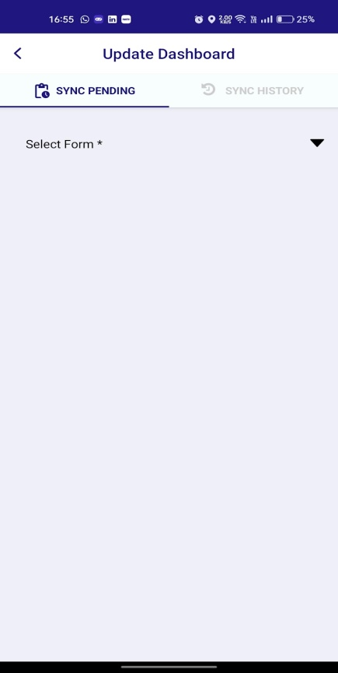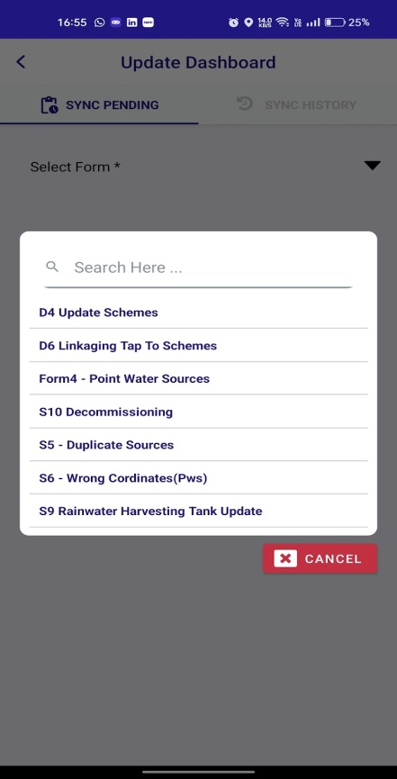
Click on the arrow mark to get the record by filter.
Select the updated form for sync.
Click on the tab to see Updated data
- After click on send button the record will sync to the main server and accessible to all devices.
- The success message will appear.
- Then we can get the synced data in sync history tab.
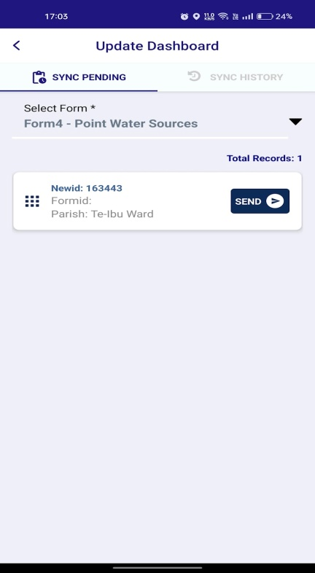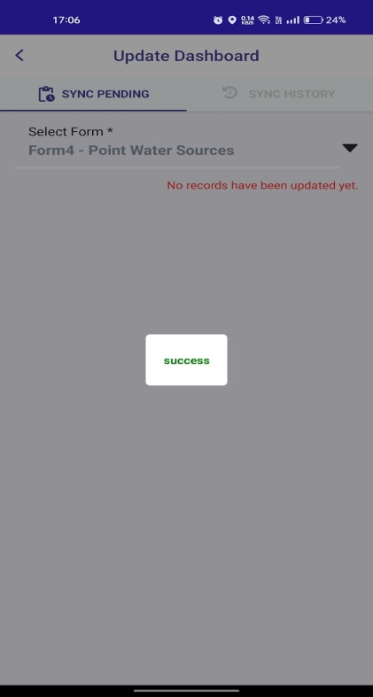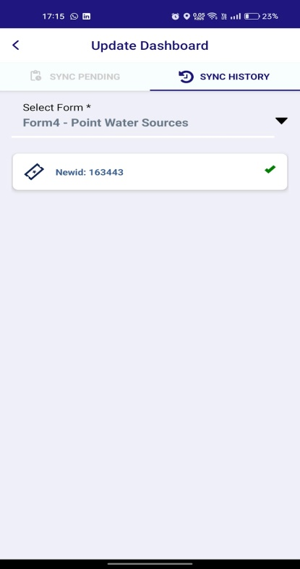
Click on the “SEND” button to sync the record.
- The same sync process will happen in “Point Water Source” and “Piped Water Schemes”.

User Manual for WASMIS Profile Screen
Introduction
This user manual provides instructions on how to navigate and utilize the Profile screen within the WASMIS app. The Profile screen displays your personal information and allows you to make certain changes to your account.
Profile Screen Overview
The Profile screen typically displays the following elements:
- Profile Picture: A placeholder image with a camera icon to upload a profile picture.
- Username: Your WASMIS username.
- Department: Your department or organization.
- Mobile Number: Your registered mobile number.
- Logout Button: A button to log out of the app.
Using the Profile Screen
- View Profile Information: The screen displays your username, department, and mobile number.
- Logout: Tap the "Logout" button to log out of the WASMIS app.
Additional Tips
- Profile Picture: Ensure the uploaded profile picture is clear and appropriate.
- Account Security: Keep your WASMIS login credentials confidential.
- App Updates: Regularly update the WASMIS app to ensure optimal performance and access to new features.
Contact Support
If you encounter any issues or have questions, please contact the WASMIS support team for assistance.
Disclaimer:
This user manual is a general guide and may not cover all specific features and functionalities of the WASMIS Profile screen. Please refer to the app itself and any official documentation for the most accurate information.

