

WATER AND ENVIRONMENT MANAGEMENT INFORMATION SYSTEM

WATER SUPPLY DATABASE – WATER SUPPLY MANAGEMENT INFORMATION SYSTEM

USER MANUAL

MAY 2024

Table of Contents
1. INTRODUCTION 3
1.1 Content 3
1.2 About the Database 4
1.2.1 Data Entrants forms 5
1.2.2 Online Update Forms 5
1.2.3 Reports 5
1.2.4 Query Tool 6
1.2.5 Activity Dashboard 6
1.2.6 Search Records 6
1.2.7 WASMIS Database Purpose 6
1.2.8 Structure of the database 7
1.2.9 This Report 9
2 WATER SUPPLY DATABASE - DATABASE PORTAL 9
2.1 Process Flow 9
2.2 WSDB Database Workflow and Access Rights 9
3 WATER SUPPLY MANAGEMENT INFORMATION SYSTEM - LOGIN 10
3.1 WATER SUPPLY MANAGEMENT INFORMATION SYSTEM – REGISTERED USER 10
3.2 EXISTING USER – CHANGE PASSWORD 11
3.3 WATER SUPPLY MANAGEMENT INFORMATION SYSTEM – EDIT PROFILE 11
4 WATER SUPPLY MANAGEMENT INFORMATION SYSTEM - ACESS RIGHTS (USER MANUALS) 12
4.1 WASMIS DASHBOARDS 12
4.1.1 Data Entrants forms 12
4.1.2 Online Update Forms 12
4.1.3 Reports 13
4.1.4 Query Tool 13
4.1.5 Activity Dashboard 14
4.1.6 Search Records 14
4.2 PIPED WATER SOURCES (F1A) 15
4.2.1 PIPED WATER SCHEMES (F2A) 19
4.2.2 ONLINE UPDATE FORMS 24
4.2.3 REPORTS 28
4.2.4 ACTIVITY DASHBOARD 43
4.2.5 QUERY TOOL 46
4.2.6 SEARCH RECORDS 47
END 47

INTRODUCTION

Content
WASMIS, acronym for Water Supply Management Information System, operated under the purview of the Ministry of Water and Environment, is a comprehensive database previously known as the "Water Supply Database" or "Water Supply Atlas." Its primary objective is to furnish stakeholders with robust knowledge and information regarding various aspects of water supply, including coverage, functionality and distribution.
- Historical Context and Evolution
Originally recognized as the Water Supply Database or Water Supply Atlas, WASMIS underwent a transformation to become a more integrated and sophisticated information system. This evolution reflects the growing need for a centralized platform to manage, analyze and disseminate water-related data effectively.
- Scope and Coverage
WASMIS encompasses a vast geographical area, covering all 137 districts of Uganda. This extensive coverage ensures that stakeholders have access to comprehensive data on water supply infrastructure and services across the nation, facilitating informed decision-making and resource allocation.
- Data Compilation and Sources
The database aggregates data from various sources, including Point Water Sources, Piped Schemes and the National Water & Sewerage Corporation. By consolidating information from diverse sources, WASMIS offers a holistic view of water supply infrastructure, functionality and distribution patterns.
- Information Provided
WASMIS furnishes stakeholders with a wealth of information, ranging from the current status of safe water supply coverage to the functionality of water sources. Additionally, it offers insights into the distribution of water resources, enabling stakeholders to assess accessibility and equity across different regions.
- Utility for Stakeholders
Stakeholders, including policymakers, water utility agencies, researchers, and development partners, rely on WASMIS to inform policy formulation, strategic planning, and resource allocation initiatives. By providing accurate and up-to-date information, WASMIS facilitates evidence-based decision-making and promotes sustainable water management practices.

About the Database
WASMIS serves as a comprehensive repository of technical data pertaining to water supply management and conservation efforts across Uganda. The database boasts a wide array of functionalities, including an activity dashboard, data entry forms, online update forms, and query tools. Users can easily generate tables and standard or user-defined reports in various formats, including Atlas, annual, real-time, and map reports. Moreover, WASMIS provides a filter tool, which streamlines the process of generating non-standard reports tailored to specific needs.
The various categories of forms available in the database include:

Data Entrants forms
- Point Water Sources (F1A)
- Piped Water Schemes (F2A)

Online Update Forms
- Point Water Source Update (F1A)
- Piped Water Scheme Update (F2A)
- D4 Save
- D6 Save
- S4 Save
- S5 Save
- S6 Save
- S9 Save
- S10 Save

Reports
- Atlas
- National Reports
- District Reports

- Real Time Reports
- Annual Key Facts Reports
- District Key Facts Reports
- District Serves per The
- Village Analysis
- District Software Report
- District Summary Report
- Source per village Reports
- Source without village Reports
- Sub County Key Facts Reports
- Sub county Summary Reports
- Form 1: Records List (mini)
- Form 1: Records List (Full)
- Form 1: Sources without Village
- Form 1: Abandoned Sources
- Form 1: Non-Function Sources List
- Form 2: Record List (Full)

- Annual Reports
- Tabular Reports
- Graphical Reports

- Map Reports
- District Indicator Map
- District Point Sources Map

- Trends Reports
- National Key Trends Reports (Table)
- National Key Trends Reports (Graph)
- District Key Trends Reports (Table)

Query Tool
- Point Water Source
- Piped Scheme
- District Indicator Figure
- Sub county Indicator Figure
- Administrative Units

Activity Dashboard
- Piped Scheme Submit (F2A)
- Point Water Source Submit (F1A)
- D4 Piped Schemes Submit
- D6 Tap Stand Linkage to Piped Scheme
- S4 Source Functionality & Management
- S5 List with Duplicate Source
- S6 Source with Wrong Coordinates
- S9 Rainwater Harvesting Update

Search Records
- Approved Pipe Water Records
- Approved Point Water Records

WASMIS Database Purpose
The information contained within the WASMIS database serves a variety of purposes, including but not limited to;
- Centralized Repository: WASMIS consolidates technical data related to water supply management and conservation efforts, providing a centralized repository for easy access and reference.
- Comprehensive Coverage: The database encompasses information from all 137 districts of Uganda, offering a comprehensive overview of water infrastructure and services nationwide.
- Decision Support: WASMIS facilitates evidence-based decision-making by providing policymakers, water agencies, and researchers with accurate and up-to-date information on water-related metrics.
- Monitoring Progress: Stakeholders can use WASMIS to monitor progress towards water supply goals, track the functionality of water sources, and assess coverage and distribution patterns.
- Strategic Planning: The database aids in strategic planning by identifying areas in need of improvement, allocating resources effectively, and implementing targeted interventions to address water supply challenges.
- Transparency and Accountability: WASMIS promotes transparency and accountability by making water-related data readily accessible to stakeholders, fostering greater transparency in decision-making processes.
- Resource Allocation: Policymakers can use WASMIS to allocate resources efficiently, prioritizing areas with the greatest need for infrastructure development and service expansion.
- Performance Evaluation: The database allows for the evaluation of water supply programs and initiatives, enabling stakeholders to assess the effectiveness of interventions and make data-driven adjustments as needed.
- Stakeholder Engagement: WASMIS facilitates stakeholder engagement by providing a platform for sharing information, collaborating on projects, and soliciting feedback from users and communities.
- Sustainable Management: By promoting the sustainable management of water resources, WASMIS contributes to long-term environmental conservation and the achievement of water-related Sustainable Development Goals (SDGs).

Structure of the database
The database is built with the sections listed below which are based on the WASMIS general completion form. It has a number of fields as listed below.
- Dashboard
  - Users have access to an activity dashboard, offering a snapshot of key metrics and performance indicators related to water supply management.
- Data Categories
  - The database is organized into distinct categories, encompassing technical data related to water supply management and conservation efforts.
- Geographical Segmentation
  - Information is structured according to geographical regions, allowing users to access data specific to each of Uganda's 137 districts.
- Data Entry Forms
  - WASMIS provides user-friendly data entry forms, facilitating the input of information on water infrastructure, functionality and distribution.
- Query Tools
  - Query tools enable users to retrieve specific data sets, filter information based on user-defined criteria, and extract relevant insights for analysis.
- Report Generation
  - The database offers robust report generation capabilities, allowing users to generate tables, charts, and maps in various formats, including standard, user-defined, annual and real-time reports.
- Filtering Mechanisms
  - WASMIS incorporates filtering mechanisms to enhance the ease of generating non-standard reports, enabling users to tailor reports to their specific needs and requirements.
- Data Verification and Validation
  - The database includes mechanisms for data verification and validation, ensuring the accuracy and reliability of information entered into the system.
- Accessibility and User Permissions
  - Access to the database is governed by user permissions, with different levels of access granted based on user roles and responsibilities.
- Integration and Interoperability
  - WASMIS is designed to integrate with other systems or databases, facilitating interoperability and seamless data exchange with external platforms or stakeholders as needed.

This Report
The aim of this manual is to acquaint the user with the features, functionality, required inputs, anticipated outputs and utilization of various options within the WASMIS database portal of WEMIS. It is structured into multiple chapters, excluding the introduction, each dedicated to distinct subsections of the portal.

WATER SUPPLY DATABASE - DATABASE PORTAL

Process Flow
The WSDB database portal organizes its processes into the following sub-sections:
- WSDB – login
- WSDB – dash boards
- WSDB – data entry
- WSDB – Approvals

WSDB Database Workflow and Access Rights
Table 1: Simplified WASMIS Database Workflow and Access rights
The below table outlines the steps involved in the workflow, the roles responsible for each step, the actions they take and the subsequent steps.
ROLE NAME | SECURITY RIGHT | VIEW | EDIT | REMARKS
ROLES OF DATABASE MANAGER | MODIFICATION, UPDATING, USER MANUAL AND USER CREATION AND DELETION, USER MANAGEMENT, DATABASE MANAGEMENT, UPDATING THE MASTERS, | YES | YES | APPROVED DATA CAN NOT BE EDITED
DATA COLLECTORS/  ENUMERATORS | FROM USING MOBILE APPLICATION AND ONLNE APPLICATION, CAN DIRECTLY SEND THE DATA | YES | YES | BEFORE SENDING APPROVAL THEY CAN EDIT
DATA VALIDATORS | APPROVING AUTHORITY OF QUALITY DATA | YES | NO

The forthcoming chapters will delineate the necessary inputs and elaborate the functionalities.

WATER SUPPLY MANAGEMENT INFORMATION SYSTEM - LOGIN
The user management section of the Water Supply Management Information System portal regulates "login" procedures to ensure access is restricted to authorized users. This section provides the following;
- Login
- Change password
- Edit profile

WATER SUPPLY MANAGEMENT INFORMATION SYSTEM – REGISTERED USER
Step 1: Users who are registered can access the database and utilize portal functionalities by providing their username/email and password.
Step 2: A Captcha feature on the login screen ensures system security by verifying the authenticity of users.
Step 3: Standard features like password recovery and alerts for incorrect entries are integrated into the login section.
Step 4: After successfully logging in, users are presented with various options within the portal, including dashboards and categorized forms, enabling a variety of database activities.
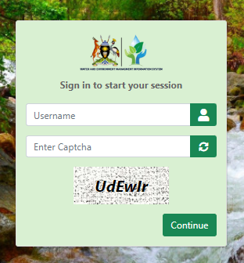

EXISTING USER – CHANGE PASSWORD
Users have the option to modify their password by selecting the "Change Password" feature. It is advisable for users to update their password promptly following the acceptance of their registration.

WATER SUPPLY MANAGEMENT INFORMATION SYSTEM – EDIT PROFILE
This option enables user to edit his/her profile after registration. To edit profile user clicks profile icon (in the upper corner) then click “profile”.
Insert screenshot………………………………………………….. section not done in the system
Following inputs are mandatory to change the profile of any user.
- First name
- Last name
- Email ID
- Middle Name
- Mobile number
Once all the details are submitted, user profile shall be updated with the changed information.

WATER SUPPLY MANAGEMENT INFORMATION SYSTEM - ACESS RIGHTS (USER MANUALS)

WASMIS DASHBOARDS
Authorized Users are granted permission to access the system. Their responsibilities include inputting collected data in diverse formats. Within the system's dashboard, they have the ability to observe different stages of data processing, query and access reports.
The following sections outline the areas accessible to the users as displayed on the Dashboard shown below:

Data Entrants forms
- Point Water Sources (F1A)
- Piped Water Schemes (F2A)

Online Update Forms
- Point Water Source Update (F1A)
- Piped Water Scheme Update (F2A)
- D4 Save
- D6 Save
- S4 Save
- S5 Save
- S6 Save
- S9 Save
- S10 Save

Reports
- Atlas
- National Reports
- District Reports

- Real Time Reports
- Annual Key Facts Reports
- District Key Facts Reports
- District Serves per The
- Village Analysis
- District Software Report
- District Summary Report
- Source per village Reports
- Source without village Reports
- Sub County Key Facts Reports
- Sub county Summary Reports
- Form 1: Records List (mini)
- Form 1: Records List (Full)
- Form 1: Sources without Village
- Form 1: Abandoned Sources
- Form 1: Non-Function Sources List
- Form 2: Record List (Full)

- Annual Reports
- Tabular Reports
- Graphical Reports

- Map Reports
- District Indicator Map
- District Point Sources Map

- Trends Reports
- National Key Trends Reports (Table)
- National Key Trends Reports (Graph)
- District Key Trends Reports (Table)

Query Tool
- Point Water Source
- Piped Scheme
- District Indicator Figure
- Sub county Indicator Figure
- Administrative Units

Activity Dashboard
- Piped Scheme Submit (F2A)
- Point Water Source Submit (F1A)
- D4 Piped Schemes Submit
- D6 Tap Stand Linkage to Piped Scheme
- S4 Source Functionality & Management
- S5 List with Duplicate Source
- S6 Source with Wrong Coordinates
- S9 Rainwater Harvesting Update

Search Records
- Approved Pipe Water Records
- Approved Point Water Records
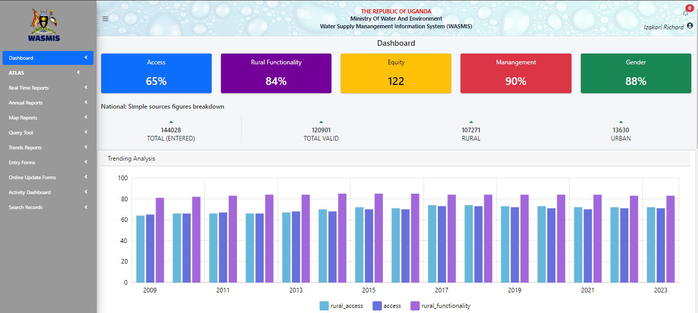
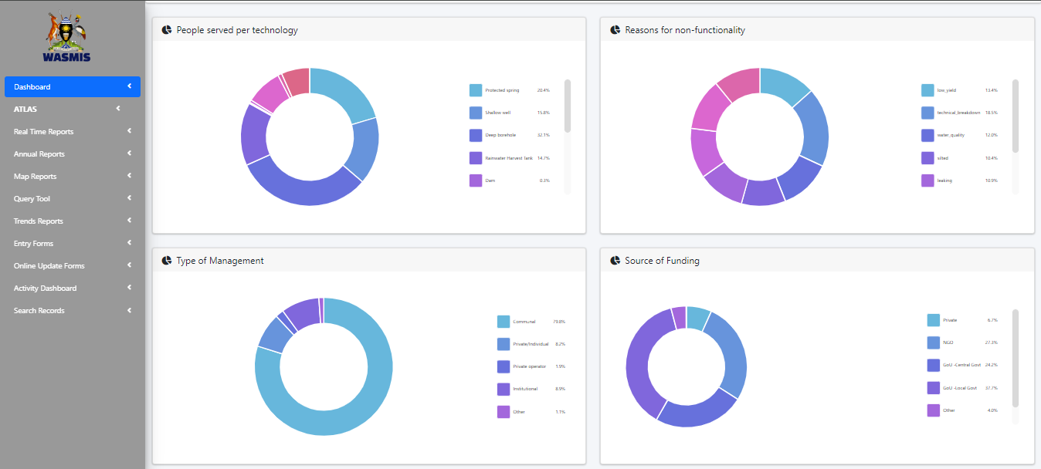

PIPED WATER SOURCES (F1A)
Users can access the Point Water Sources (F1A) and add details or forms as below:
Step 1: Open the form and systematically fill in the fields with the correct data, the fields with asterisk are mandatory:
- Location
- Select RWSRC
- District
- County
- Sub County
- Parish
- Village

- GPS Information
- Elevation (m) – Elevation Should be between 600 to 2500m
- UTM
- UTM Zone No *
- North/South *
- Easting *
- Northing *

- Decimal Degrees
- Latitude
- Longitude

- DMS
- DMS Latitude
- DMS Longitude

- Source Location
- Refugee Camp
- (IDP) Camp

- Source Type
- Type Of Source *(choose from the below dropdown list)
- Dam
- Deep borehole
- Kiosk
- Protected spring
- Public Stand Post
- Rainwater Harvest Tank
- Shallow well
- Un-Protected Spring
- Valley Tank
- WfP Borehole
- Yard tap for public use
NOTE:
If taps, Indicate scheme/system details
Indicate type of mother scheme/system details
- Indicate scheme/system *(choose from the dropdown list)
- Combined Water Based
- Ground water based
- Surface water based
- Name of piped scheme/system *
- Name of piped scheme/system *
- Is this source within the premise? * (select Yes/No)
- No. Of Households Within The Premise
- Estimation Number Of Households
- Within 0-500m radius
- Within 500m-1000m radius
- Beyond>1000m radius

- Construction & Ownership
- Date Of Construction * (Dd/mm/yyyy)
- Estimate (Yes No): If not known, please estimate and indicate (EST) afer the year:
- Source Name *
- Source Number
- Source Of Funding *
- GoU -Central Govt
- Gol -Local Govt
- NGO
- Other
- Partnerships
- Private
- Current Ownership*
- Community
- Institutional - Education
- Institutional - Health
- Other
- Private

- Operation & Maintenance
- Type Of Management *
- Communal
- Institutional
- Other
- Private operator
- Private/Individual
- Does this source have a WSC? (Yes/No)
- Was WSC Established? (Yes/No)
- Year Of Establishment (dd/mm/yyyy)
- Was it trained? (Yes/No)
- Year Of Training (dd/mm/yyyy)
- Is WSC functional? (Yes/No)

- Tick applicable boxes
- WSC is collecting user fees
- WSC undertakes regular servicing/minor repair
- WSC is holding regular meetings

- Environment/Sanitation around the source is ok
- No of members on wsc
- No of active members on wsc
- No of women on wsc
- Are there women in key positions? (Yes/No)
- No of women in key positions
- Key Positions
- Chairperson
- Vice-Chairperson
- Secretary
- Treasurer
- Operational Status (Functionality)
- Type Of Functionality *
- Functional
- Functional (not in use)
- Non-Functional
- officially decommissioned
- recom. for decommissioning

- Date Of Last Repair (Dd/mm/yyyy)
- Details Of Repair

- Water Quality
- In your observation, Is this source free from any contamination?* (Yes/No)

- Village Guide/Respondent
- Give details of the person at the site who is providing information on the water source
- Respondent Name*
- Gender :* Male/Female
- Phone No*
- Title/Responsibility*

- Enumerator Details & Survey Time
- Date Of Data Collection*(Dd/mm/yyyy)
- Name*
- Designation/Title*
- Phone No*

- Attach photo
- Choose file
Step 2: Save or clear data to start afresh
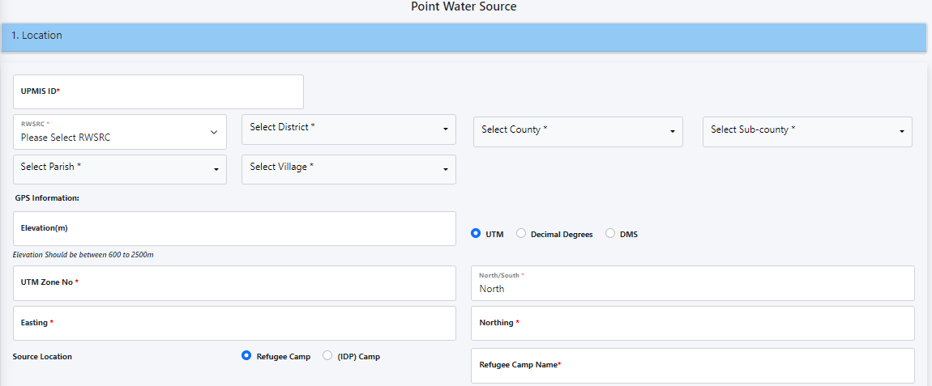
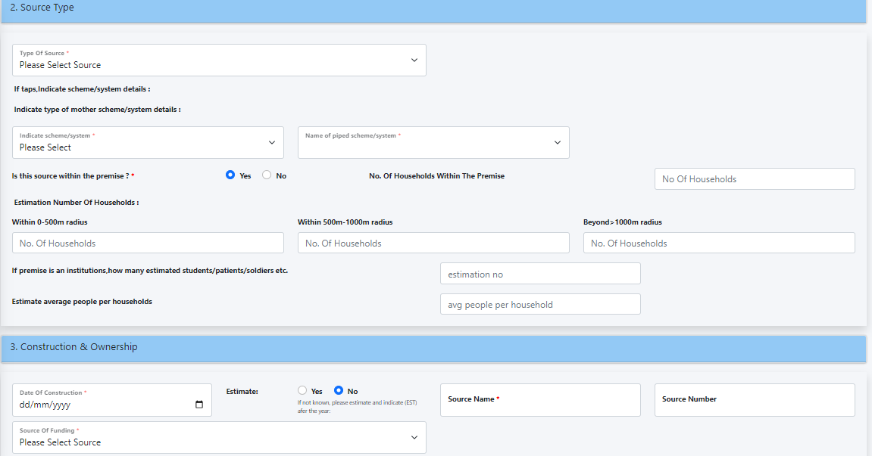
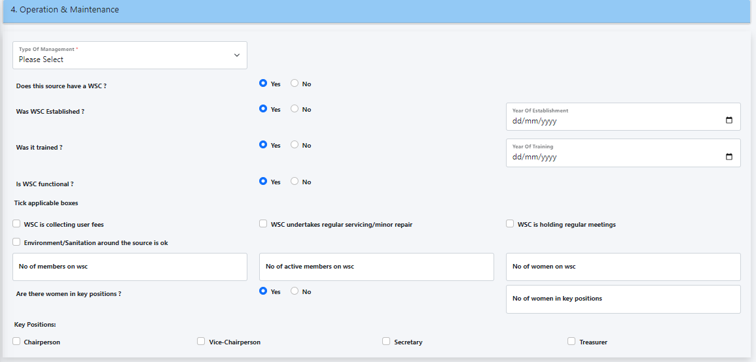
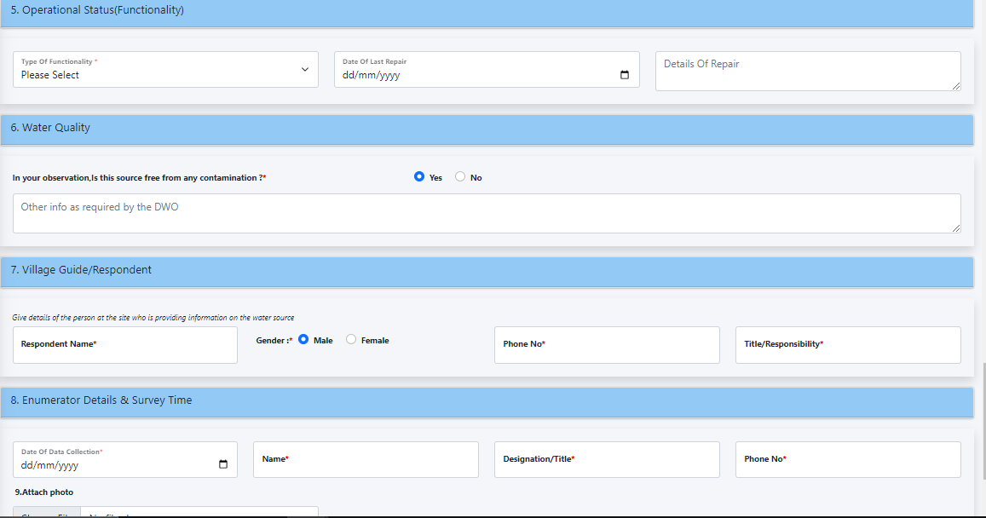

PIPED WATER SCHEMES (F2A)
The user can add data into the Piped Water Schemes (F2A) considering the below fields;
Step 1: Open the form to access the fields, fill them in systematically:
- Location (Source Location)
- UPMIS ID
- RWSRC
- District
- County
- Sub County
- Parish
- Village

- GPS Information
- Elevation (m) – Elevation Should be between 600 to 2500m
- UTM
- UTM Zone No *
- North/South *
- Easting *
- Northing *

- Decimal Degrees
- Latitude
- Longitude

- DMS
- DMS Latitude
- DMS Longitude

- Type of Piped Scheme/System
- Type Of Scheme *
- Local ID Number Of Piped System/Scheme
- Name of piped scheme/system *
- Energy Source For Pumping * (select from the below list)
- Gravity Flow Scheme
- National Grid/Electricity
- Generator/Diesel
- Solar Powered
- Windmill
- Hybrid

- Does this scheme have a surface water source? (Yes/No)
- Type of source *
- Lake
- River
- Wetland/swamp

- Does this scheme have a ground water source? (Yes/No)
- Borehole
- No of borehole*
- Name of borehole*
- Springs
- Other
- Source of funding *
- GoU - Central Govt
- GoU - Local Govt
- NGO
- Other

- General Information
- Total number of current connections/outlets
- No Of Public Transport *
- No Of Yard Taps *
- No Of Kiosks *
- No Of House Connections *
- No Of Institutional Connections *
- No Of Non-Institutional Connections
- No Of Industrial Connections
- Other Connections
- Population Served By System
- Date Of Commissioning (dd/mm/yyyy)
- If not known, please estimate and indicate (EST)
- Is The Scheme Gazetted? (Yes/No)
- What is water authority name? (Umbrella/NWSC)
- Is a treatment system in place? (Yes/No)
- Treatment type
- Water treatment plant
- Chlorine dosing
- Aeration/Iron removal
- Frequency of water treatment (choose from list)
- Daily
- Weekly
- Monthly
- Quarterly
- Bi-Annually
- Annually
- Transmission pipe length
- Distribution pipe length
- Total pipe length
- Total storage capacity

- Operation & Maintenance
- Type Of Management *
- NWSC
- Other
- Private operator
- Private/Individual
- Water and Sanitation Committee

- Is a Water Board (WB)/WSC in place? Yes/No
- Is a WB/WSC functional? Yes/No
- Functionality Of The WB/WSC
- WB/WSC holds quarterly meetings
- WB/WSC undertakes monitoring visits
- WB/WSC checks books of accounts of the operator
- No. of members on WB/WSC
- No. of active members on WB/WSC
- No. of women on WB/WSC
- Are there women in key positions? Yes/No
- No. of women holding key positions*
- Tick Key Positions Below
- Chairperson
- Vice-Chairperson
- Secretary
- Treasurer

- Operational Status (Functionality)
- Type Of Functionality *
- Decommissioned
- Functional
- Non-Functional
- Partially Functional
- Under construction
- Date of Last Repair/Replacement
- Give Details Of Repair

- Other info as required by the DWO
- Does the scheme offer pro-poor services (Yes/No)
i.e. Where people pay less or equal to house connection traffic in service area

- Respondent
- Respondent Name*
- Gender :* Male/Female
- Phone No*
- Title/Responsibility*

- Enumerator Details
- Date Of Data Collection*
- Name*
- Designation/Title*
- Phone No*

- Attach photos
- Attach office photo
- Attach reservoir photo
- Attach intake photos
- Attach kiosk/public tap stand photo
Step 2: Save or clear content of the data and start afresh.
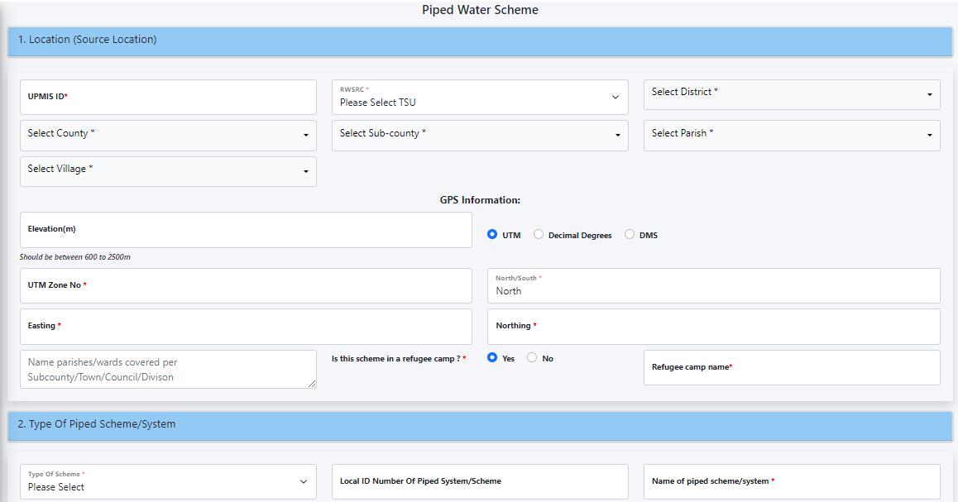
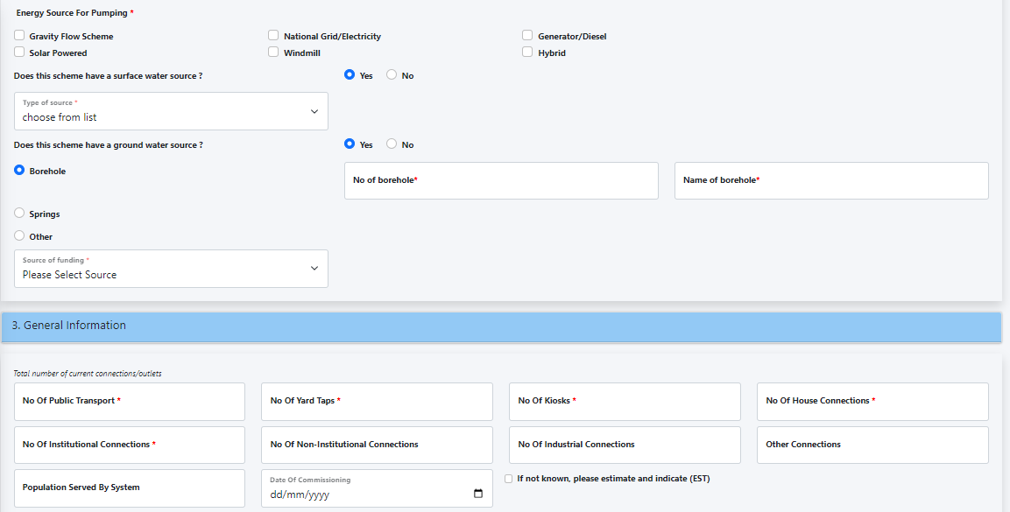
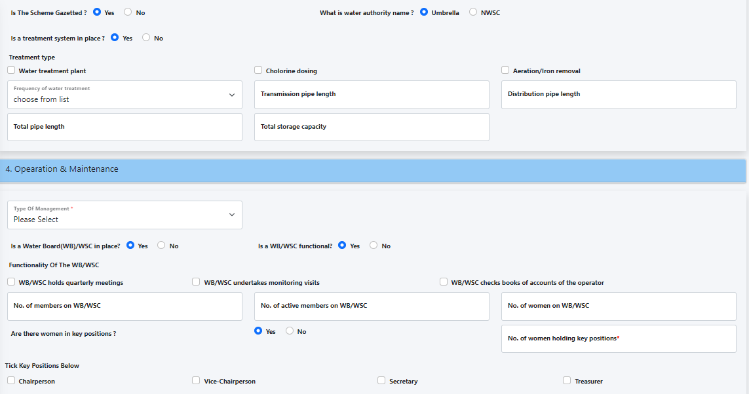
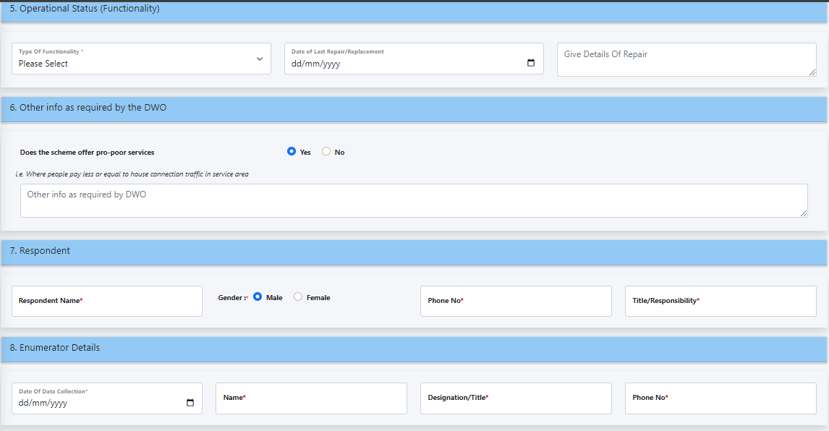
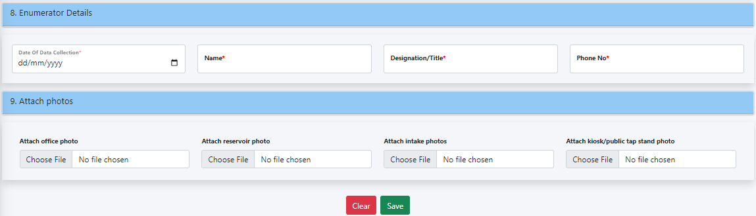

ONLINE UPDATE FORMS
The User can access the below forms for the online update forms;
- Point Water Source Update (F1A)
- Piped Water Scheme Update (F2A)
- D4 Save
- D6 Save
- S4 Save
- S5 Save
- S6 Save
- S9 Save
- S10 Save

Point Water Source Update (F1A)
Step 1: The user can enter the following details and click go, forms will display for updating.
Step 2: Choose the form and action to take, then save or reload the form.
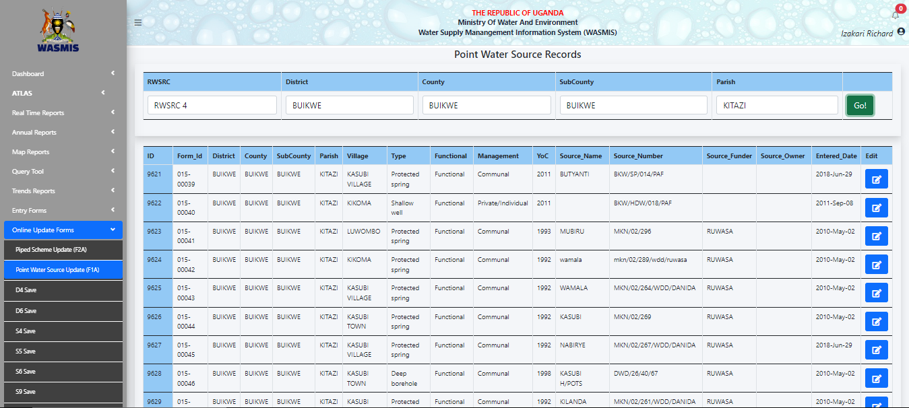

Piped Water Scheme Update (F2A)
Step 1: The user can enter the following details and click go, forms will display for updating.
Step 2: Choose the form and action to take, then save or reload the form.
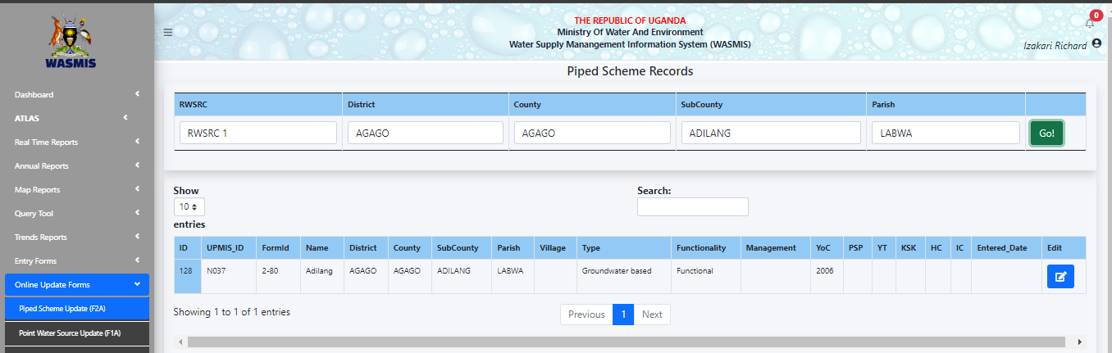

D4 Save
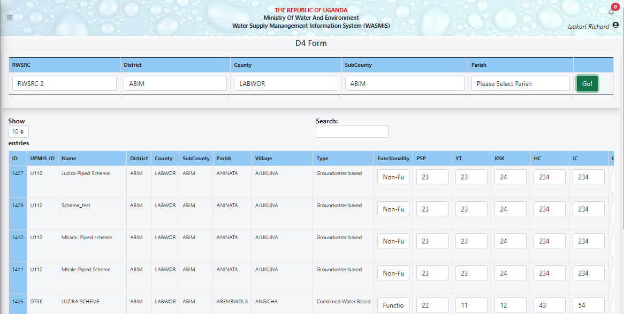

S4 Save
Step 1: The user can enter the following details and click go, forms will display for updating.
Step 2: Choose the form and action to take, then save or reload the form.
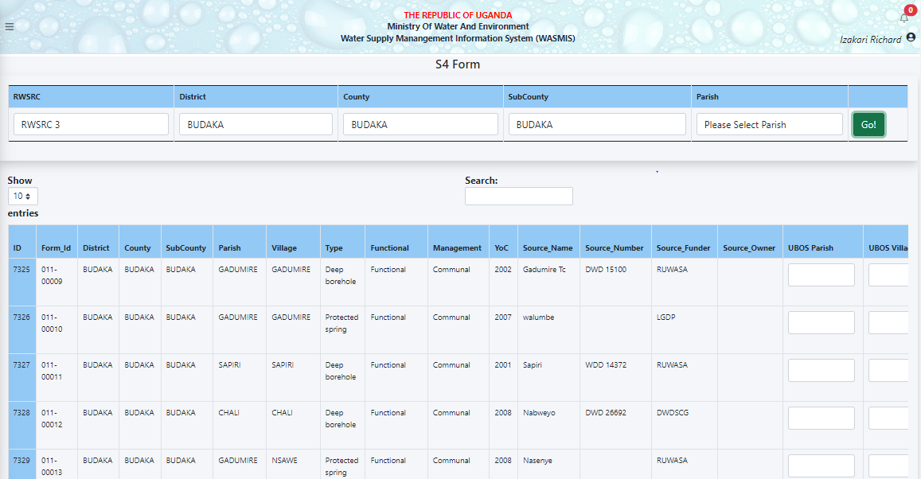

S5 Save
Step 1: The user can enter the following details and click go, forms will display for updating.
Step 2: Choose the form and action to take, then save or reload the form.
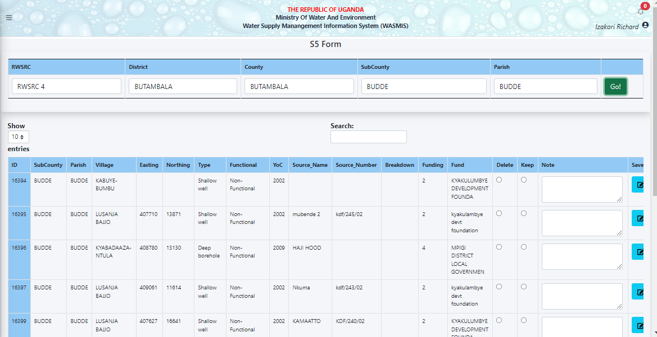

S6 Save
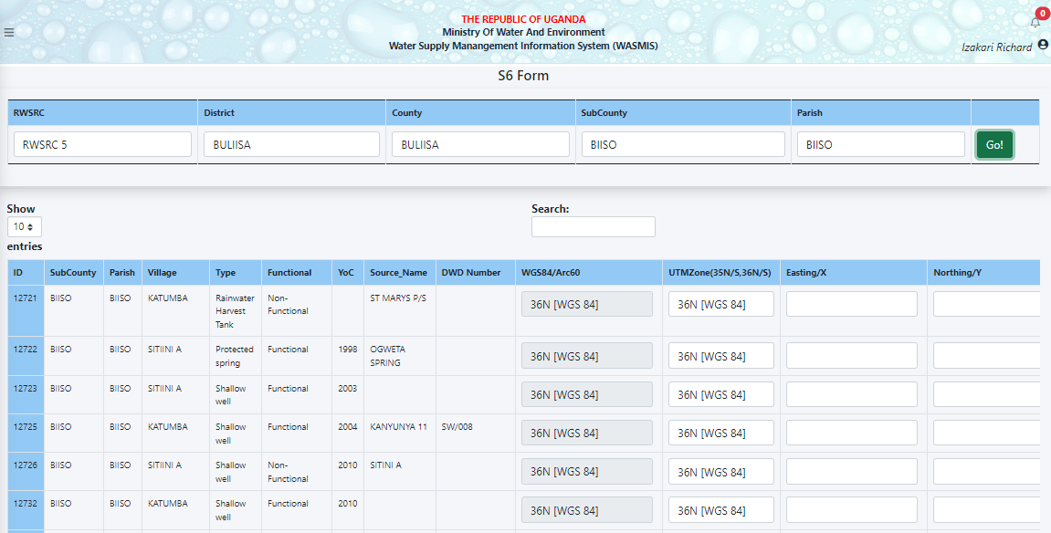

S9 Save
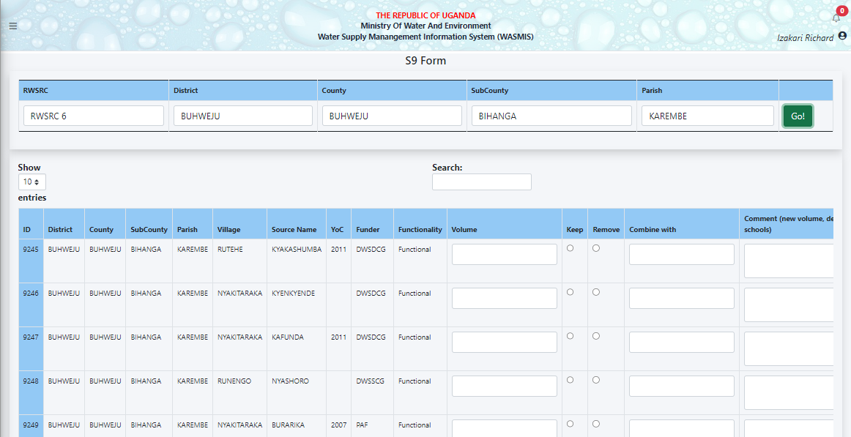

S10 Save
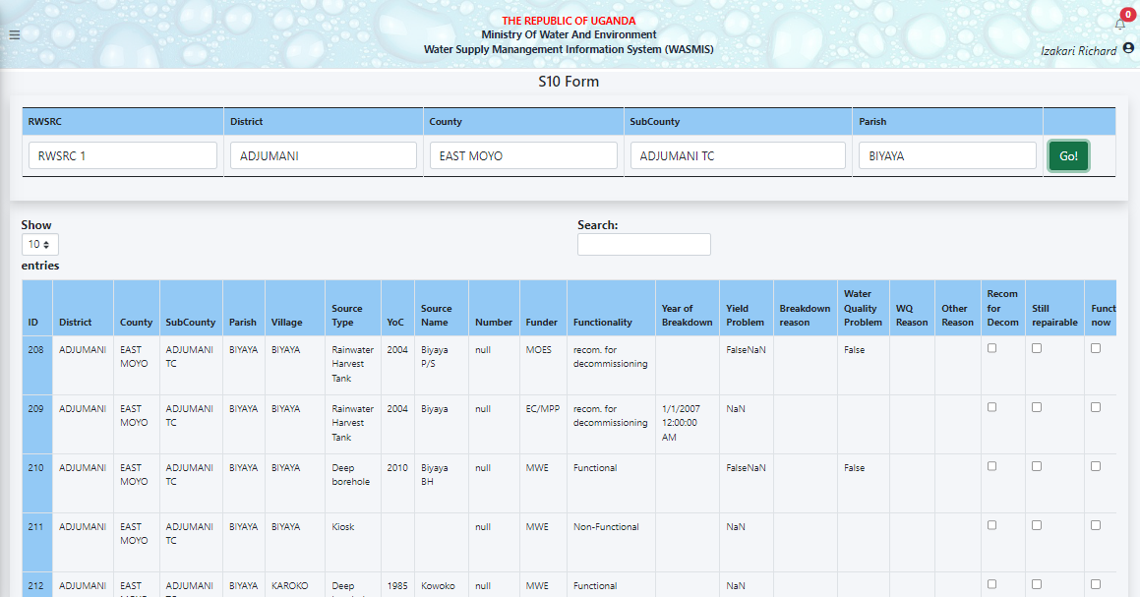

REPORTS
The below are the samples of the reports that can be accessed and viewed by the users. They can be exported to excel.
- Atlas
- National Reports
- District Reports

- Real Time Reports
- Annual Key Facts Reports
- District Key Facts Reports
- District Serves per The
- Village Analysis
- District Software Report
- District Summary Report
- Source per village Reports
- Source without village Reports
- Sub County Key Facts Reports
- Sub county Summary Reports
- Form 1: Records List (mini)
- Form 1: Records List (Full)
- Form 1: Sources without Village
- Form 1: Abandoned Sources
- Form 1: Non-Function Sources List
- Form 2: Record List (Full)

- Annual Reports
- Tabular Reports
- Graphical Reports

- Map Reports
- District Indicator Map
- District Point Sources Map

- Trends Reports
- National Key Trends Reports (Table)
- National Key Trends Reports (Graph)
- District Key Trends Reports (Table)

Atlas

National Reports
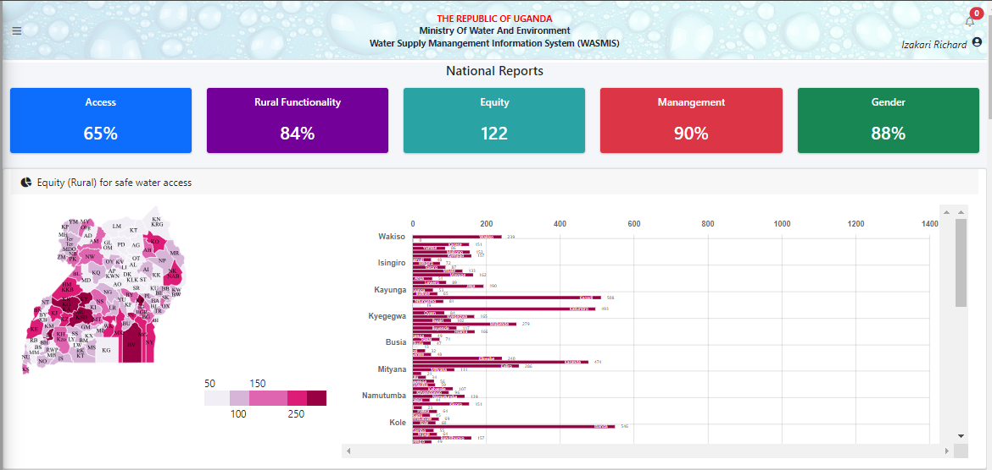
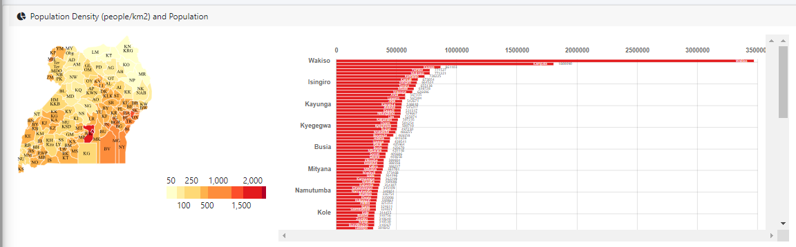
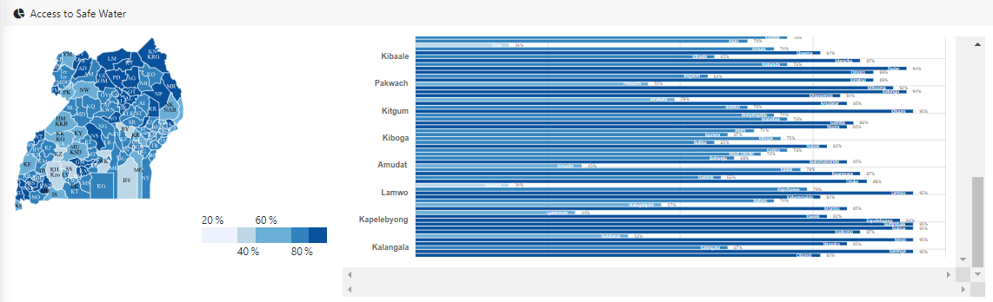
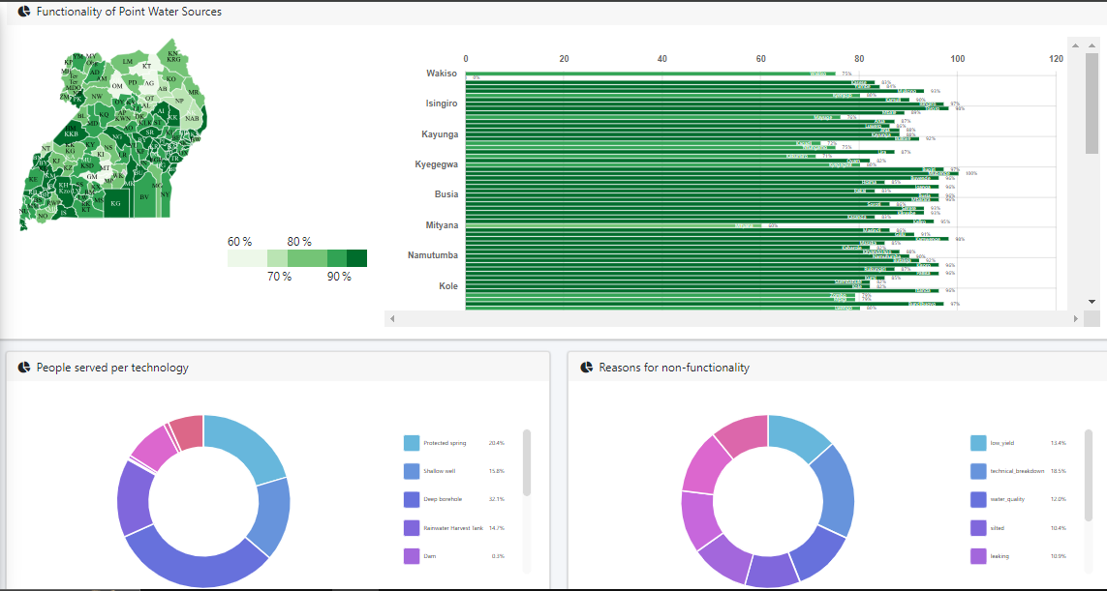
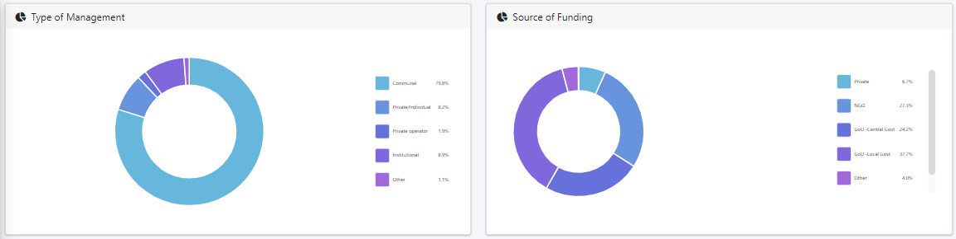
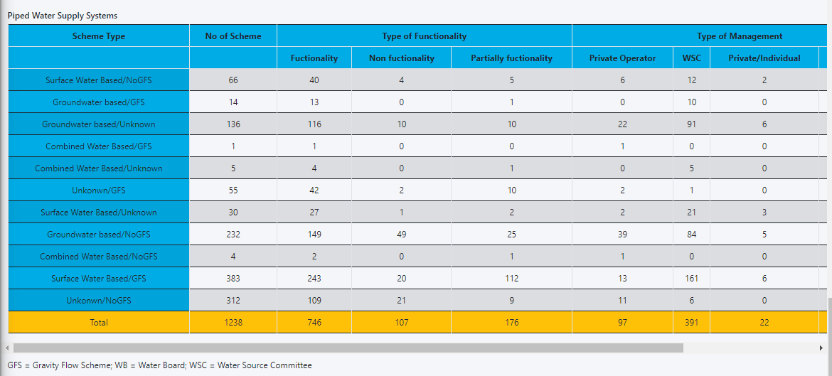

District Reports
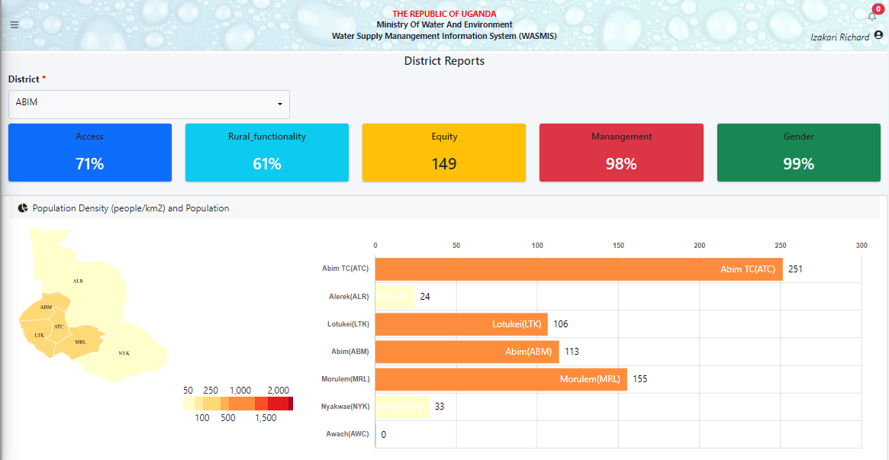
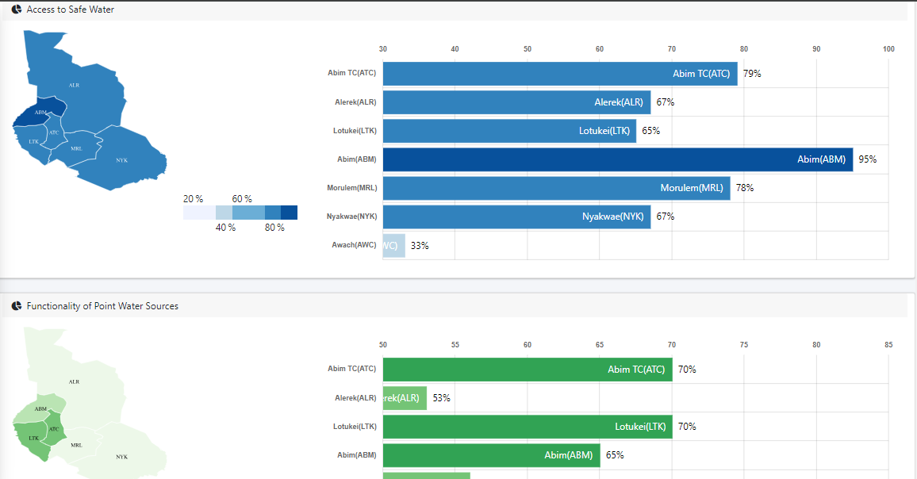
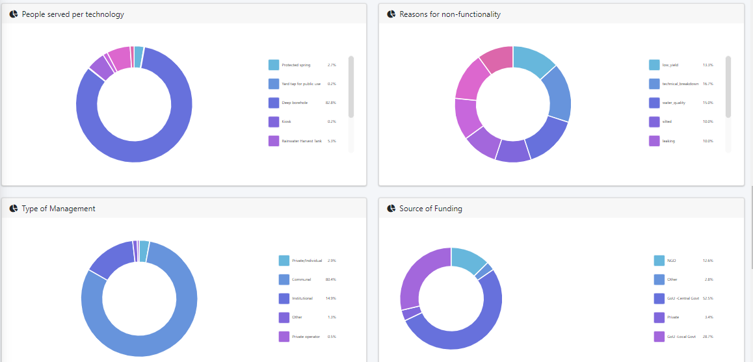
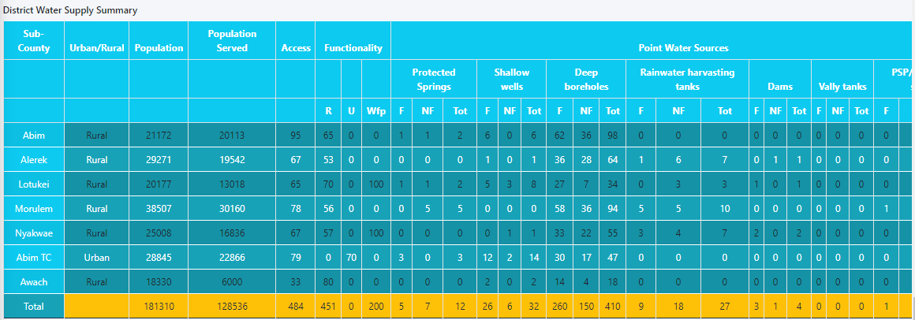
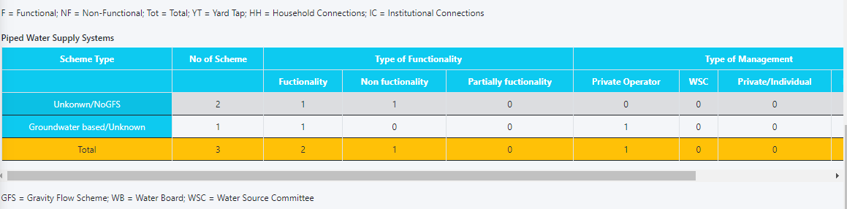

Real Time Reports

Annual Key Facts Reports
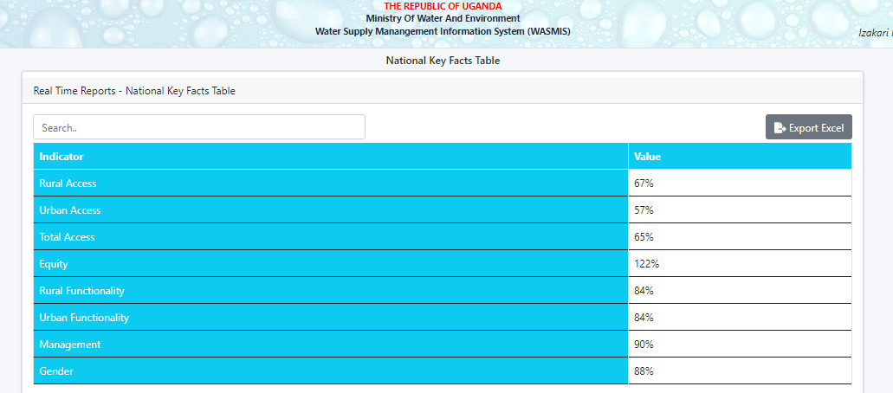

District Key Facts Reports
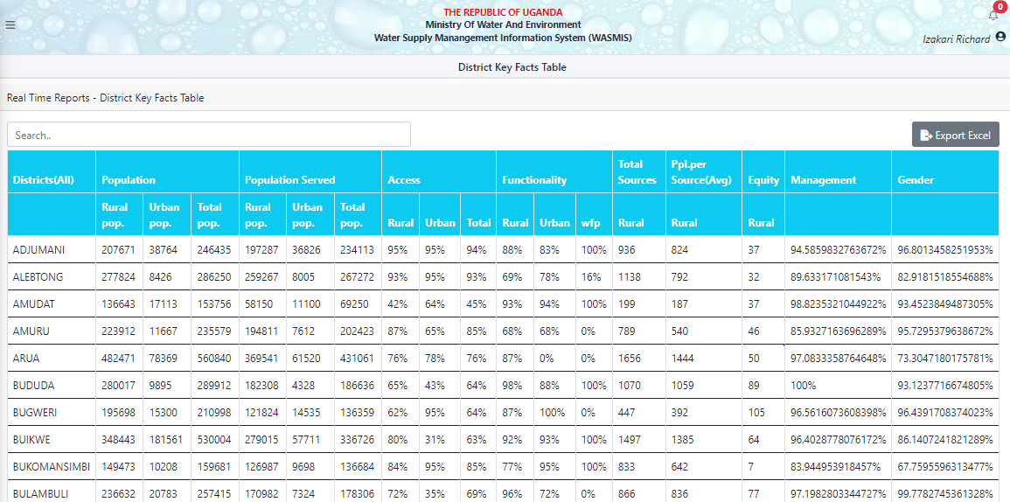

District Serves per Tech
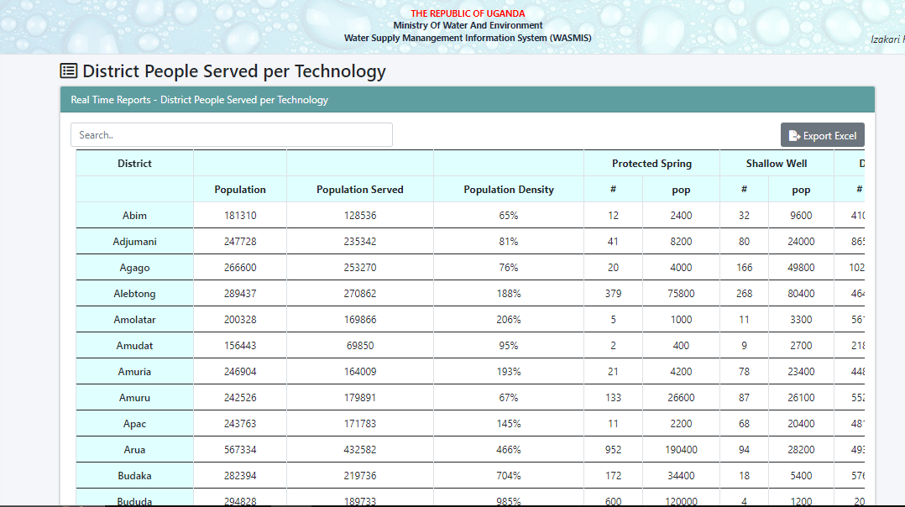

Village Analysis
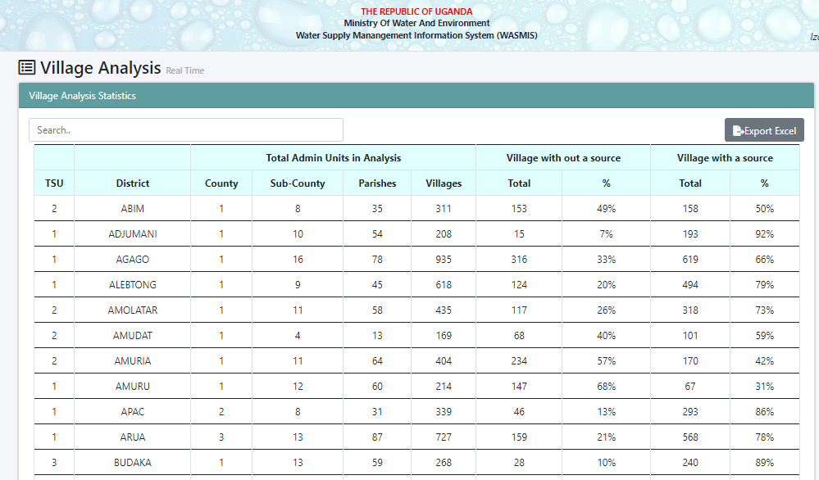

District Software Report

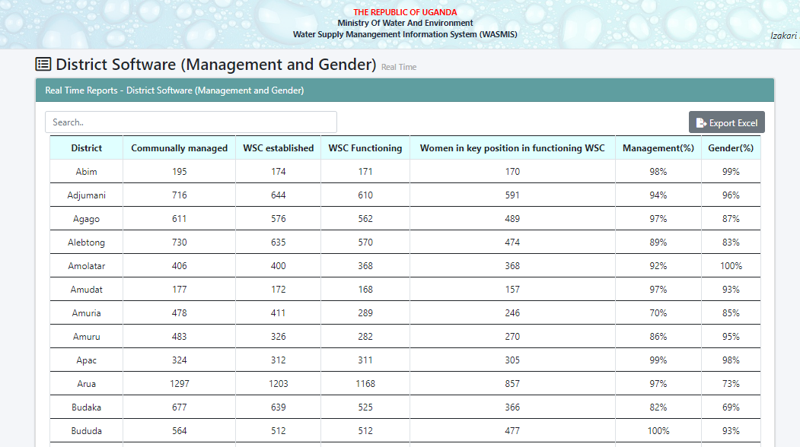

District Summary Report
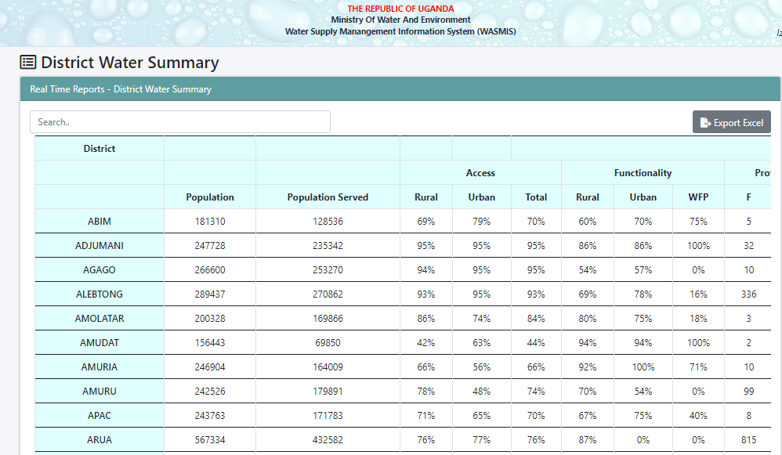

Source per village Reports
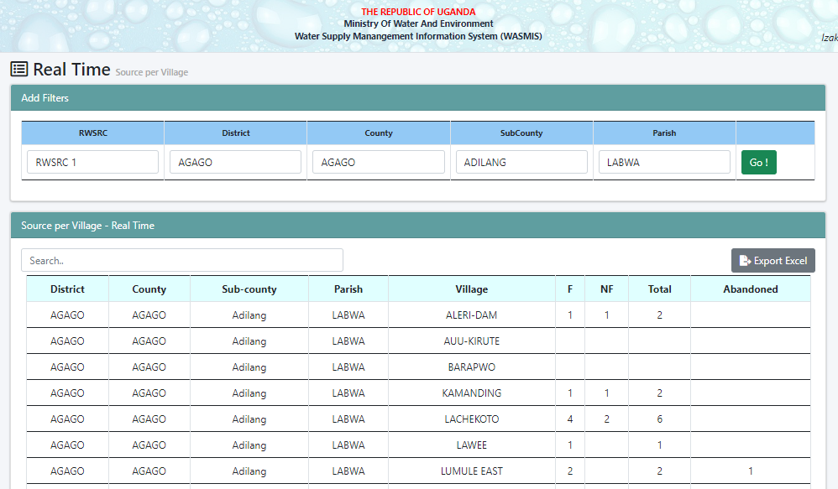

Source without village Reports
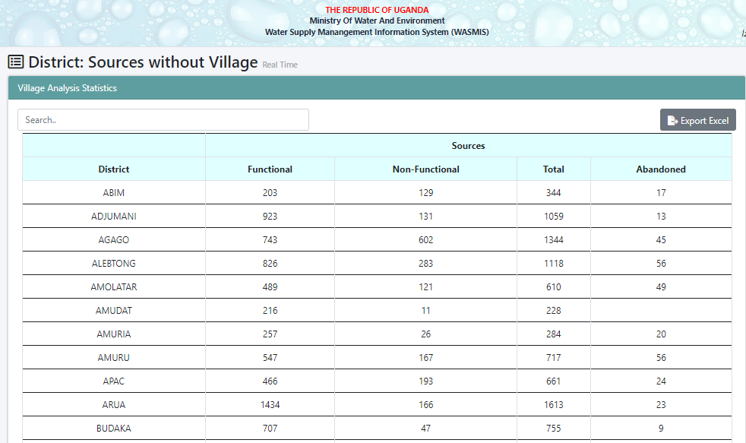

Sub County Key Facts Reports
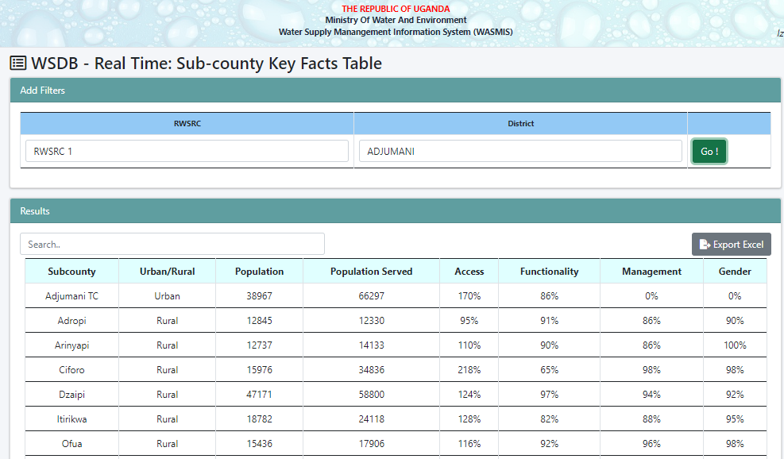

Sub County Summary Reports
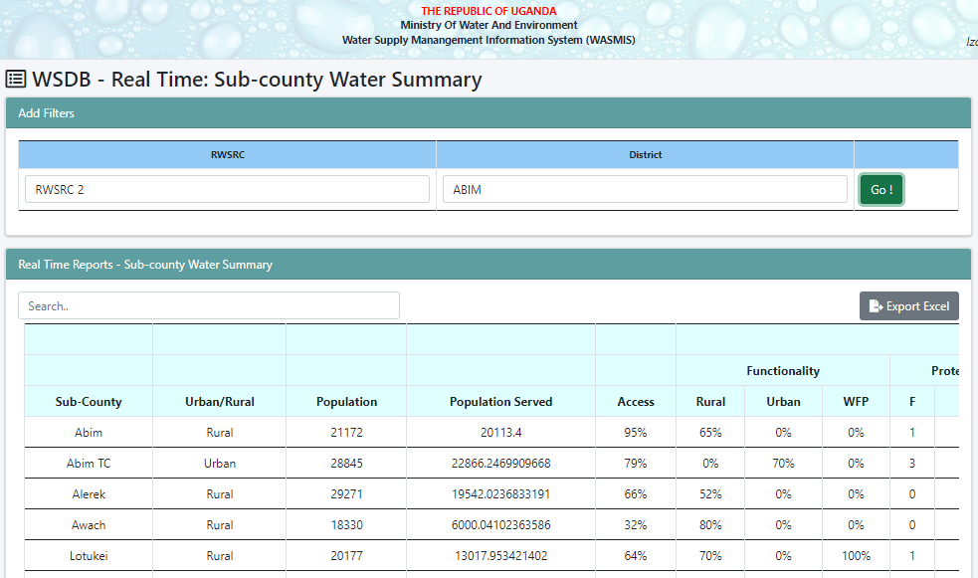

Form 1: Records List (mini)
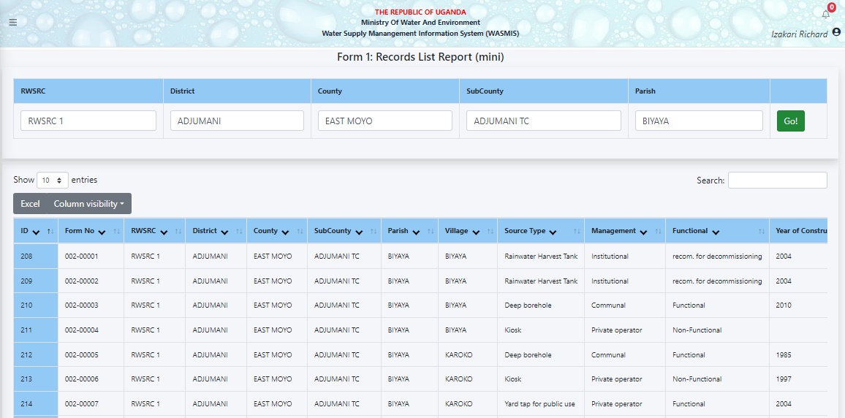

Form 1: Records List (Full)
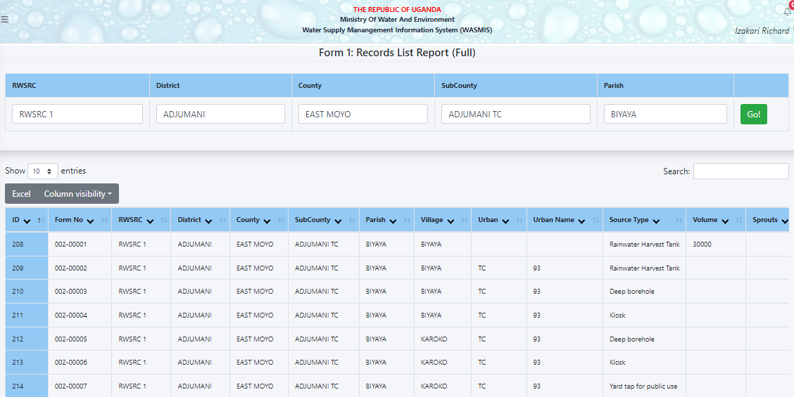

Form 1: Sources without Village
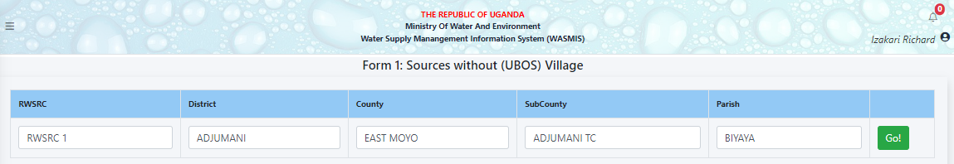

Form 1: Abandoned Sources
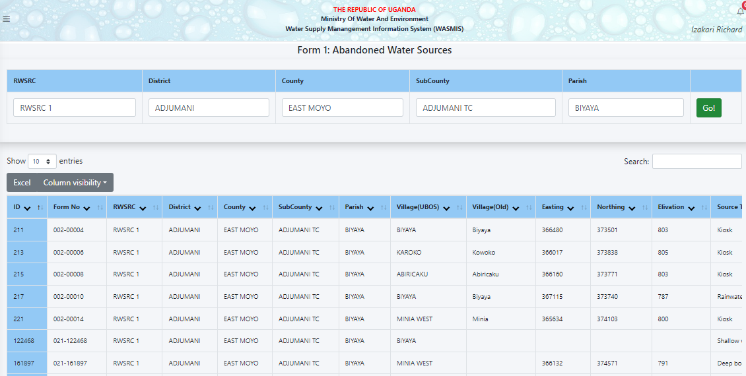

Form 1: Non-Function Sources List
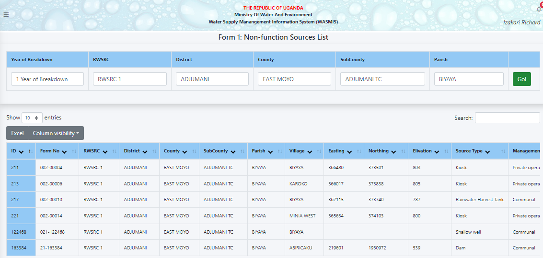

Form 2: Record List (Full)
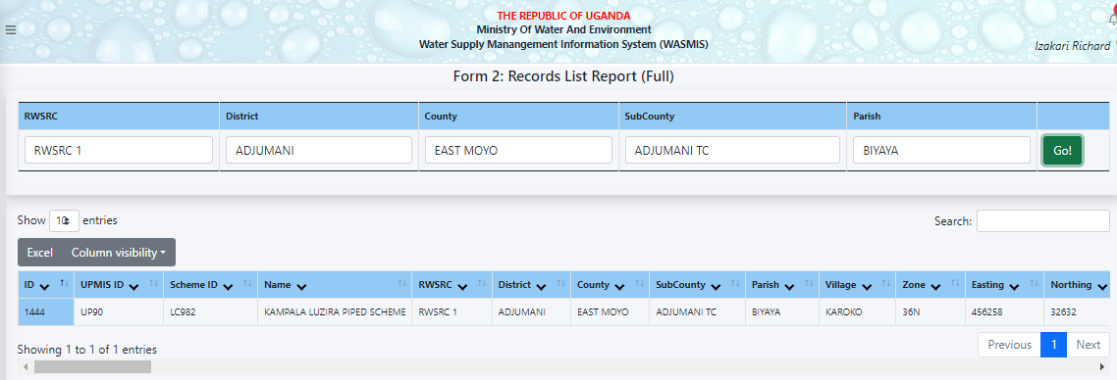

Annual Reports

Tabular Reports
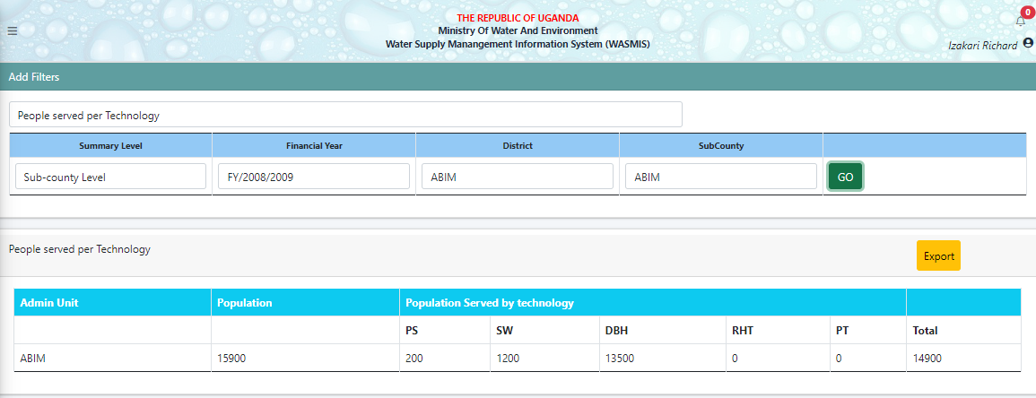

Graphical Reports
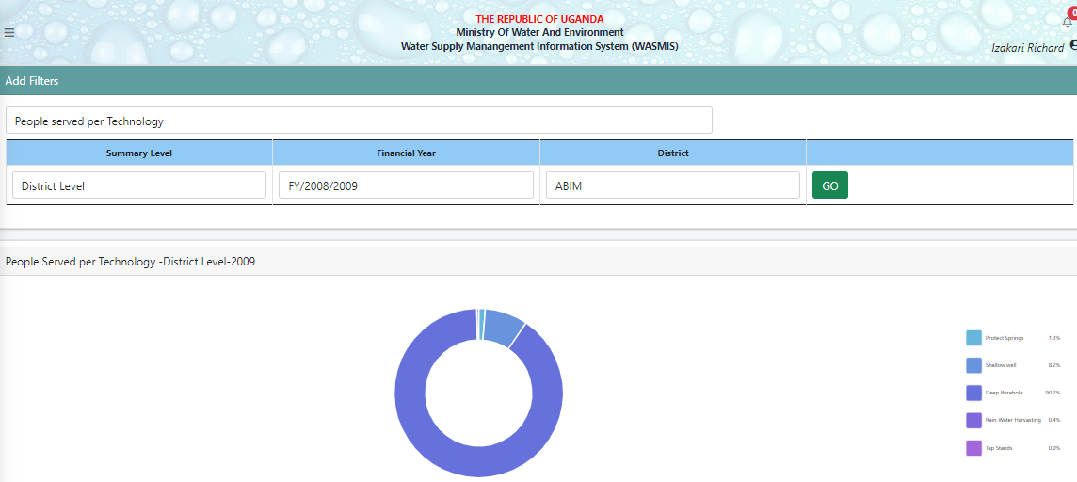

Map Reports

District Indicator Map
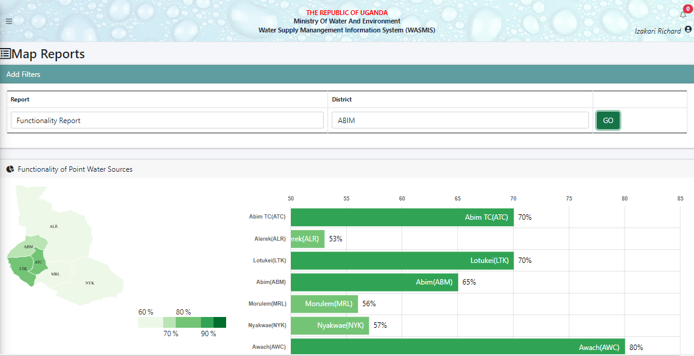

District Point Sources Map
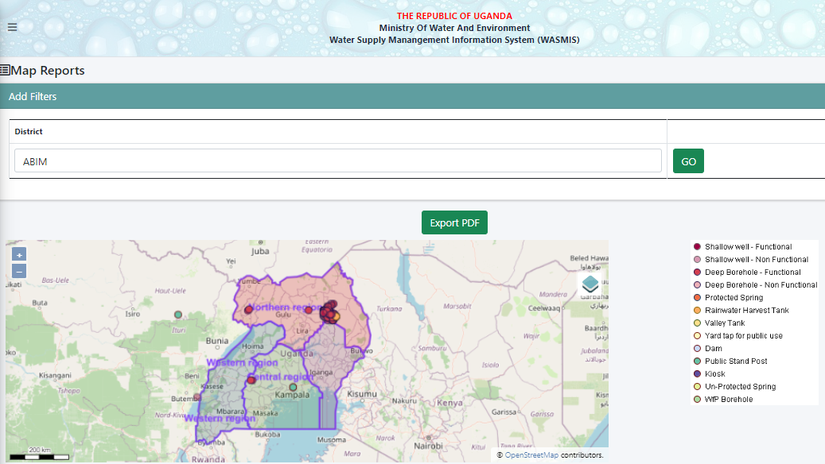

Trends Reports

National Key Trends Reports (Table)
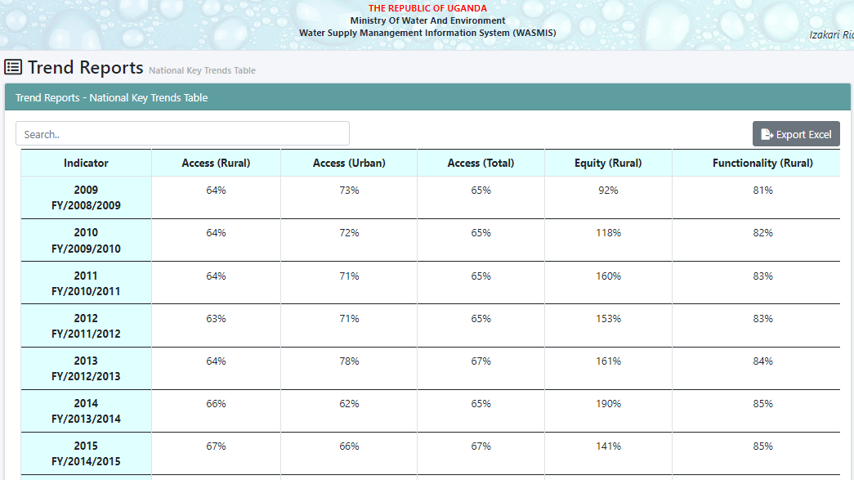

National Key Trends Reports (Graph)
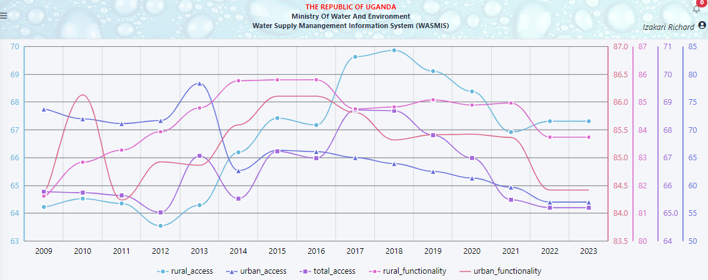

District Key Trends Reports (Table)
Displays error for “Server Error in '/' Application. The resource cannot be found.”………………………..

ACTIVITY DASHBOARD
It displays the actions that have been taken, the pending actions, referred back and received. Below is the list of the activity dashboards:
- Piped Scheme Submit (F2A)
- Point Water Source Submit (F1A)
- D4 Piped Schemes Submit
- D6 Tap Stand Linkage to Piped Scheme
- S4 Source Functionality & Management
- S5 List with Duplicate Source
- S6 Source with Wrong Coordinates
- S9 Rainwater Harvesting Update

Piped Scheme Submit (F2A)
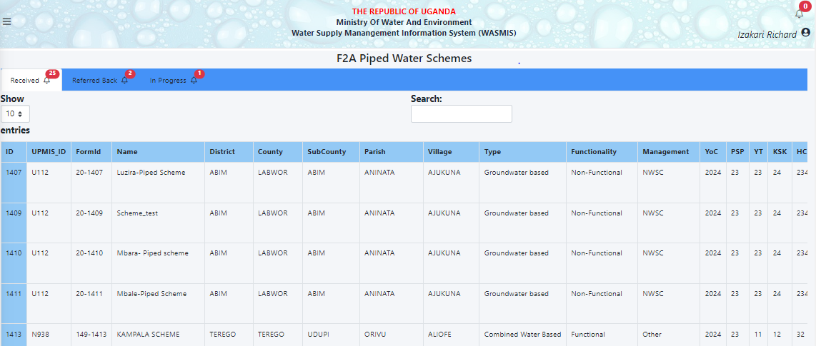

Point Water Source Submit (F1A)
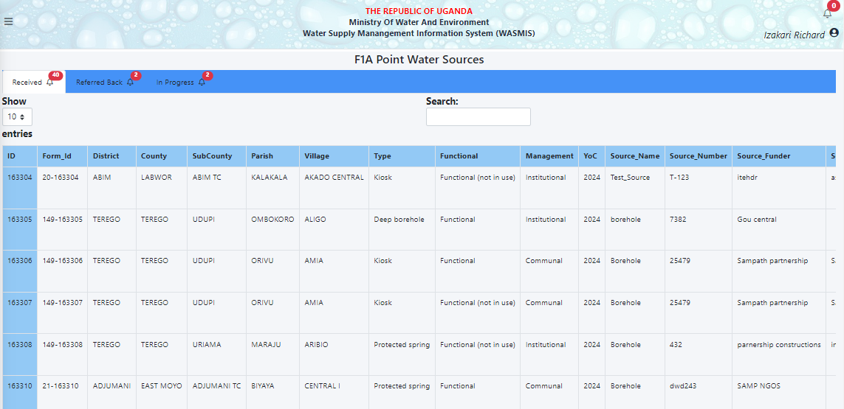

D4 Piped Schemes Submit
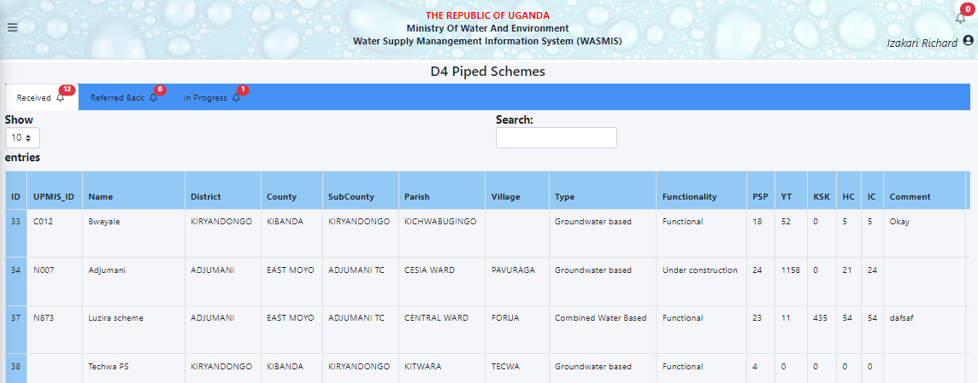

D6 Tap Stand Linkage to Piped Scheme
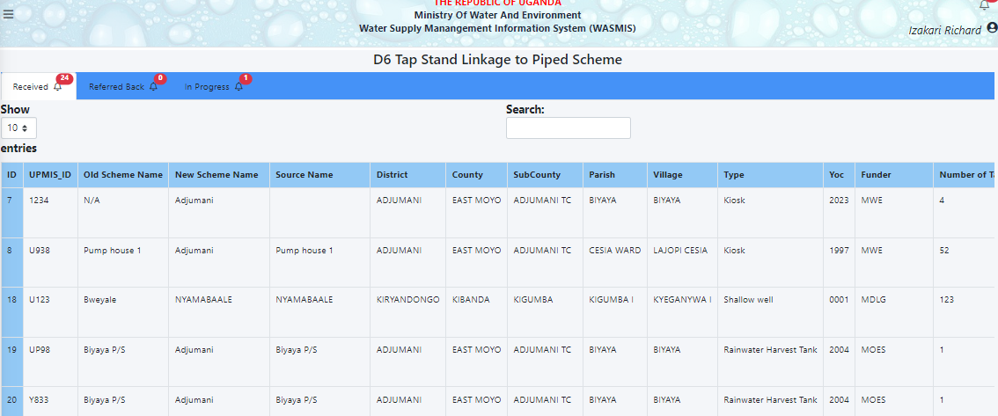

S4 Source Functionality & Management
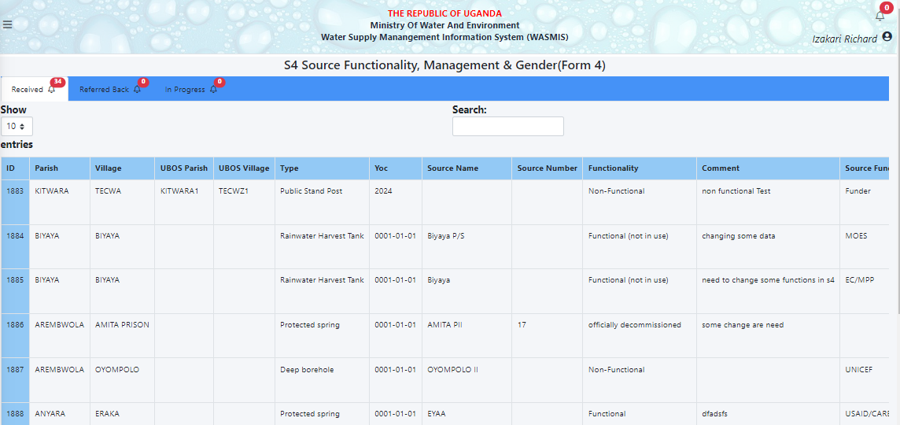

S5 List with Duplicate Source
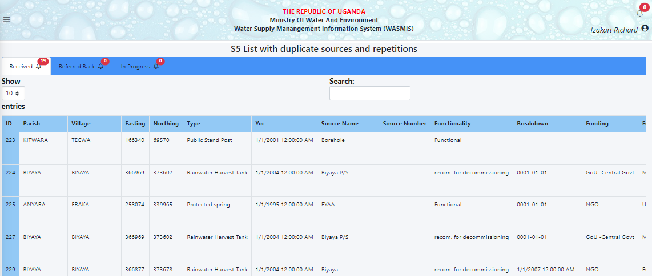

S6 Source with Wrong Coordinates
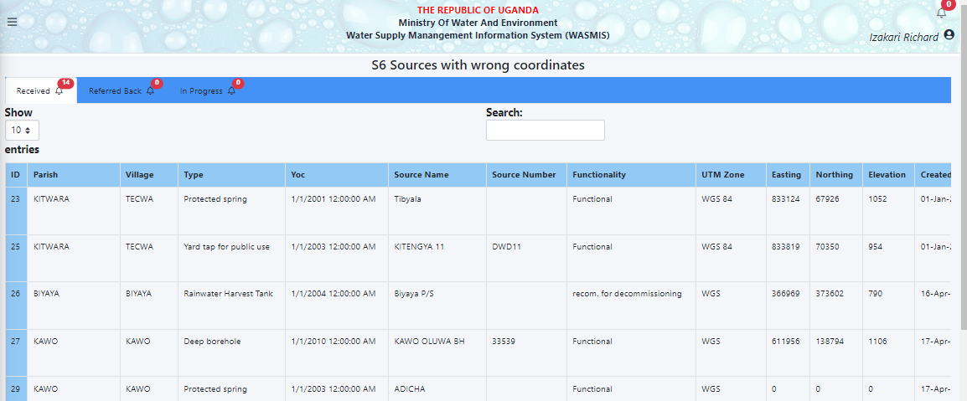

S9 Rainwater Harvesting Update
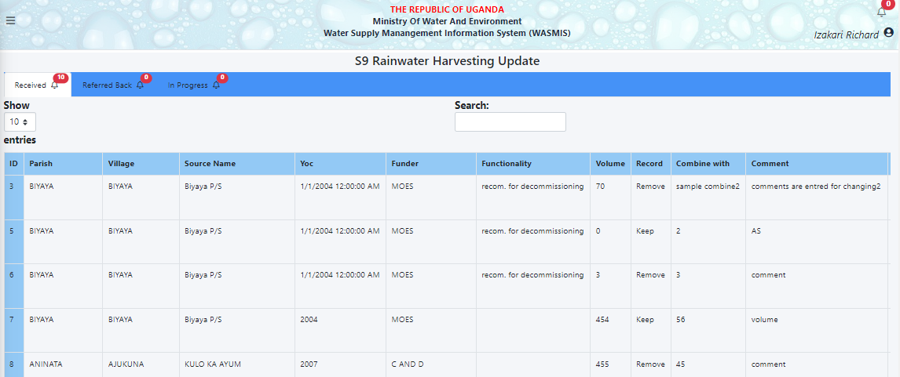

QUERY TOOL
The tool is used to search for any given parameters in the system as needed by the user. Below is the list of the sections that can be queried in the system:
- Point Water Source
- Piped Scheme
- District Indicator Figure
- Sub county Indicator Figure
- Administrative Units

Point Water Source
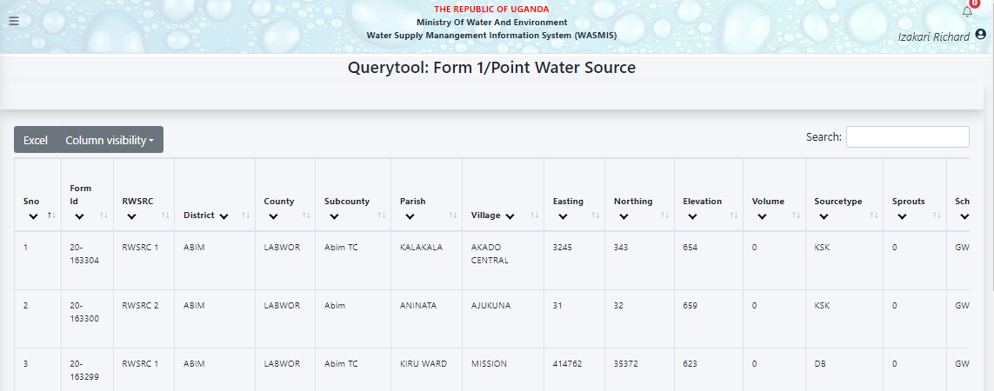

Piped Scheme

District Indicator Figure
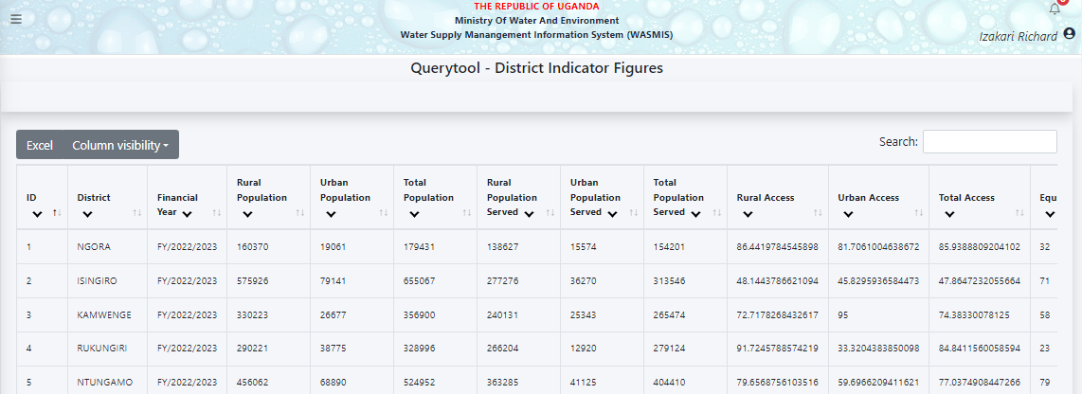

Sub County Indicator Figure

Administrative Units

SEARCH RECORDS
This section of the system allows the user to search items, records or facilities in the WASMIS. Below are the categories that can be searched;
- Approved Pipe Water Records
- Approved Point Water Records

Approved Pipe Water Records
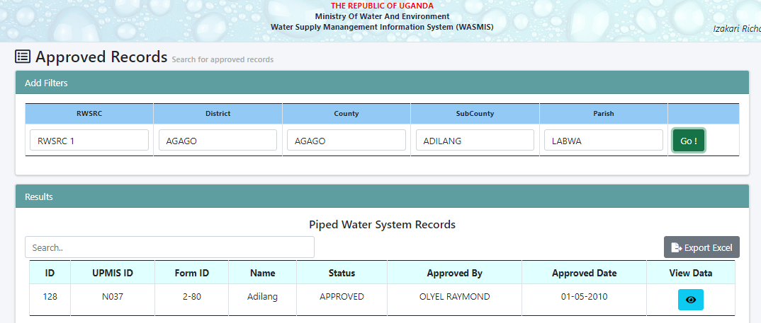

Approved Point Water Records
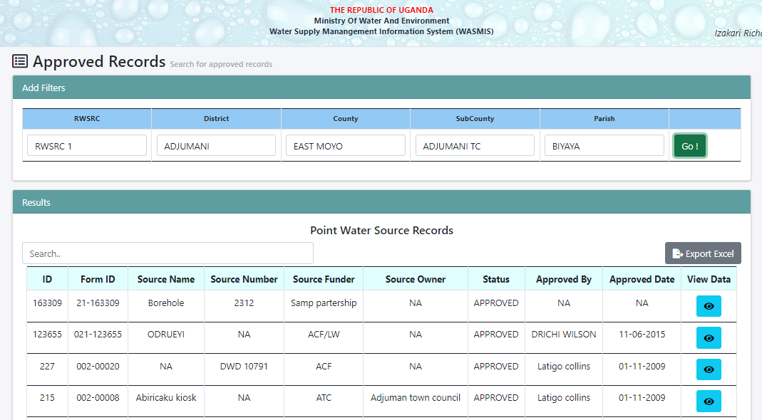

END

